Software Usability and Graphical User Interface Validation through Eye Tracking

Rishabh Sharma

May 2018

Department of Computer Science

California State University, Fresno

Software Usability and Graphical User Interface Validation through Eye Tracking

Rishabh Sharma

May 2018



Department of Computer Science

California State University, Fresno

Fresno, CA 93740

Project Advisor

Dr. Hubert Cecotti

Submitted in partial fulfillment of the requirements   
for the degree of Master of Science

Abstract

Graphical User Interfaces (GUIs) represent a key part for building interactive applications, and act as a direct interface between the users and the software. The complexity of the GUIs increases in relation to the number of users interacting with software and performing multiple complex tasks, resulting in software that are the maze of functionalities, with multiple GUIs interacting with each other for performing a user defined task. The impact of such a GUI system is adverse on the software quality. Software quality assessment becomes critical to maintain their robustness with the increase of complex GUIs. To measure software quality, one has to measure the attributes such as usability, efficiency, and learnability. With the advancement in software engineering, well-established testing techniques and models for measuring software efficiency have been developed. However, there is no general approach for measuring software validity subjectively in a non-invasive way, i.e. without directly asking the users to evaluate the software.

In this project, we propose to classify different GUI states developed using horizontal key value pair architecture. GUIs are primarily classified in two unique states: GUIs with congruent pairs i.e., perfect match of pairs in GUIs – GUIs with high usability, and GUIs with incongruent pairs i.e., GUIs with anomaly – GUIs with low usability. GUIs with incongruent pairs are further classified into three states: GUI with one key value pair having unconventional value, GUI with all the values shuffled in key value pair, and GUI with only two values swapped with each other in a key value pair. A portable eye tracker is used for collecting the user’s gaze information during the interaction with the GUI’s. The collected gaze information is then analyzed to generate a set of thirteen features related to the gaze on the different key value pairs present on the screen. The performance of five classifiers: a density-based method: K – Nearest Neighbor, linear distribution based: Support Vector Machine and Linear Discriminant Analysis, tree based: Random Forest Tree, and naïve based: Gaussian Naïve Bayes is evaluated. Finally, the choice of the best discriminant features is analyzed through a modified backward elimination technique. The result supports the conclusion that congruent GUI states using one versus rest and one versus one binary classification can be predicted through gaze-based features with an average AUC of >76 (+/- 3.63%) and >73.66 (+/- 9.81%) respectively using Gaussian Naïve Bayes classifier.

Preface

The research project report “Software Usability and Graphical User Interface Validation through Eye Tracker” is undertaken as a part of Master of Science in Computer Science curriculum at California State University, Fresno. Software Usability plays an important role in the determining of its acceptance by the large majority of users after release in the market and it is often avoided during the design and development of the software.

The academic research study is performed on 20 students of California State University, Fresno during which each student was asked to pay attention a series of items presented on a screen for four second and classify the items presented on the screen as congruent or incongruent while their gaze over the GUI is recorded. Based on the user’s gaze information, classification is performed to develop a classifier that can classify GUI types with respect to each other.

The report is divided into the following sections: In Section 1, software usability and previous studies about software usability improvement are presented. Section 2, discuss the experiment and feature extraction from the gaze data. In Section 3, results of the classification using various classifiers are shown. The results are discussed in Section 4. Finally, the paper is concluded with potential future works in Section 5.

Acknowledgement

I wish to thank my mentor, Dr. Hubert Cecotti for his great teaching, support, and guidance throughout my course-work. Through his guidance and proactive teaching skills, I was able to understand the theoretical and practical aspect of Machine Learning and Eye Tracking. I am thankful to all the faculty of Computer Science Department for being supportive throughout this beautiful journey. Finally, I would like to extend my heartfelt gratitude to my parents, and my friends for their love, support, and encouragement while pursuing my course of study.

TABLE OF CONTENTS

Abstract 3

Preface 4

Acknowledgement 5

1. Introduction 11

1.1 State of the Art 11

2. methods 14

2.1 Experiments 14

2.1.1 GUI Description 14

2.1.2 Participants 15

2.1.3 Task Performed by Participants 15

2.2 Feature Extraction 16

2.1.1 Distance Based Feature Extraction 17

2.1.2 Centroid Based Feature Extraction 18

2.1.3 Time Based Feature Extraction 18

2.3 Classification of Data 22

2.4 Classifier 23

2.4.1 K Nearest Neighbor 24

2.4.2 Support Vector Machine 25

2.4.3 Linear Discriminant Analysis 25

2.4.4 Random Forest Tree 26

2.4.5 Gaussian Naïve Bayes 26

2.5 Feature Selection 27

2.5 Performance Evaluation 29

3. results 31

3.1 Human Behavior Analysis 31

3.2 Classifier Performance Evaluation 31

4. Discussion 35

5. Conclusion 36

References 37

Appendix A 39

Appendix B 52

Appendix C 65

*LIST OF THE FIGURES* *PAGE NO.*

Figure 1 Advancing technology Vs Declining user ability 11

Figure 2 GUI types 15

Figure 3 K Nearest Neighbor 24

Figure 4 Support Vector Machine 25

Figure 5 Linear Discriminant Analysis 26

Figure 6 Random Forest Tree 26

Figure 7 KNN Features Selection: 1 vs Rest; 2 vs Rest 39

Figure 8 KNN Features Selection: 3 vs Rest; 4 vs Rest 40

Figure 9 KNN Features Selection: 1 vs 2; 1 vs 3 40

Figure 10 KNN Features Selection: 1 vs 4; 2 vs 3 41

Figure 11 KNN Features Selection: 2 vs 4; 3 vs 4 41

Figure 12 SVM Features Selection: 1 vs Rest; 2 vs Rest 42

Figure 13 SVM Features Selection: 3 vs Rest; 4 vs Rest 42

Figure 14 SVM Features Selection: 1 vs 2; 1 vs 3 43

Figure 15 SVM Features Selection: 1 vs 4; 2 vs 3 43

Figure 16 SVM Features Selection: 2 vs 4; 3 vs 4 44

Figure 17 LDA Features Selection: 1 vs Rest; 2 vs Rest 44

Figure 18 LDA Features Selection: 3 vs Rest; 4 vs Rest 45

Figure 19 LDA Features Selection: 1 vs 2; 1 vs 3 45

Figure 20 LDA Features Selection: 1 vs 4; 2 vs 3 46

Figure 21 LDA Features Selection: 2 vs 4; 3 vs 4 46

Figure 22 RFT Features Selection: 1 vs Rest; 2 vs Rest 47

Figure 23 RFT Features Selection: 3 vs Rest; 4 vs Rest 47

Figure 24 RFT Features Selection: 1 vs 2; 1 vs 3 48

Figure 25 RFT Features Selection: 1 vs 4; 2 vs 3 48

Figure 26 RFT Features Selection: 2 vs 4; 3 vs 4 49

Figure 27 GNB Features Selection: 1 vs Rest; 2 vs Rest 49

Figure 28 GNB Features Selection: 3 vs Rest; 4 vs Rest 50

Figure 29 GNB Features Selection: 1 vs 2; 1 vs 3 50

Figure 30 GNB Features Selection: 1 vs 4; 2 vs 3 51

Figure 31 GNB Features Selection: 2 vs 4; 3 vs 4 51

Figure 32 Feature Influence Graph Across All Classifiers 28

Figure 33 Confusion Matrix 29

Figure 34 KNN ROC Curve: 1 vs Rest; 2 vs Rest 52

Figure 35 KNN ROC Curve: 3 vs Rest; 4 vs Rest 53

Figure 36 KNN ROC Curve: 1 vs 2; 1 vs 3 53

Figure 37 KNN ROC Curve: 1 vs 4; 2 vs 3 54

Figure 38 KNN ROC Curve: 2 vs 4; 3 vs 4 54

Figure 39 SVM ROC Curve: 1 vs Rest; 2 vs Rest 55

Figure 40 SVM ROC Curve: 3 vs Rest; 4 vs Rest 55

Figure 41 SVM ROC Curve: 1 vs 2; 1 vs 3 56

Figure 42 SVM ROC Curve: 1 vs 4; 2 vs 3 55

Figure 43 SVM ROC Curve: 2 vs 4; 3 vs 4 57

Figure 44 LDA ROC Curve: 1 vs Rest; 2 vs Rest 57

Figure 45 LDA ROC Curve: 3 vs Rest; 4 vs Rest 58

Figure 46 LDA ROC Curve: 1 vs 2; 1 vs 3 58

Figure 47 LDA ROC Curve: 1 vs 4; 2 vs 3 59

Figure 48 LDA ROC Curve: 2 vs 4; 3 vs 4 59

Figure 49 RFT ROC Curve: 1 vs Rest; 2 vs Rest 60

Figure 50 RFT ROC Curve: 3 vs Rest; 4 vs Rest 60

Figure 51 RFT ROC Curve: 1 vs 2; 1 vs 3 61

Figure 52 RFT ROC Curve: 1 vs 4; 2 vs 3 61

Figure 53 RFT ROC Curve: 2 vs 4; 3 vs 4 62

Figure 54 GNB ROC Curve: 1 vs Rest; 2 vs Rest 62

Figure 55 GNB ROC Curve: 3 vs Rest; 4 vs Rest 63

Figure 56 GNB ROC Curve: 1 vs 2; 1 vs 3 63

Figure 57 GNB ROC Curve: 1 vs 4; 2 vs 3 64

Figure 58 GNB ROC Curve: 2 vs 4; 3 vs 4 64

Figure 59 KNN ROC Curve after removing false prediction: 1 vs Rest; 2 vs Rest 65

Figure 60 KNN ROC Curve after removing false prediction: 3 vs Rest; 4 vs Rest 66

Figure 61 KNN ROC Curve after removing false prediction: 1 vs 2; 1 vs 3 66

Figure 62 KNN ROC Curve after removing false prediction: 1 vs 4; 2 vs 3 67

Figure 63 KNN ROC Curve after removing false prediction: 2 vs 4; 3 vs 4 67

Figure 64 SVM ROC Curve after removing false prediction: 1 vs Rest; 2 vs Rest 68

Figure 65 SVM ROC Curve after removing false prediction: 3 vs Rest; 4 vs Rest 68

Figure 66 SVM ROC Curve after removing false prediction: 1 vs 2; 1 vs 3 69

Figure 67 SVM ROC Curve after removing false prediction: 1 vs 4; 2 vs 3 69

Figure 68 SVM ROC Curve after removing false prediction: 2 vs 4; 3 vs 4 70

Figure 69 LDA ROC Curve after removing false prediction: 1 vs Rest; 2 vs Rest 70

Figure 70 LDA ROC Curve after removing false prediction: 3 vs Rest; 4 vs Rest 71

Figure 71 LDA ROC Curve after removing false prediction: 1 vs 2; 1 vs 3 71

Figure 72 LDA ROC Curve after removing false prediction: 1 vs 4; 2 vs 3 72

Figure 73 LDA ROC Curve after removing false prediction: 2 vs 4; 3 vs 4 72

Figure 74 RFT ROC Curve after removing false prediction: 1 vs Rest; 2 vs Rest 73

Figure 75 RFT ROC Curve after removing false prediction: 3 vs Rest; 4 vs Rest 73

Figure 76 RFT ROC Curve after removing false prediction: 1 vs 2; 1 vs 3 74

Figure 77 RFT ROC Curve after removing false prediction: 1 vs 4; 2 vs 3 74

Figure 78 RFT ROC Curve after removing false prediction: 2 vs 4; 3 vs 4 75

Figure 79 GNB ROC Curve after removing false prediction: 1 vs Rest; 2 vs Rest 75

Figure 80 GNB ROC Curve after removing false prediction: 3 vs Rest; 4 vs Rest 76

Figure 81 GNB ROC Curve after removing false prediction: 1 vs 2; 1 vs 3 76

Figure 82 GNB ROC Curve after removing false prediction: 1 vs 4; 2 vs 3 77

Figure 83 GNB ROC Curve after removing false prediction: 2 vs 4; 3 vs 4 77

*LIST OF THE TABLES* *PAGE NO.*

Table 1 GUI type with description 14

Table 2 GUI comparison types with description 23

Table 3 Classifiers 24

Table 4 AUC values for one versus rest Classification 33

Table 5 AUC values for one versus one Classification 33

*LIST OF THE ALGORITHMS* *PAGE NO.*

Algorithm 1 Distance Vector Computation 17

Algorithm 2 Transition Matrix Computation 18

Algorithm 3 Feature Selection 28

1. Introduction

Software usability is one of the most important factor for the design and development of modern GUI (Graphical User Interface) based interactive software, websites, and mobile applications. Unusable user interfaces of any software application are probably the single largest reasons why encompassing interactive systems – computers and users, fail in actual use, or are the source of potential errors. With the rapid development in the technology over time, developers have started designing software with more complex GUI implementations, allowing users to execute multiple tasks with a single click making software more robust and efficient. However, this advancement in the technology allure users from different knowledge backgrounds, thus maintaining the continuation of the same usability level for all the users is difficult as shown in Figure 1.



Figure 1: Advancing technology vs declining user ability [3].

* 1. State of the Art

Previous research studies have shown that software usability and graphical user interface validation is critical for the development of robust GUI applications that can be used by a large number of users [2,4,5,8]. In Software Industries (SI), Quality Assurance (QA) tester works closely with both programmer and the designers in order to make software more efficient and user friendly. Quality assurance testers make efforts to ensure the correct implementation of the GUI application, with the former following the design specification, which was drawn by the latter. Without such an effort, there is no definite promise that a desired usability will be achieved after the complete implementation of the chosen design [2]. However, the task of the QA tester is tedious as it requires manual effort and a constant attention to be performed correctly and despite such an effort the usability of the software is not guaranteed for all the users. To the majority of users, usability can be summarized in three distinct aspects Effectiveness, Efficiency, and Satisfaction [9].

Effectiveness and efficiency of the software are affected by the implementation of the software and can be improved by using software testing techniques or appropriate software development life cycle model, while satisfaction is more an abstract quantity to measure, as it is fathomed by the user’s interaction with the graphical user interface of the underline software and can be measured relatively by analyzing the user behavior during the interaction.

In the academic research, we found two main methods for analyzing the user behavior for predicting the usability of the software. First, in the survey method, the numbers of users were provided with a survey form to complete after using the software for some amount of time [1,4,5]. Second, assessing software usability using computer vision technology, where QA tester were supposed to write a script to automate the GUI interaction and analyze if the automation works according to the provided requirement document [2]. Limitation in the above-mentioned approaches were, the survey-based method is time consuming and based on the subjective assessment of the subjects testing the software [12], whereas the computer vision-based method increases the task of QA tester and is dependent to the screen resolution.

A strong interest in software testing and for its improvement over the time with the addition of functionalities, a modern approach is used to directly gather information from the users, without asking them explicitly to perform a testing task. Currently, a large number of software’s are released in non-final versions to users (e.g. early access software), where users who have already paid for the software participate for the enhancement of the application by helping developers in finding bugs. In such a context, the users are both users as well as the testers of the application. By considering this paradigm of dynamic enhancement and correction of an application, we propose to investigate the extent to which it is possible to detect possible issues in an existing application, without asking directly the user to participate to testing phase, i.e. the testing phase is invisible to the user. In order to test such an approach, we propose an eye tracking based approach for predicting the usability of the software. As eye-tracking is free form the subjective assessment of the user using the software and is independent of the screen resolution, it overcomes the limitation of both the proposed method in the academic research for analyzing the user behavior for predicting the usability of the software. Moreover, the eye-tracking technology has been undergoing rapid development with improvements in the accuracy, stability and sampling rate making devices more reliable to use [18]. Moreover, it has been observed that eye tracking can help people to do scientific research by recording and analyzing visual behavior [9]. Therefore, we proposed in this project an eye tracking approach to analyze the recorded user gaze for classifying the GUI with low usability.

1. Methods

This section describes the methodology used in the project.

* 1. Experiments

The project was divided into two phases, the first phase comprises the design and the implementation of the GUI to collect the users gaze information, while the second phase encapsulates the design and analysis of the machine learning classifier to classify the GUI designed in the phase one into two categories i.e., congruent and incongruent.

* + 1. GUI Description

For the experiment in phase 1, we designed a software containing Nt number of trials, each trial was categorized in one of the four types of GUI design as shown in Table 1 and Figure 2, in each trial there are Np key – value pairs corresponding a total of Nc components (keys and values) given by the Equation 1. Each pair contains a key as a label and a corresponding value as an image that represents the label. The pixel coordinates of the label and image in ith trial are represented as $Π_{(x_{(i)lab},y_{(i)lab})}$ and $Π_{(x_{(i)img},y_{(i)img})}$ respectively.

$$\begin{aligned}N_{c}=2* N_{p}\#\left(1\right)\end{aligned}$$

Table 1 GUI types with description

|  |  |  |
| --- | --- | --- |
| **Trial type** | **GUI category** | **Description** |
| Type 1 | Congruent GUI | All the pairs of in a trial are in congruence with each other. |
| Type 2 | Wrong GUI | For one pair image and label in the trial was not congruent |
| Type 3 | 100% Shuffle GUI | Images and labels in a trial are shuffled in random order. |
| Type 4 | 33% Shuffle GUI | Labels of 2 trials are swapped with each other |

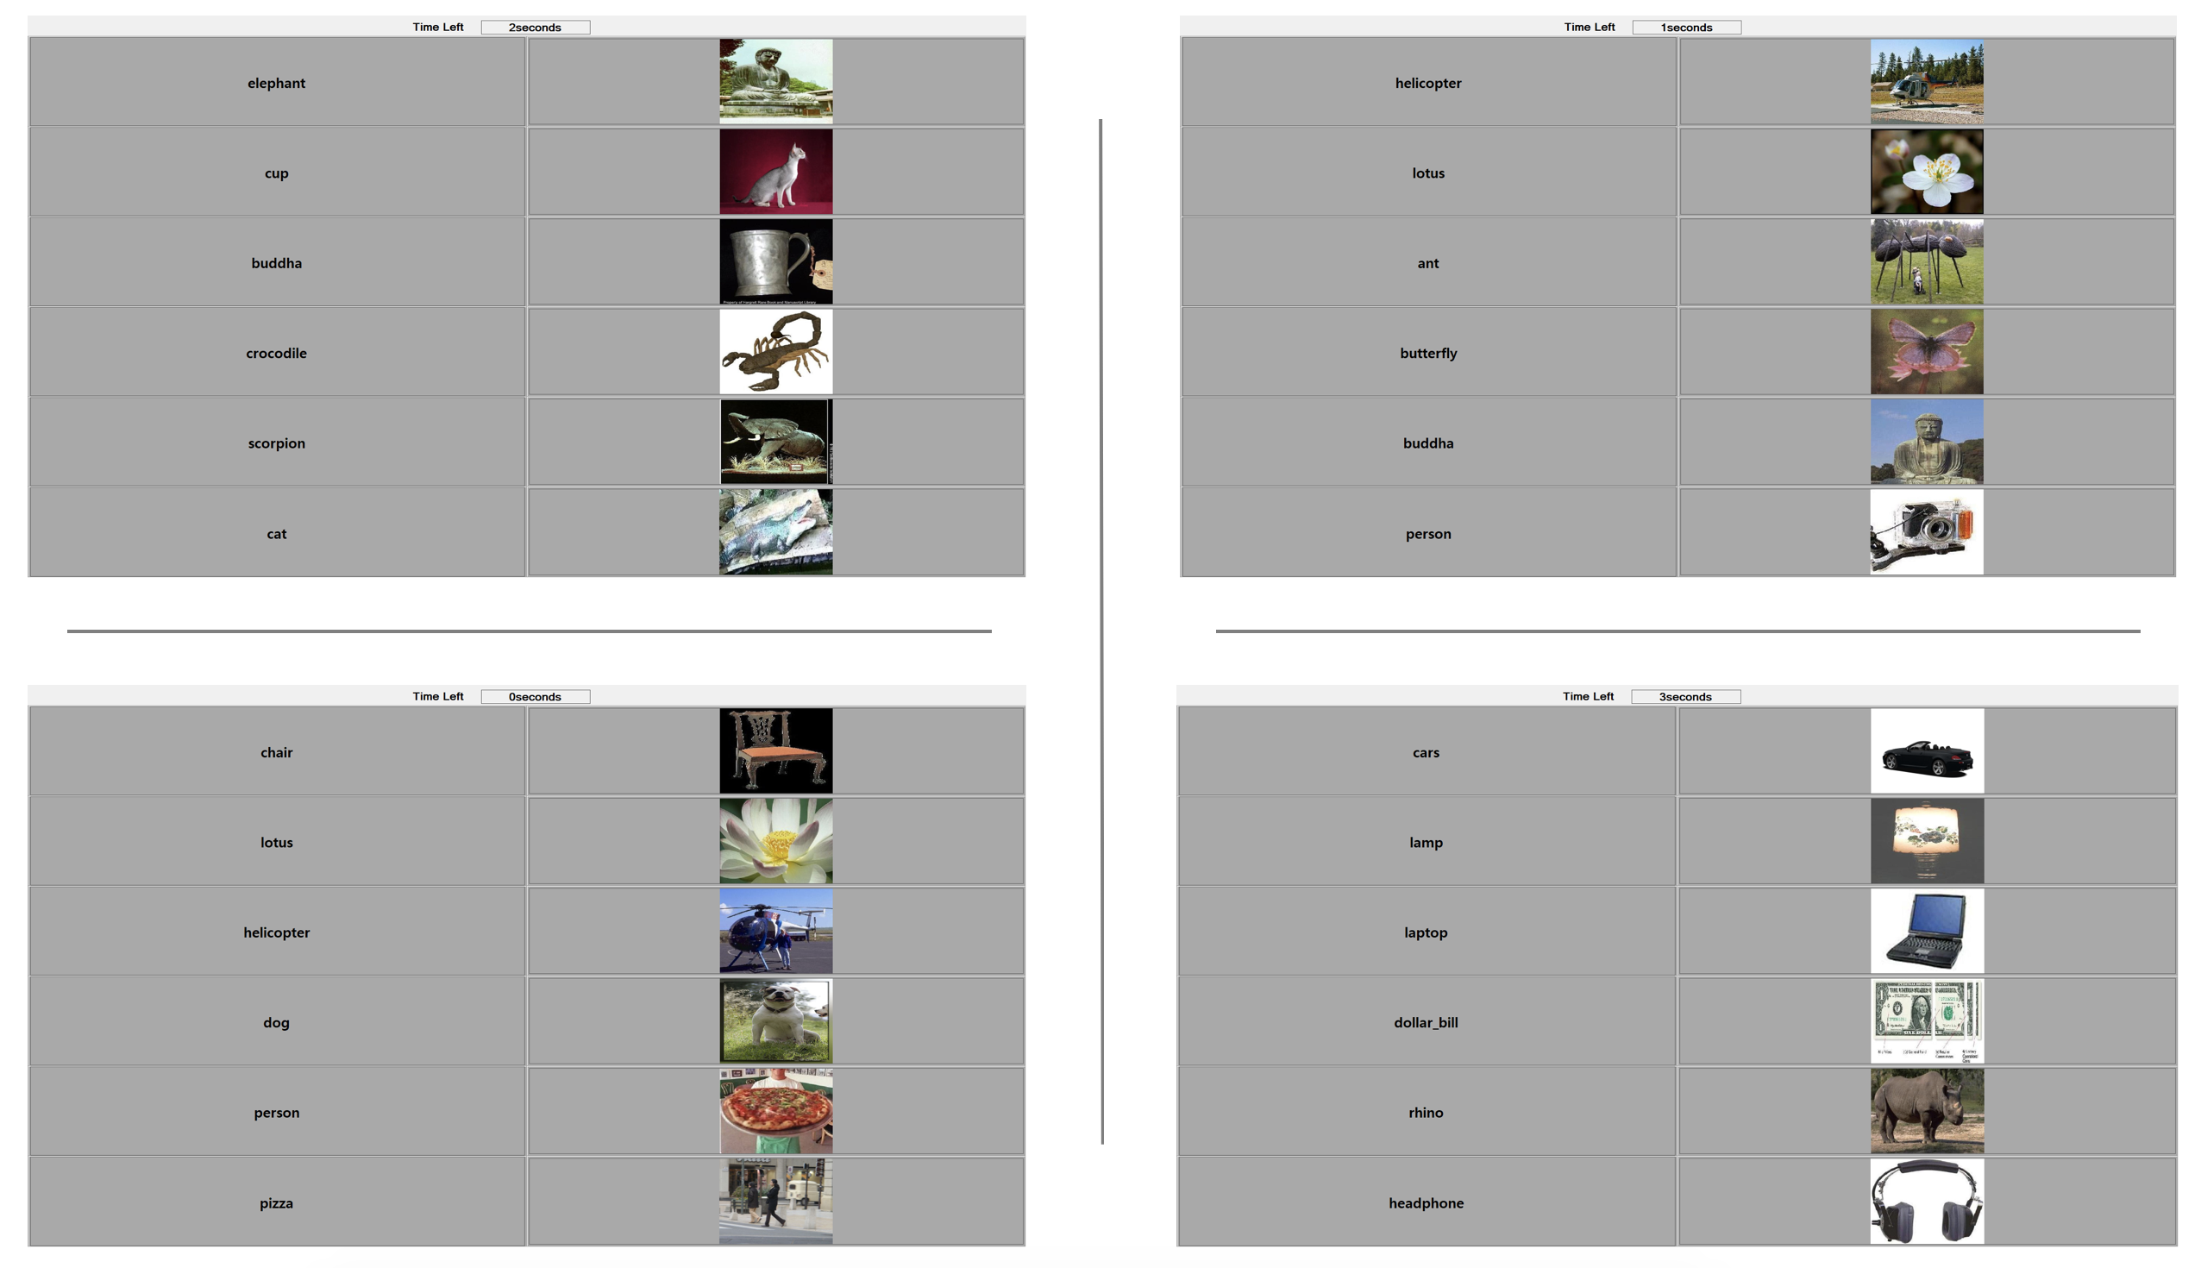

Figure 2: GUI Types (top left: Type 3 GUI; top right: type 2 GUI; bottom left: type 4 GUI; bottom right: type 1 GUI).

* + 1. Participants

Twenty-five healthy adult students and faculties from California State University, Fresno, participated to this study (mean age=23 (3.5), 5 females). Participants were verbally informed about the experimental procedure and purpose prior to the experiment. The experimental procedures involving human subjects described in this study were approved by the Institutional Review Board.

* + 1. Task Performed by Participants

Participants were asked to be the part of experiment which lasted about 5 minutes to complete all the Nt trials of the experiment. For each trial, participants had to gaze through the GUI for 4 seconds and predict the type of GUI as congruent or incongruent (Type 1 or Type 2, 3, 4). The gaze coordinates of the participants were recorded during the experiment using a Tobii Eye tracker 4C (frequency of 120 Hz) which is portable and is high accuracy in gaze recording [16]. The recorded gaze data were in the form of X, Y coordinate (of the screen) and time stamp T for the user’s gaze.

As the experiment consist of Nt trials, total collected data for X, Y coordinate and Timestamp T was given by the following equation 2, 3 and 4.

$$\begin{aligned}X= \bigcup_{i=1}^{N_{t}}{{\{\vec{x}}_{i}\}} \#\left(2\right)\end{aligned}$$

$$\begin{aligned}Y= \bigcup_{i=1}^{N_{t}}{{\{\vec{y}}_{i}\}}\#\left(3\right)\end{aligned}$$

$$\begin{aligned}T= \bigcup_{i=1}^{N_{t}}{{\{\vec{t}}_{i}\}}\#\left(4\right)\end{aligned}$$

Here, ${\vec{x}}_{i}$, ${\vec{y}}_{i}$ and ${\vec{t}}_{i}$ are the recorded X, Y coordinate and T Timestamp of the user’s gaze for the ith trial and the total number of gaze point recorded in ith trial are denoted as n(i)g. The values of n(i)g are different for each trial, as it depends on the time taken by the participant for completing each trial. So, the recorded pixel value and timestamp for the ith trial was represented by equation 5, 6 and 7.

$$\begin{aligned}{\vec{x}}_{i}=\left\{x_{\left(i\right)1},x_{\left(i\right)2}, x_{\left(i\right)3}, …, x_{\left(i\right) n_{\left(i\right)g}}\right\}\# \left(5\right)\end{aligned}$$

$$\begin{aligned}{\vec{y}}_{i}=\left\{y_{\left(i\right)1},y_{\left(i\right)2}, y_{\left(i\right)3}, …, y_{\left(i\right) n_{\left(i\right)g}}\right\}\#\left(6\right)\end{aligned}$$

$$\begin{aligned}{\vec{t}}_{i}=\left\{t_{\left(i\right)1},t_{\left(i\right)2}, t_{\left(i\right)3}, …, t_{\left(i\right) n_{\left(i\right)g}}\right\}\#\left(7\right)\end{aligned}$$

All the further calculation is explained using single ith trial calculation and can be repeated for Nt trials of the experiment.

* 1. Feature Extraction

For performing the classification of the different types of GUIs, the collected raw data was not enough as it represents the high-level pixel information which is too noisy and variable. Thus, we extracted high-level features from the raw data by performing statistical computation to obtain potential discriminative features. As the information is relevant in both time and distance, we computed the probability density moment on transition between the components, and the time spent on each component, calculating properties such as the mean (first moment), standard deviation (second moment), skew (third moment), and kurtosis (fourth moment) respectively along with the maximum viewed components and maximum time spend component. Furthermore, we have also calculated the distance traveled by the gaze using Euclidian distance along with the total distance traveled in either direction i.e., horizontal and vertical. The distance travel-based calculation was performed from the centroid of the component (key and value) in the GUI [14].

* + 1. Distance Based Feature Extraction

For the calculation of the distance based feature, we considered a distance vector Di containing the component number such that there exists a transition between the k1th component and k2th component, with k1 != k2 as shown in Algorithm 1 and a 2D distance Matrix Mi of size Nc x Nc for ith trial of the experiment as in Algorithm 2 showing the count of the number of transitions between two components during the trial. The transition is calculated from the component number in a row (source) to the component number in a column (destination).

Algorithm1: Distance Vector Computation

N(i)g = total number of recorded gaze reading in ith trial

${\vec{x}}_{i}$ = vector of recorded x coordinate of the gaze

${\vec{y}}_{i}$ = vector of recorded y coordinate of the gaze

${\vec{t}}_{i}$ = vector of recorded timestamp of the gaze

function distance_vector (${\vec{x}}_{i}$, ${\vec{y}}_{i}$, ${\vec{t}}_{i}$, N(i)g)

1 T = threshold #minimum number of time points corresponding to the minimum duration(in second) spent by a user gazing to a component (label or image)

2 D = [] #list containing the component numbers between which the transition exists

4 for k in range(N(i)g): # for each time point in the trial i

5 final = k + T

6 comp = componentID(x(i)k, y(i)k)

7 if final >= N(i)g: # handling the out of bound exception for final

8 final = N(i)g

9 while(k < final) && (componentID(x(i)k, y(i)k) == comp):

10 k+=1

11 if k == final:

12 D.append(comp)

Nd is the length of the Distance vector

Algorithm2: Transition Matrix Computation

D = Distance vector

Nc = Total number of components in a trial

function transition_matrix (D, Nc)

1 for k in range(len(D) - 1):

2 M(i)(D[k], D[k++]) += 1

* + 1. Centroid Based Feature Extraction

For the calculation of the centroid based feature extraction, we calculated a centroid vector CV shown in equation 8 such that, for the cth component in the GUI, the centroid value is represented by the coordinate CVc = (xc, yc)

Here, ${CV}_{1}$ to ${CV}_{N_{p}}$ represent the centroids of the labels (from top to bottom) and ${CV}_{N_{p+1}}$ to ${CV}_{N_{c}}$ represent the centroids of the images (from top to bottom). All the centroid based statistical measurements are calculated using the centroid vector and distance vector CV for Di for ith trial of the experiment respectively.

* + 1. Time Based Feature Extraction

For the calculation of the time-based feature, we created a heat map vector hi which represents the total amount of time spent (in milliseconds) by the participant gazing at each component (label or image) during the ith trial and is given by equation 9.

$$\begin{aligned}h_{i}=\left\{h_{\left(i\right)1},h_{\left(i\right)2},h_{\left(i\right)3}, …, h_{\left(i\right)N_{c}} \right\}\#\left(9\right)\end{aligned}$$

Here, $h_{\left(i\right)1}$ to $h_{\left(i\right)N_{p}}$ represent the time (in millisecond) spent by the participant gazing on the labels (top to bottom), and $h_{\left(i\right)N_{p+1}}$ to $h_{\left(i\right)N_{c}}$ represent the time (in millisecond) spent by the participant gazing on the images (top to bottom).

All the time based statistical measurements are calculated using the heat map vector $h_{i}$ for ith trial of the experiment.

*Feature 1 and 9:* Mean of the transition matrix and the heat map vector (Moment – 1)

For the Mean of the transition matrix we calculated the mean of the total number of transitions performed in the ith trial i.e., average number of times the user gaze perform transition from one component (image or label) in the GUI to the another using equation 10. Similarly, for the mean of the heat map vector we calculated the average duration (in millisecond) spent by the user during the ith trial of the experiment gazing the component (image and label) in the GUI using equation 11.

$$\begin{aligned}μ_{di}= \frac{\sum_{j=1}^{N_{c}}{\sum_{k=1}^{N_{c}}{{M_{\left(i\right)}}_{jk}}}}{N_{c}* N_{c}}\#\left(10\right)\end{aligned}$$

$$\begin{aligned}μ_{ti}= \frac{\sum_{j=1}^{N_{c}}{h_{\left(i\right)j}}}{N_{c}}\#\left(11\right)\end{aligned}$$

*Feature 2 and 10:* Standard deviation of the transition matrix and the heat map vector (Moment – 2)

For the standard deviation of the transition matrix we calculated the amount of dispersion in a transition matrix for ith trial i.e., standard deviation in the gaze transition performed from each component (label and image) in the GUI using equation 12 [13]. Similarly, for the standard deviation of the heat map vector we calculated the standard deviation of the time (in millisecond) spend by the participant in the ith trial of the experiment gazing the component (image and label) in the GUI i.e., the variation in the time spend by the user gazing each component in the GUI and is given by equation 13 [13].

$$\begin{aligned}s_{di}= \sqrt{\frac{\sum_{j=1}^{N_{c}}{\sum_{k=1}^{N_{c}}{ {\left({M_{\left(i\right)}}_{jk}-μ_{di}\right)}^{2}}}}{{(N}_{c}* N_{c})-1}}\#\left(12\right)\end{aligned}$$

$$\begin{aligned}s_{ti}= \sqrt{\frac{\sum_{j=1}^{N_{c}}{{\left(h_{\left(i\right)j}- μ_{i}\right)}^{2}}}{N_{c}-1}}\#\left(13\right)\end{aligned}$$

*Feature 3 and 11:* Skewness of the transition matrix and heat map vector (Moment – 3)

For the skewness in the transition matrix we calculated the skewness of the total number of transition performed in the ith trial i.e., the symmetry in the number of gaze transitions between each component (label or image) in the GUI and was given by the equation 14 [14]. Similarly, for the skewness in the heat map vector we calculated the skewness in the time spend (in millisecond) by the participant in the ith trial of the experiment and was given by equation 15 [14]. If the gaze transitions and time distribution belong to a normal distribution, then value of skewness was close to 0. It referred to the “third standardized central moment for the probability model”.

$$\begin{aligned}γ_{di}= \frac{1}{{(N}_{c}-1)}\sum_{j=1}^{N_{c}}{\sum_{k=1}^{N_{c}}{ \frac{{\left({M_{\left(i\right)}}_{jk}-μ_{di}\right)}^{3}}{{s_{di}}^{3}}}}\#\left(14\right)\end{aligned}$$

$$\begin{aligned}γ_{ti}= \frac{1}{{(N}_{c}-1)}\sum_{j=1}^{N_{c}}{ \frac{{\left(h_{\left(i\right)j}- μ_{i}\right)}^{3}}{{s_{ti}}^{3}}}\#\left(15\right)\end{aligned}$$

*Feature 4 and 12:* Kurtosis of the transition matrix and heat map vector (Moment – 4)

For the kurtosis measurement of the transition matrix we calculated the kurtosis of the transition performed by the participant in the ith trial i.e., the measure of the combined weight of the tails relative to the rest of the gaze transition distribution performed from each component (label or image) in the GUI. Similarly, for the kurtosis if the heat map vector we calculated the Kurtosis of the time spend (in millisecond) by the participant in the ith trial of the experiment i.e., a measure of the combined weight of the tails relative to the rest of the gaze time spend distribution vector (heat map vector) on each component (image and label) in the GUI. If the gaze transitions and time distribution belong to a normal distribution, then the value of kurtosis would be 0. It referred to the “fourth standardized central moment for the probability model” and was given by the equation 16 for the transition matrix and equation 17 for the heat map vector [14].

$$\begin{aligned}κ_{di}=\frac{1}{{(N}_{c}-1) }\sum_{j=1}^{N_{c}}{\sum_{k=1}^{N_{c}}{ \frac{{\left({M_{\left(i\right)}}_{jk}-μ_{di}\right)}^{4}}{{s_{di}}^{4}}}}\#\left(16\right)\end{aligned}$$

$$\begin{aligned}κ_{ti}=\frac{1}{{(N}_{c}-1) }\sum_{j=1}^{N_{c}}{\frac{{\left(h_{\left(i\right)j}- μ_{i}\right)}^{4}}{{s_{ti}}^{4}}}\#\left(17\right)\end{aligned}$$

*Feature 5:* Maximum transition block number

It is the row number of the transition matrix, from which the maximum number of transitions were performed during the ith trial. It is given by the following equation 18.

$$\begin{aligned}{B_{Num}}_{di}= \underset{j}{ArgMax}{\sum_{k=0}^{N_{c}}{{M_{\left(i\right)}}_{jk}}}\# \left(18\right)\end{aligned}$$

*Feature 6:* Total distance

We calculated the total distance traveled by the gaze during the ith trial. The distance is calculated using the Euclidian distance equation on the centroid vector using distance vector as shown in 19.

$$\begin{aligned}{TD}_{i}= \sum_{j=1}^{N_{d}-1}{\sqrt{{\left({CV[D}_{i_{j}}\right].x - {CV[D}_{i_{j+1}}].x)}^{2}-{\left({CV[D}_{i_{j}}\right].y - {CV[D}_{i_{j+1}}].y)}^{2}}}\#\left(19\right)\end{aligned}$$

*Feature 7 and 8:* Total gaze distance - X direction an Y direction

We calculated the linear distance travel during the ith trial in horizontal direction i.e., in X (or Y) axis using the X (or Y) coordinate of the centroid vector on the distance vector as shown in equation 20 and 21, respectively.

$$\begin{aligned}{TDX}_{i}= \sum_{j=1}^{N_{d}-1}{\left|{CV[D}_{i_{j}}].x - {CV[D}_{i_{j+1}}].x\right|}\#\left(20\right)\end{aligned}$$

$$\begin{aligned}{TDY}_{i}= \sum_{j=1}^{N_{d}-1}{\left|{CV[D}_{i_{j}}].y - {CV[D}_{i_{j+1}}].y\right|}\#\left(21\right)\end{aligned}$$

*Feature 13:* Total time for trial

The summation of the time (in millisecond) spend by the participant in the ith trial of the experiment and is shown in equation 22.

* 1. Classification of Data

For the experiment in this study, as the recorded data was classified into four different types of GUI, two types of binary classification tasks were performed: one-vs-rest and one-vs-one. Hence, we can classify the given data in four one-vs-rest and six one-vs-one binary comparison for training the classifier as shown in Table 2.

We define the following binary classification tasks: $C_{{pair}_{(i,j)}} :1≤i≤j≤4$ corresponding to classification Ti vs Tj and $C_{{all}_{i}} :1≤i≤4$ corresponding the classification of Ti vs the other types of GUIs where Ti and Tj represents GUI type i.e., Type 1, Type 2, Type 3, and Type 4 GUI respectively.

We used the data that was recorded using the portable eye tracker (Tobii Eyetracker 4C) [16]. We performed the statistical computation on the recorded gaze signal to obtain the above-mentioned features and trained five different classifiers and study the performance of the classifiers for predicting the accurate GUI category. The distribution of the GUI information in the dataset is as follow 50% Type 1 GUI, 15% Type 2 GUI, 15% Type 3 GUI and 20% Type 4 GUI.

Table 2: GUI comparison types with description

|  |  |  |
| --- | --- | --- |
| **Classification No.** | **Comparison Type** | **Description** |
| C1 | 1-Vs-Rest | Correct (Congruent: Type 1) GUI vs all incorrect GUI (Type 2, type 3, and type 4) |
| C2 | 2-Vs-Rest | Incorrect (Non-Congruent: Type 2) GUI vs all incorrect GUI (Type 1, type 3, and type 4) |
| C3 | 3-Vs-Rest | Incorrect (Non-Congruent: Type 3) GUI vs all incorrect GUI (Type 1, type 2, and type 4) |
| C4 | 4-Vs-Rest | Incorrect (Non-Congruent: Type 4) GUI vs all incorrect GUI (Type 1, type 2, and type 3) |
| C5 | 1-Vs-2 | Correct (Congruent: Type 1) GUI vs incorrect GUI (Non-Congruent: Type 2) |
| C6 | 1-Vs-3 | Correct (Congruent: Type 1) GUI vs incorrect GUI (Non-Congruent: Type 3) |
| C7 | 1-Vs-4 | Correct (Congruent: Type 1) GUI vs incorrect GUI (Non-Congruent: Type 4) |
| C8 | 2-Vs-3 | Correct (Non-Congruent: Type 2) GUI vs incorrect GUI (Non-Congruent: Type 3) |
| C9 | 2-Vs-4 | Correct (Non-Congruent: Type 2) GUI vs incorrect GUI (Non-Congruent: Type 4) |
| C10 | 3-Vs-4 | Correct (Non-Congruent: Type 3) GUI vs incorrect GUI (Non-Congruent: Type 4) |

* 1. Classifiers

Five classifiers mentioned in table 3 were selected from four different categories for evaluating the ten binary classification mentioned in Table 2. [15]

Table 3: Classifier

|  |  |  |
| --- | --- | --- |
| **Sr. No.** | **Classifier** | **Classifier Categories** |
| 1 | K Nearest Neighbor | Density based Classifier |
| 2 | Support Vector Machine | Linear Classifier |
| 3 | Linear Discriminant Analysis | Linear Classifier |
| 4 | Random Forest Tree | Tree-Based Classifier |
| 5 | Gaussian Naïve Bayes | Naïve Bayes Classifier |

* + 1. K Nearest Neighbor

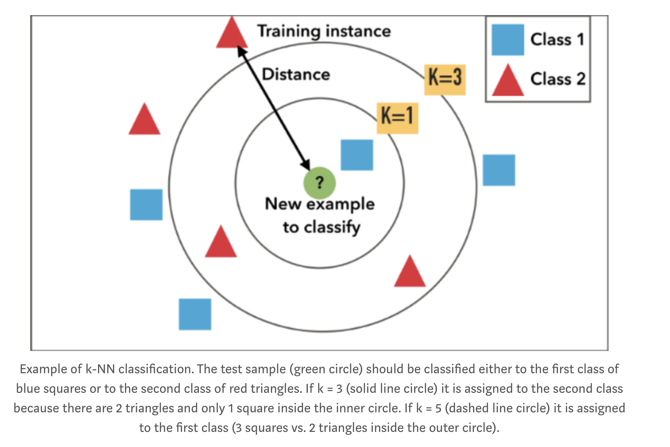

Figure 3 K Nearest Neighbor

K Nearest Neighbor (KNN) algorithm is one of the simplest classification algorithm, it is a non-parametric, lazy learning algorithm purposed to use with a database in which the data points are separated into several classes to predict the classification of a new sample point. KNN does not make any assumptions on the underlying data distribution. KNN Algorithm is based on the feature similarity: How closely out-of-sample features resemble our training set determines how we classify a given data point. The K in the KNN is the boundary to which the similarity calculation is taken into account and is shown in Figure 3. For the experiment, we set the value of K = 5 [19].

* + 1. Support Vector Machine

Support vector machines (SVM) belongs to a set of supervised learning algorithms used for classification and regression. SVM when used for classification, creates a hyper plane that separates the data into two classes with the maximum-margin. Figure 4 shows the SVM classifier with hyper plane. Given training examples labeled either "yes" or "no", a maximum-margin (optimal margin) hyper plane (optimal hyper plane) is identified which splits the "yes" from the "no" training examples, such that the distance between the hyper plane and the closest examples (the margin) is maximized. [20] SVM can be implemented using various kernels for creating hyper-planes such as linear, radial bias function, polynomial, and sigmoidal. For the experiment, we used the radial bias function kernel for creating non-linear hyperplane and the penalty parameter C was set to 1.0 which was used for penalizing the wrongly predicted values for making classifier more reliable and accurate.

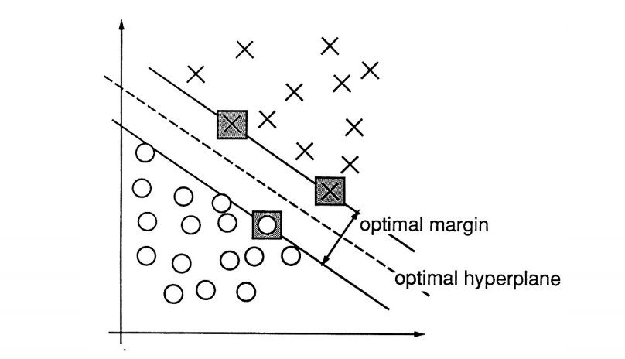

Figure 4 Support Vector Machine [20]

* + 1. Linear Discriminant Analysis

Linear Discriminant Analysis (LDA) classifier, classifies data with a linear decision boundary, generated by fitting class conditional densities to the data and using Bayes’ rule as shown in Figure 5. The LDA model fits a Gaussian density to each class, assuming that all classes share the same covariance matrix. The fitted model can also be used to reduce the dimensionality of the input by projecting it to the most discriminative directions [21]. For the experiment, we had used LDA with singular value decomposition i.e., classification is performed without computing covariance matrix.

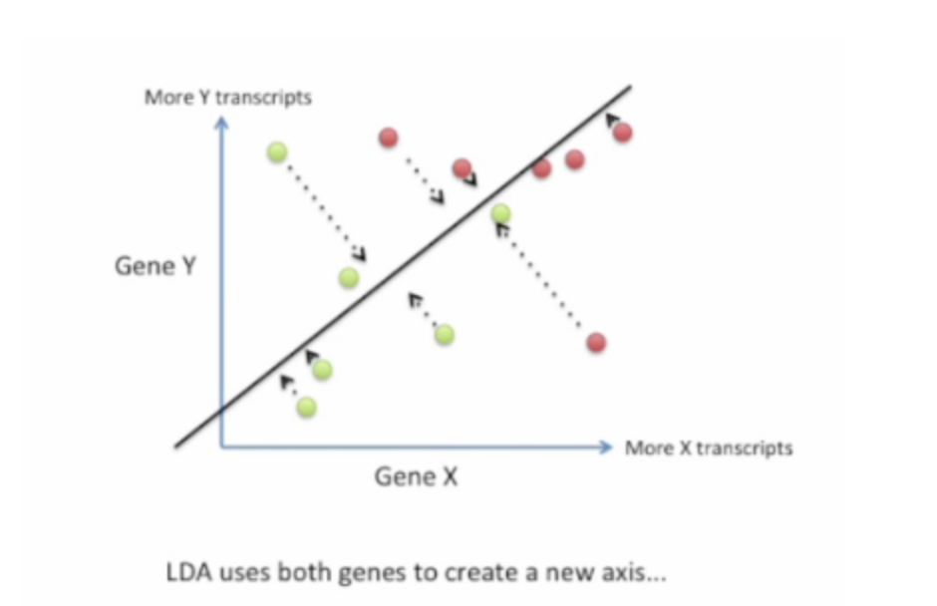

Figure 5 Linear Discriminant Analysis [21]

* + 1. Random Forest Tree

Random Forest Tree (RFT) classifier or random decision tree classifier are the ensemble learning method for classification, and regression. RFT worked in two stages, one is random forest creation and the second is to make prediction from the random forest classifier created in the first stage. Figure 6 shows the working of the RDF classifier. For the experiment, we set the maximum number of random tree in the forest to 10 [23].

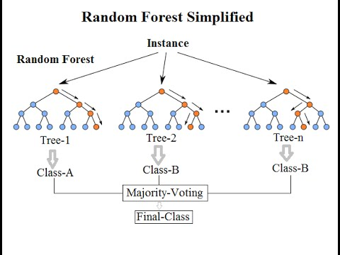

Figure 6 Random Forest Tree

* + 1. Gaussian Naïve Bayes

Gaussian Naïve Bayes classifier belong to the probabilistic classifier category used for solving classification and regression problems. Gaussian Naïve Bayes classifier works on the assumption on that the continuous values associated with each class are distributed according to a Gaussian distribution. For example, suppose the training data contains a continuous attribute x. We first segment the data by the class, and then compute the mean and variance of x in each class. Let $μ_{k}$ be the mean of the values in x associated with class Clk, and let $σ_{k}^{2}$  be the variance of the values in  x associated with class Clk. Suppose we have collected some observation value $ν$ . Then, the probability distribution of $ν$   given a class Clk, p ( x = v | Clk), can be computed by plugging $ν$  into the equation for a Normal distribution parameterized by $μ_{k}$  and $σ_{k}^{2}$  as shown in equation 23 [22].

* 1. Feature Selection

Feature selection is performed using modified backward elimination technique algorithm for classifications C1 to C10 mentioned in table 2 on all the five classifiers mentioned in table 3. The modified feature selection algorithm returns the feature dictionary containing feature name as the key and feature influence ratio in term of AUC of the ROC as the value.

Appendix A shows the feature dictionary plot for all the KNN classifiers for all the ten classification cases in figure 7 to 11; for SVM classifier is shown in figure 12 to 16; for RFT classifier is shown in figure 17 to 21; for LDA classifier is shown in 22 to 26; for GNB classifier is shown in figure 27 to 31.

From the feature selection plots in appendix A, we concluded that distance-based feature was having more influence on the classification than centroid-based feature and time-based feature respectively. Feature number 1, 2, 4, and 7 are the most influential features, while Feature number 3, 8, 9, and 11 are the least influential features for classifying the GUI’s as shown in Figure 32.

Algorithm3: Feature Selection

all_feature = List containing names of all the features

feature_dict=Dictionary containing feature names as key and values for all the key is assigned to 0

clf = Classifier object

X = column of features

Y = true class of the feature

1 function feature_select (clf, all_feature, feature_dict, X, Y):

2 for i in range(len(all_feature)) # for each feature in all_feature

3 # create a list containing the set of unique combination of the features ${}_{i}^{n}C$

4 fc = combination (all_feature, i)

5 list_auc[:] = [] # list containing all the auc value for the ith combination

6 list_feature[:] = [] # list containing the list of feature for the ith combination.

7 for feature in fc: # for all the feature in fc

8 # create the list of feature/column that we want to drop from the data frame

9 drop feature = [x for x in f if x not in feature]

10 X_new = X.drop(drop_feature)

11 # split the data into 80 – 20 ratios

12 X_train, X_test, Y_train, Y_test = train_test_split (X_new, Y, test_size = 0.2)

13 clf.fit (X_train, Y_train) # train the model

14 Y_predict = clf.predict(X_test) # get the prediction value from the trained classifier

15 auc = roc_auc(Y_test, Y_predict)# calculate the area under the curve

16 list_auc.append(auc)

17 list_feature.append(feature)

18 index, _ = max(enumerate(list_auc)) # get the index of the maximum auc

19 # increment the count of the feature that have the maximum auc for the ith combination in

20 # feature dictionary

21 for x in index: # for all the feature in index

22 feature_dict[x] += 1

23 return feature_dict

Figure 32 Feature Influence graph across all classifier

* 1. Performance Evaluation

The performance evaluation of the classifiers mentioned in Table 3 was computed by performing cross-validation for splitting the random shuffled data into two sets 80% for training and 20% for development/testing and all the ten GUI comparison were analyzed. Due to the size limitation of the collected data, we kept the testing and the development set as same. For the binary classification, actual GUI Name (column containing the correct type of the trial i.e., 1, 2, 3,and 4) was converted in binary form such that for pair wise x-vs-y classification, the trials in x was set to -1 and y were set to +1, similarly for one-vs-rest classification where x is a single trial and y is set of trials such that x $∉$ y, the trials in x was set to -1 and y were set to +1.

The binary classification was performed between two classes +1 and -1. To distinguish between the actual class and the predicted class by the classifier we use the labels {Y, N} representing {+1, -1} for the class prediction produced by a model whereas {p, n} represent the actual class of the predicted data. Given a classifier and an instance, there are four possible outcomes. If the instance is positive and it is classified as positive, it is counted as a true positive; if it is classified as negative, it is counted as a false negative. If the instance is negative and it is classified as positive, it is counted as a false positive; if it is classified as negative, it is counted as a true negative creating the confusion matrix shown in Figure 33. The number along the major diagonal of the confusion matrix represent the correct decisions made, and the number of minor diagonal represent the errors i.e., the confusion between the various classes [17].

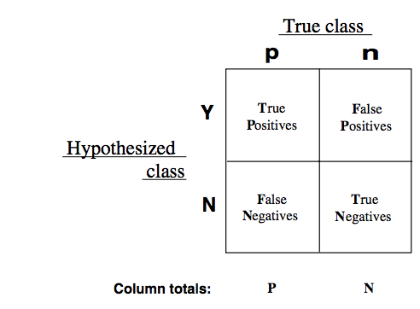

Figure 33: Confusion Matrix [17]

The true positive rate (also known as hit rate and recall) of a classifier and the false positive rate (also known as false alarm rate) of the classifier are calculated by equation 24 and 25 respectively [17].

$$\begin{aligned}T_{p}rate≈ \frac{T_{p} (Positives correctly classified)}{P (Total positives)} \# \left(24\right)\end{aligned}$$

$$\begin{aligned}F_{p} rate≈ \frac{F_{p} (Negative incorrectly classified)}{N (Total Negative)} \# \left(25\right)\end{aligned}$$

Performance is of each classifier was analyzed by calculating the Area Under the Curve (AUC) for Receiver Operating Characteristics curve (ROC). Area under the curve is calculated using the trapezoidal rule for area calculation on the ROC curve (true positive rate vs false positive rate value).

1. Results

This section describes the results obtained in the project.

* 1. Human Behavior Analysis

Behavior analysis was performed after calculating the human precision level for classification of the GUI. The recorded human precision level for the classification across all the participants was 92.5%. Furthermore, we also derive the confusion matrix from the prediction value to obtain the true positive (tp), true negative (tn), false positive (fp), and false negative (fn) values in the prediction and results are shown in matrix below.

tn, fp, fn, tp

Label 1: [[268, 70, 78, 44]

Label 2: [ 75, 27, 30, 9 ]

Label 3: [ 64, 35, 21, 19]

Label 4: [ 93, 43, 21, 28]]

* 1. Classifier Performance Evaluation

Performance of the all the five classifiers mentioned in Table 3 was evaluated by calculating the AUC of the ROC curve plotted after calculating the extracted features for each classification C1 to C10 respectively. Furthermore, AUC was calculated by removing the records from the experiment which shows the failure of the participants to classify the GUI correctly.

Appendix B contains Figures from 34 to 38 describing the ROC curve for KNN classifier, Figures 39 to 43 describing the ROC curve for SVM classifier, Figures 44 to 48 describing the ROC curve for LDA, Figures 49 to 53 describing the ROC curve for RFT and Figures 54 to 58 describing the curve for GNB. Moreover, Appendix C contains Figures 59 to 63 describing the ROC curve for KNN classifier, Figure from 64 to 68 describing the ROC curve for SVM classifier, Figure describing 69 to 73 describing the ROC curve for LDA classifier, Figure from 74 to 78 describing the ROC curve for RFT classifier, and Figure 79 to 83 describing the curve for GNB after removing the wrongly classified trials by the participants.

As all the classification are performed on the binary labels, each ROC figure contains two ROC curves for two labels (-1 and 1), along with macro – average ROC and micro – average ROC.

* micro – average ROC: Calculate ROC globally by counting the total number of times each class was correctly predicted and incorrectly predicted.
* macro – average ROC: Calculate metrics for each label and find their unweighted mean. This does not take label imbalance into account.

Furthermore, due to the class imbalance in the data, we used the average AUC of the classes for analyzing the precision level of the classifiers to classify the GUI accurately.

Table 4 and 5 shows the average AUC of the classes (+1 and -1) for each of one versus rest and one versus one classification case (i.e., C1 to C10) and for each classifier where AUC represent the AUC of the ROC curve without removing the incorrect prediction of the users and AUC – Correct represents the AUC of the ROC curve after removing the incorrect prediction of the users.

Table 4: AUC value of the one versus rest classification (All the results are in %).

|  |  |  |  |  |  |
| --- | --- | --- | --- | --- | --- |
|  |  | C1 | C2 | C3 | C4 |
| KNN | AUC | 71 | 72 | 55 | 59 |
| AUC-Correct | 69 | 74 | 57 | 54 |
| SVM | AUC | 65 | 77 | 50 | 58 |
| AUC-Correct | 68 | 74 | 51 | 56 |
| LDA | AUC | 66 | 82 | 55 | 64 |
| AUC-Correct | 67 | 70 | 56 | 62 |
| RFT | AUC | 66 | 70 | 48 | 56 |
| AUC-Correct | 68 | 78 | 53 | 60 |
| GNB | AUC | 71 | 66 | 57 | 69 |
| AUC-Correct | 76 | 75 | 55 | 62 |

Table 5: AUC value of the one versus one classification (All the results are in %).

|  |  |  |  |  |  |  |  |
| --- | --- | --- | --- | --- | --- | --- | --- |
|  |  | C5 | C6 | C7 | C8 | C9 | C10 |
| KNN | AUC | 72 | 68 | 65 | 65 | 77 | 60 |
| AUC-Correct | 78 | 74 | 62 | 64 | 71 | 74 |
| SVM | AUC | 75 | 63 | 61 | 74 | 64 | 52 |
| AUC-Correct | 78 | 57 | 75 | 62 | 77 | 64 |
| LDA | AUC | 73 | 69 | 71 | 68 | 86 | 54 |
| AUC-Correct | 78 | 63 | 66 | 76 | 79 | 65 |
| RFT | AUC | 84 | 70 | 65 | 59 | 75 | 44 |
| AUC-Correct | 71 | 51 | 59 | 59 | 70 | 56 |
| GNB | AUC | 85 | 51 | 62 | 69 | 71 | 70 |
| AUC-Correct | 85 | 68 | 68 | 74 | 81 | 60 |

From Table 4, we can conclude that the classification C3 (Type 3 GUI vs all the other type of GUI’s) is the most difficult to predict accurately as compared to all other classification in one versus rest classification (i.e., C1, C2, and C4), Moreover, for the one versus one classification, from Table 5 we can conclude that classification C10 (Type 3 GUI vs Type 4 GUI) is the most difficult to predict accurately as compared to all other classification in one versus one classification (i.e., C5, C6, C7, C8, and C9) for the both the classification, C3 and C10 Gaussian Naïve Bayes classifier results the maximum Area Under the Curve 57% and 70% when calculated without removing the wrongly predicted data item from the dataset.

Similarly, Gaussian Naïve Bayes results the maximum average AUC in classifying congruent GUI versus all the incongruent (C1 classification) GUI with or without removing the wrongly predicted data item from the dataset i.e., 71% and 76% respectively. Moreover, the average AUC score for classification C5, C6 and C7 (one versus one classification of Type 1 vs Type 2, Type 1 vs Type 3, and Type 1 vs Type 4) with and without the falsely predicted values was 66 (+/- 17.34%) and 73.66 (+/- 9.81%) respectively.

1. Discussion

In this project, we discussed the increasing importance of the software usability with the rise in the number of users and the two approaches that are used in the software industry for developing the user-friendly software. First, a Survey approach and Second, a Computer Vision approach. Moreover, we explained the limitations in those approaches i.e., the first approach is time consuming and highly dependent on the subjective assessment of the user results in the bias judgement, while the second approach for GUI testing increase the workload of the quality assurance tester, furthermore, it requires the big learning curve for writing the efficient testing script and is resolution dependent.

Additionally, we proposed an alternative approach inspired from the widely used concept of the early access software in the industry, i.e., performing the software testing with the help of the users without informing them. We proposed the approach by using an eye tracking technology as it is independent of the user’s judgement resulting in bias free observation and is not dependent on the resolution of the system on which the software is used, as well as it does not require any previous knowledge for writing scripts for UI testing. Furthermore, we designed the experiment for classifying the horizontally aligned key – value paired GUI into Congruent GUI vs Incongruent GUI by recording the gaze information of the user interacting with the software. Finally, for classification we designed thirteen statistical feature and used five linear classifiers for performing the classification. The analysis of the result suggests that Gaussian Naïve Bayes classifier is the most suitable classifier for identifying the congruent GUIs.

1. Conclusion

In this project, we demonstrated the need of the better technique for measuring the software usability and classifying the non-user-friendly GUI to user-friendly GUI. Moreover, we exhibited the eye tracking technology when combine with the machine learning techniques can detect the anomalies in the GUI with the high precision even a scarce prior knowledge of the underling software.

By using the proposed machine learning and eye tracking approach, we have achieved an average AUC >76 (+/- 3.63%) for classifying Congruent GUI vs Incongruent GUI (C1 classification) using Gaussian Naïve Bayes classifier under one versus rest classification after removing the falsely identified values by the users. Furthermore, after removing the falsely identified data items from the dataset, AUC for one versus one classification for identifying congruent GUI vs Incongruent GUI i.e., C5, C6, and C7 using Gaussian Naïve Bayes gives the maximum value with average AUC of >73.66 (+/- 9.81%) concluding that the naïve Bayes classifier is more accurate than Tree based classifier, linear classifier, or density-based classifier for eye tracking classification problem in GUI classification.

As a part of the further improvement in the project we proposed the following three improvements which can make the classifier more reliable by increase the precision. First, gather more training data, which can improve the performance of the classifiers. Second, improved feature analysis using statistical computation, more feature analysis can be formed on the recorded gaze so that the outliers in the eye tracker data can be reduced to minimal. Third, Brain signal recording can also be performed and used for training the classifier making it more reliable and accurate in classification.

Reference:

1. Seffah, Ahmed, et al. "Usability measurement and metrics: A consolidated model." *Software Quality Journal* 14.2 (2006): 159-178.
2. Chang, Tsung-Hsiang, Tom Yeh, and Robert C. Miller. "GUI testing using computer vision." *Proceedings of the SIGCHI Conference on Human Factors in Computing Systems*. ACM, 2010.
3. https://www.experienceux.co.uk/ux-blog/2010/09/14/advancing-website-technology-vs-declining-user-ability/
4. Bevan, Nigel. "Usability." *Encyclopedia of Database Systems*. Springer US, 2009. 3247-3251.
5. Nielsen, J. Usability Engineering, Academic Press, Boston, 1993.
6. Bevan, N. Measuring usability as quality of use. Software Quality Journal 4 (1995), 115-150.
7. ISO 9241-11. Ergonomic requirements for office work with visual display terminals (VDTs) - Part 11: Guidance on usability (1998).
8. Bangor, Aaron, Philip T. Kortum, and James T. Miller. "An empirical evaluation of the system usability scale." *Intl. Journal of Human–Computer Interaction* 24.6 (2008): 574-594.
9. Dix, Alan. "Human-computer interaction." *Encyclopedia of database systems*. Springer US, 2009. 1327-1331.
10. Santi Ritthiron and Arisara Jiamsanguanwong. “Usability Evaluation of the University Library Network's Website Using an Eye-Tracking Device”. In Proceedings of the International Conference on Advances in Image Processing (ICAIP 2017). ACM, 2017.
11. Kabir, Md Alamgir, Muaan Ur Rehman, and Shariful Islam Majumdar. "An analytical and comparative study of software usability quality factors." Software Engineering and Service Science (ICSESS), 2016 7th IEEE International Conference on. IEEE, 2016.
12. Fu, J., 2016, May. Usability evaluation of software store based on eye-tracking technology. In Information Technology, Networking, Electronic and Automation Control Conference, IEEE (pp. 1116-1119). IEEE.
13. Bland, J. Martin, and Douglas G. Altman. "Statistics notes: measurement error." Bmj 313.7059 (1996): 744.
14. ["Measures of Shape: Skewness and Kurtosis"](http://brownmath.com/stat/shape.htm), 2008–2016 by Stan Brown, Oak Road Systems
15. Machine Learning Models: http://scikit-learn.org
16. Tobii Developer Documentation: http://developer.tobii.com/documentation
17. Fawcett, Tom. "An introduction to ROC analysis." Pattern recognition letters 27.8 (2006): 861-874.
18. Fu, Hong, et al. "Advances in eye tracking technology: theory, algorithms, and applications." Computational intelligence and neuroscience 2016 (2016).
19. KNN: <https://medium.com/@chiragsehra42/k-nearest-neighbors-explained-easily-c26706aa5c7f>
20. Cortes, Corinna, and Vladimir Vapnik. "Support-vector networks." Machine learning 20.3 (1995): 273-297.
21. McLachlan, Geoffrey. Discriminant analysis and statistical pattern recognition. Vol. 544. John Wiley & Sons, 2004.
22. Zhang, Harry. "The optimality of naive Bayes." AA 1.2 (2004): 3.
23. Breiman, Leo. "Random forests." Machine learning 45.1 (2001): 5-32.

Appendix A

This Section shows the results of the feature selection algorithm.

The horizontal line in the graph of feature selection graph represent the threshold line. The features having the probability value higher than the threshold are selected for evaluating the performance for the respective classifier in the respective classification cases. For the experiment we set the threshold value more than or equal 75% of the maximum probability value of the features in the respective classification case.

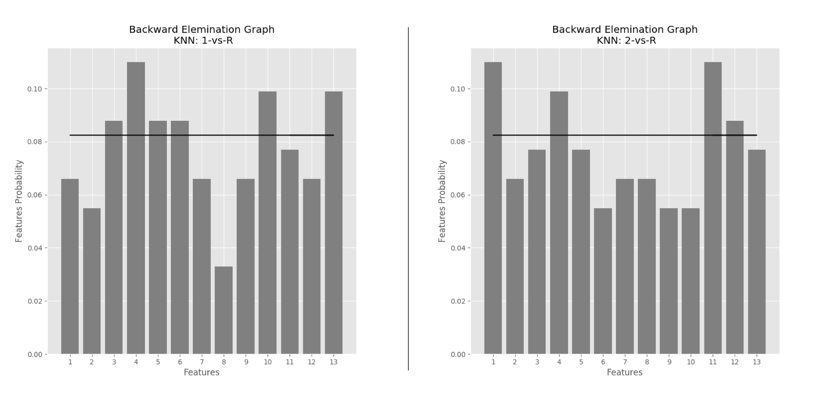

Figure 7 KNN Features Selection: 1 vs Rest/C1 classification (left); 2 vs Rest/ C2 classification(right)

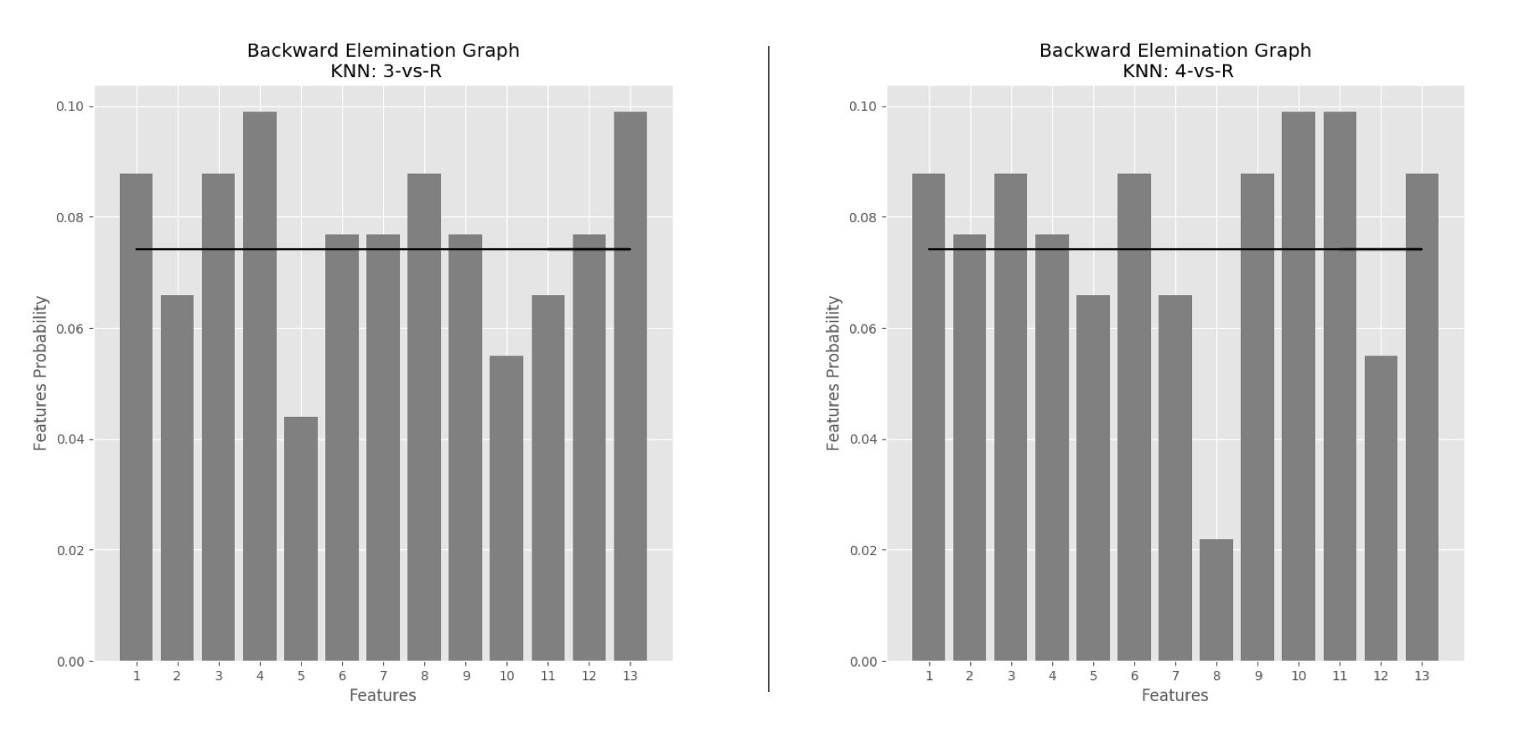

Figure 8 KNN Features Selection: 3 vs Rest/C3 classification (left); 4 vs Rest/ C4 classification(right)

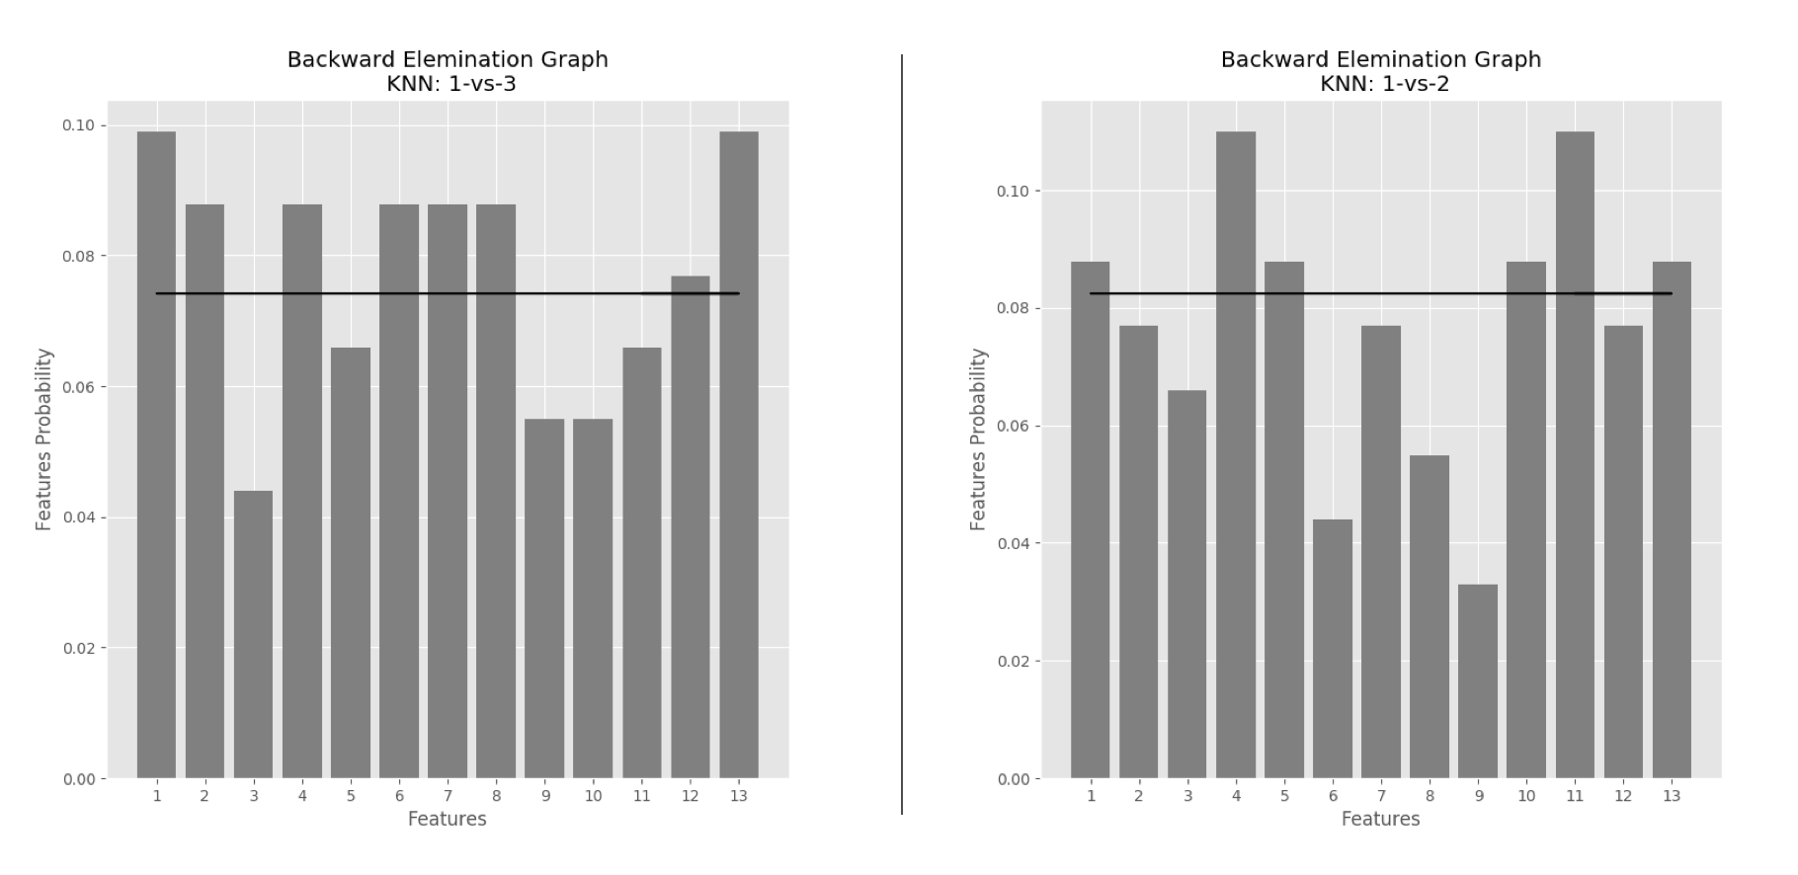

Figure 9 KNN Features Selection: 1 vs 3/C6 classification (left); 1 vs 2/C5 classification (right)

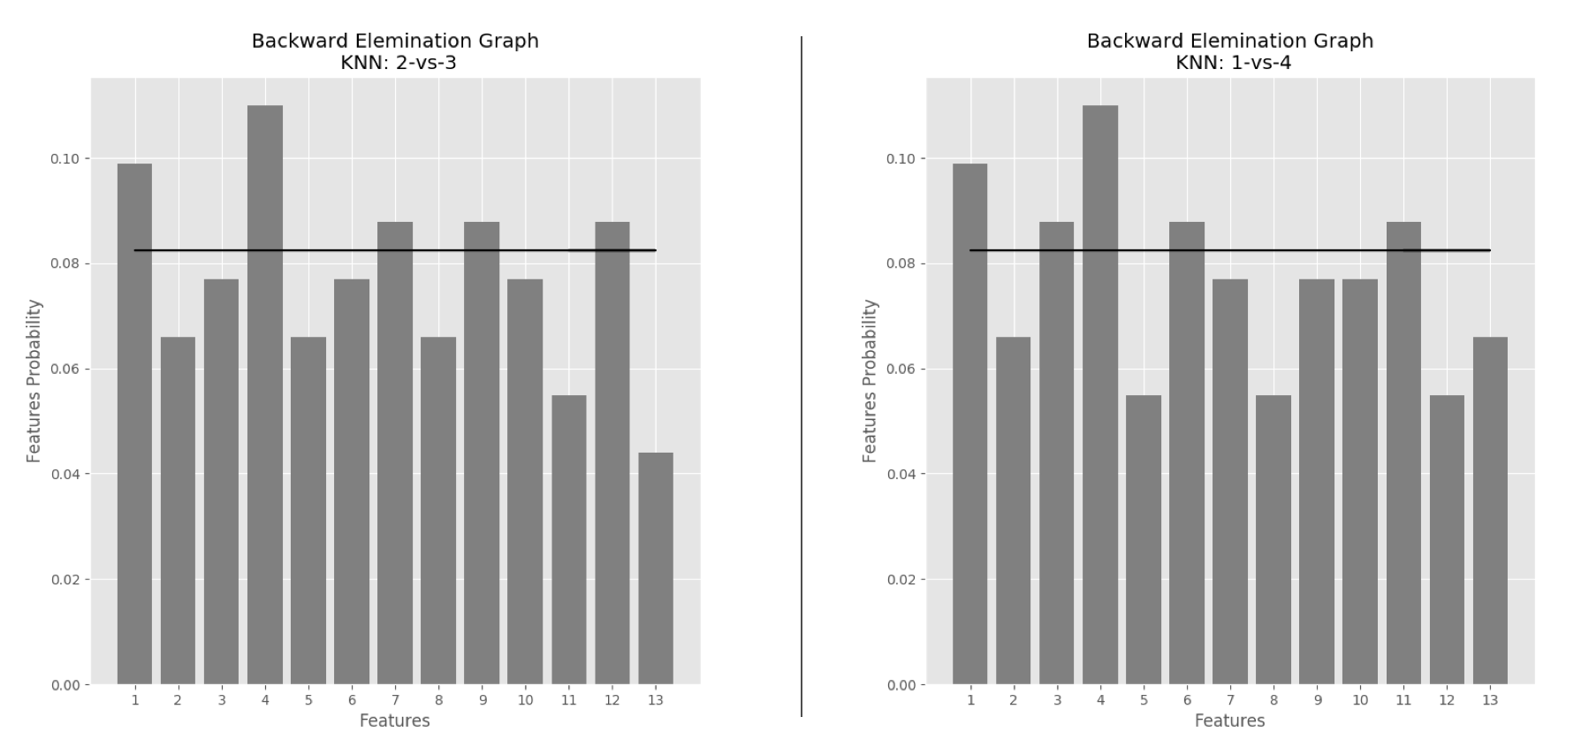

Figure 10 KNN Features Selection: 2 vs 3/C8 classification (left); 1 vs 4/C7 classification (right)

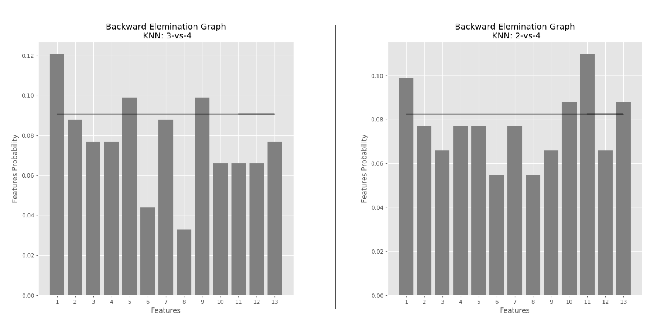

Figure 11 KNN Features Selection: 3 vs 4/C10 classification (left); 2 vs 4/C9 classification (right)

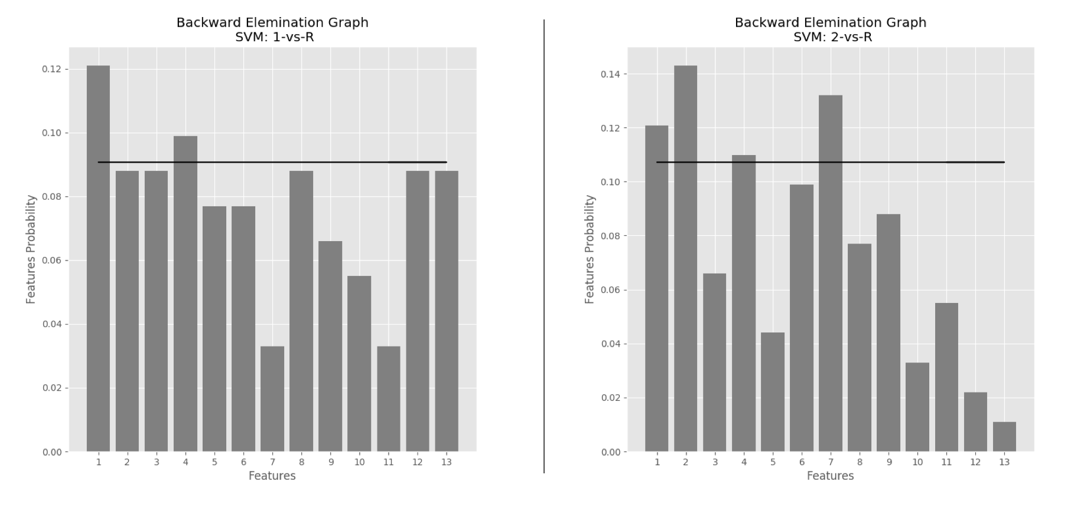

Figure 12 SVM Features Selection: 1 vs Rest/C1 classification (left); 2 vs Rest/C2 classification (right)

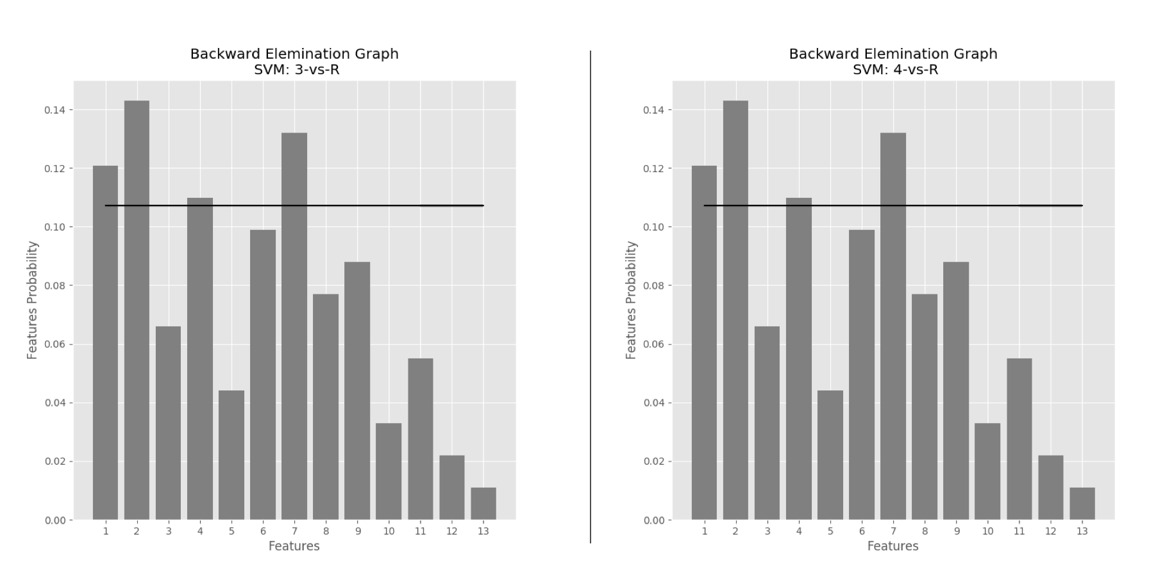

Figure 13 SVM Features Selection: 3 vs Rest/C3 classification (left); 4 vs Rest/C4 classification (right)

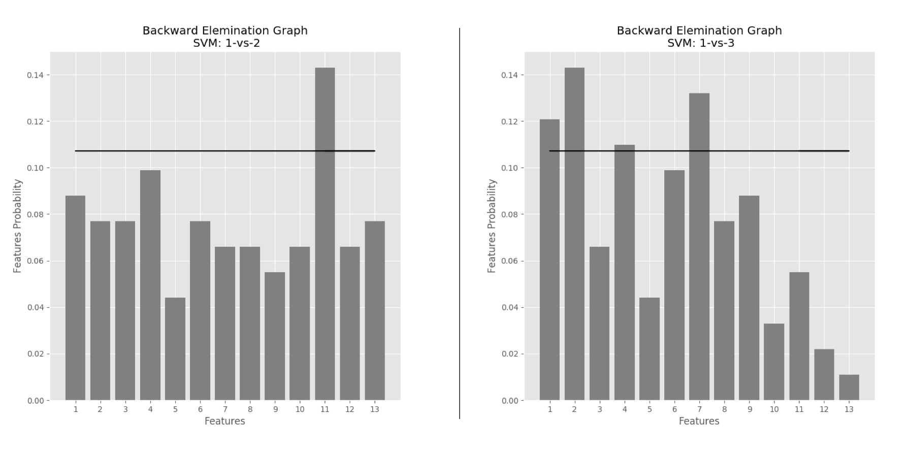

Figure 14 SVM Features Selection: 1 vs 2/C5 classification (left); 1 vs 3/C6 classification (right)

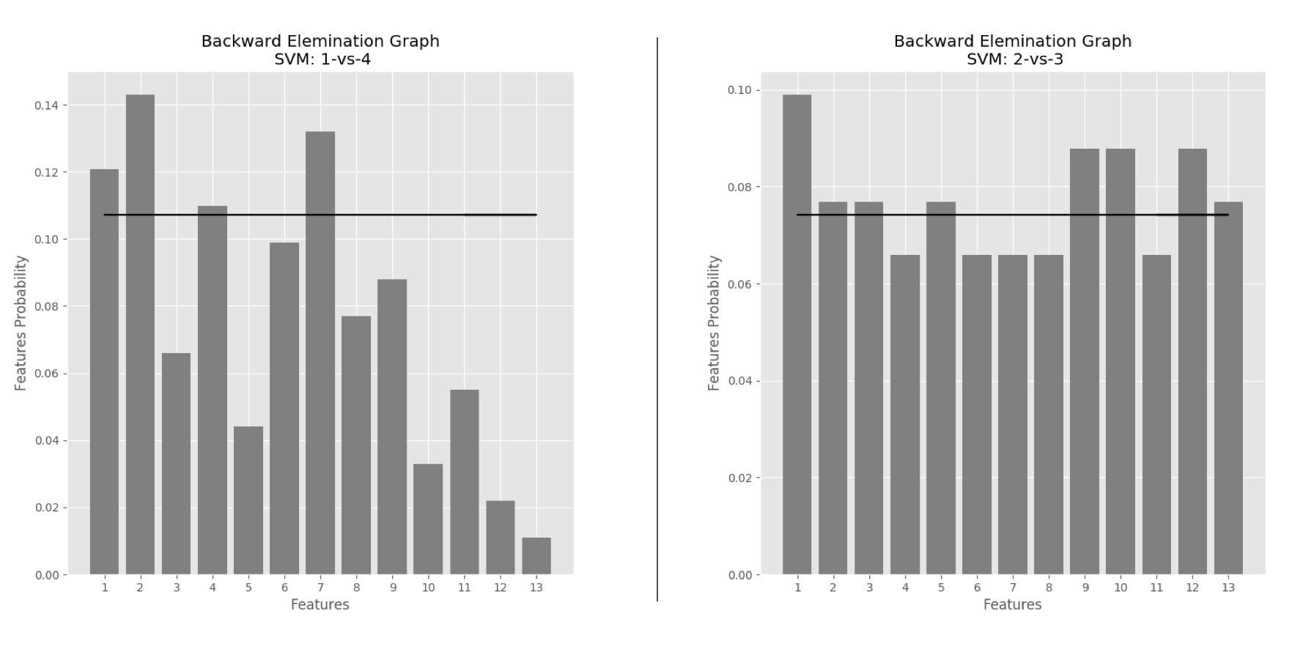

Figure 15 SVM Features Selection: 1 vs 4/C7 classification (left); 2 vs 3/C8 classification (right)

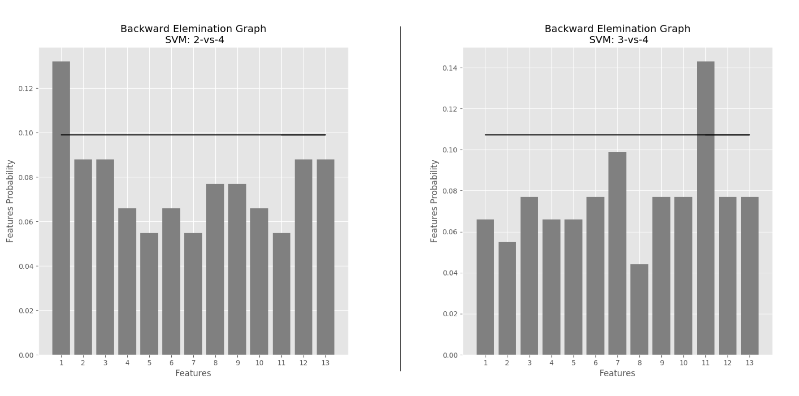

Figure 16 SVM Features Selection: 2 vs 4/C9 classification (left); 3 vs 4/C10 classification (right)

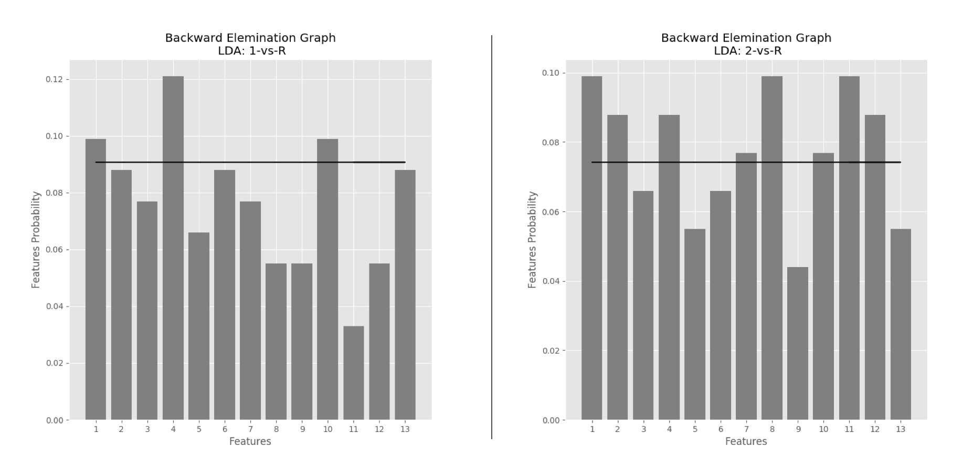

Figure 17 LDA Features Selection: 1 vs Rest/C1 classification (left); 2 vs Rest/C2 classification (right)

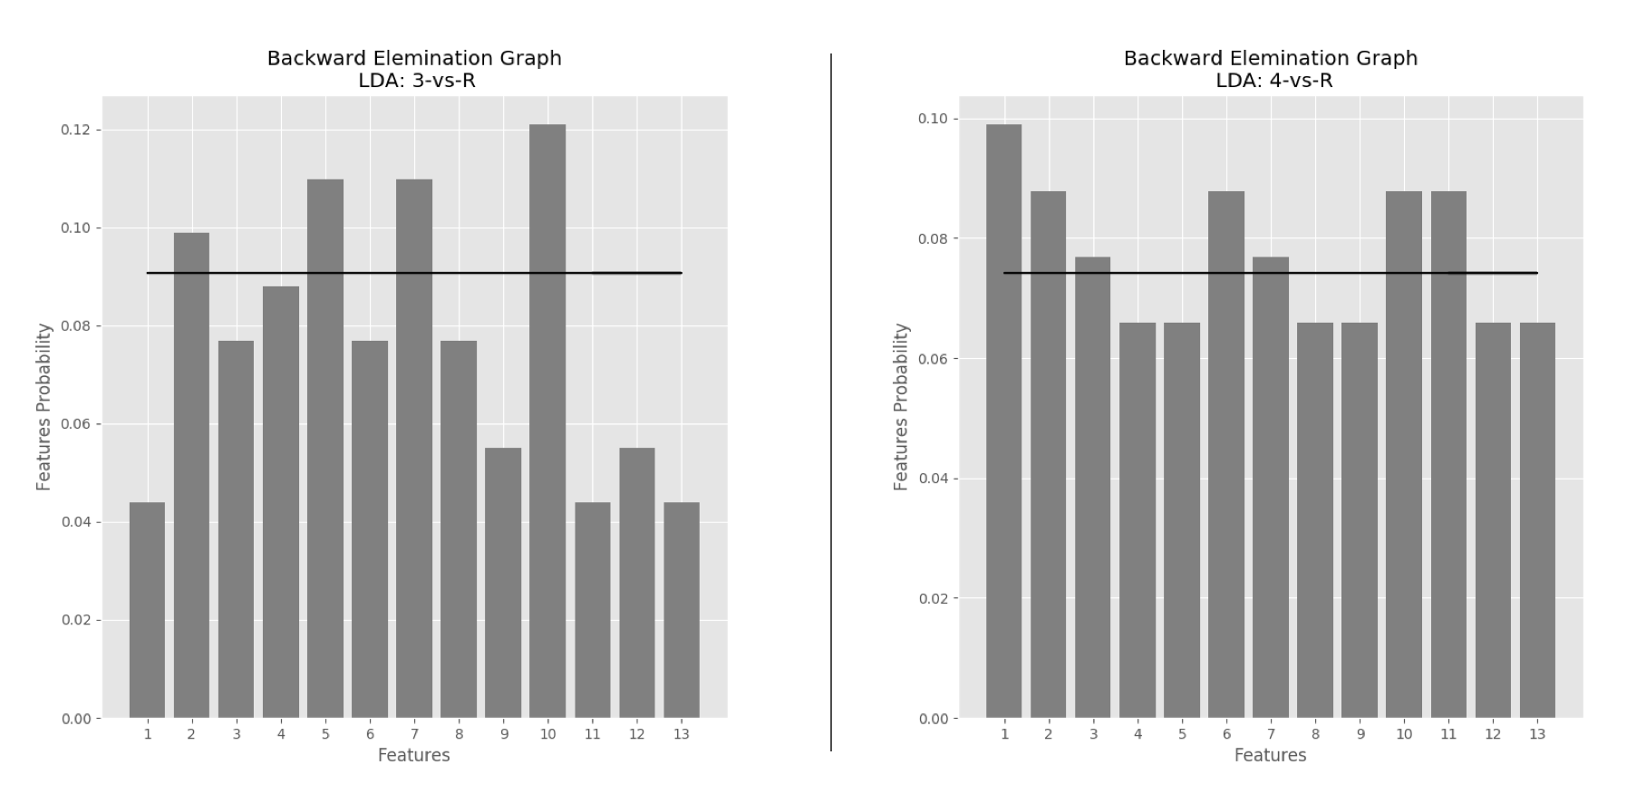

Figure 18 LDA Features Selection: 3 vs Rest/C3 classification (left); 4 vs Rest/C4 classification (right)

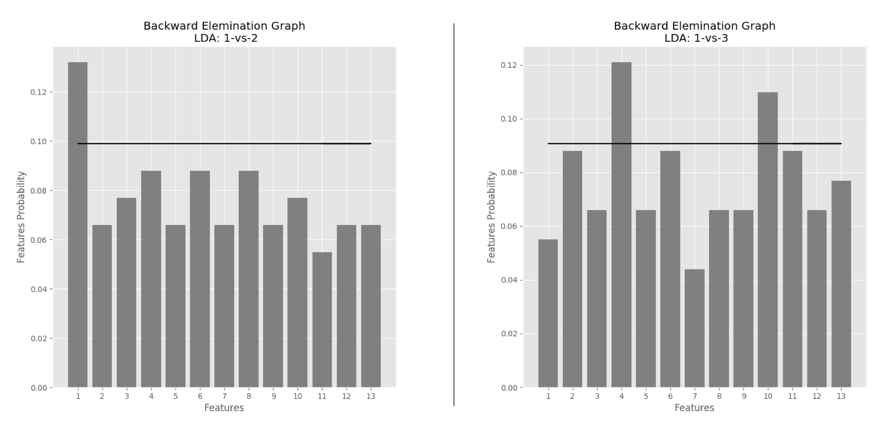

Figure 19 LDA Features Selection: 1 vs 2/C5 classification (left); 1 vs 3/C6 classification (right)

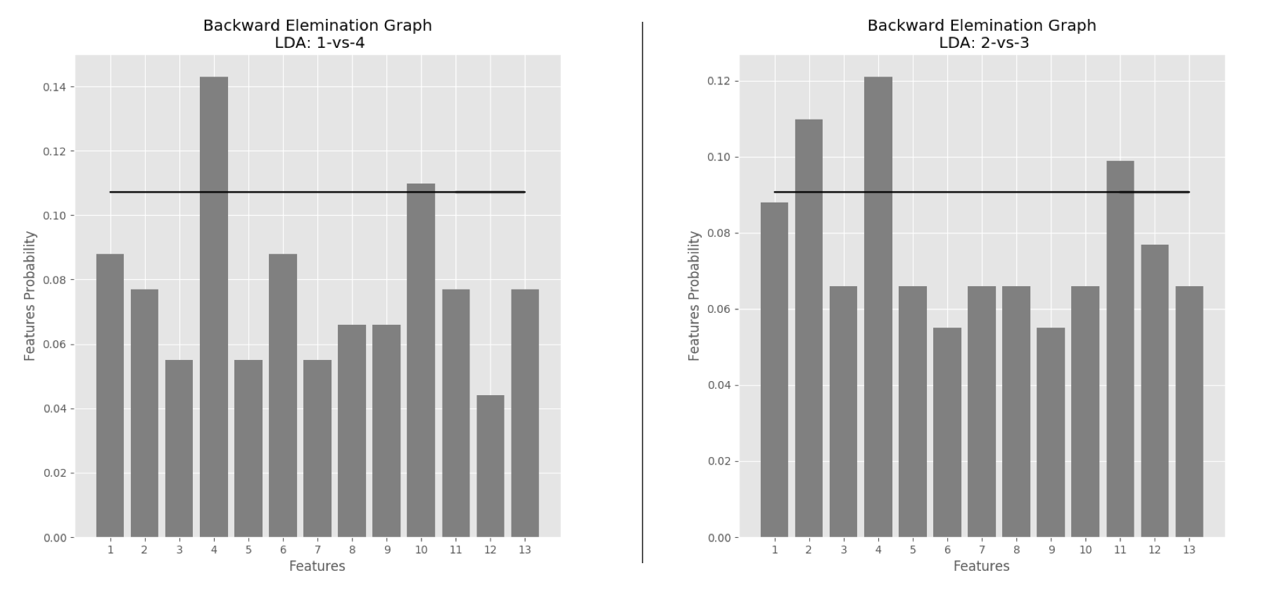

Figure 20 LDA Features Selection: 1 vs 4/C7 classification (left); 2 vs 3/C8 classification (right)

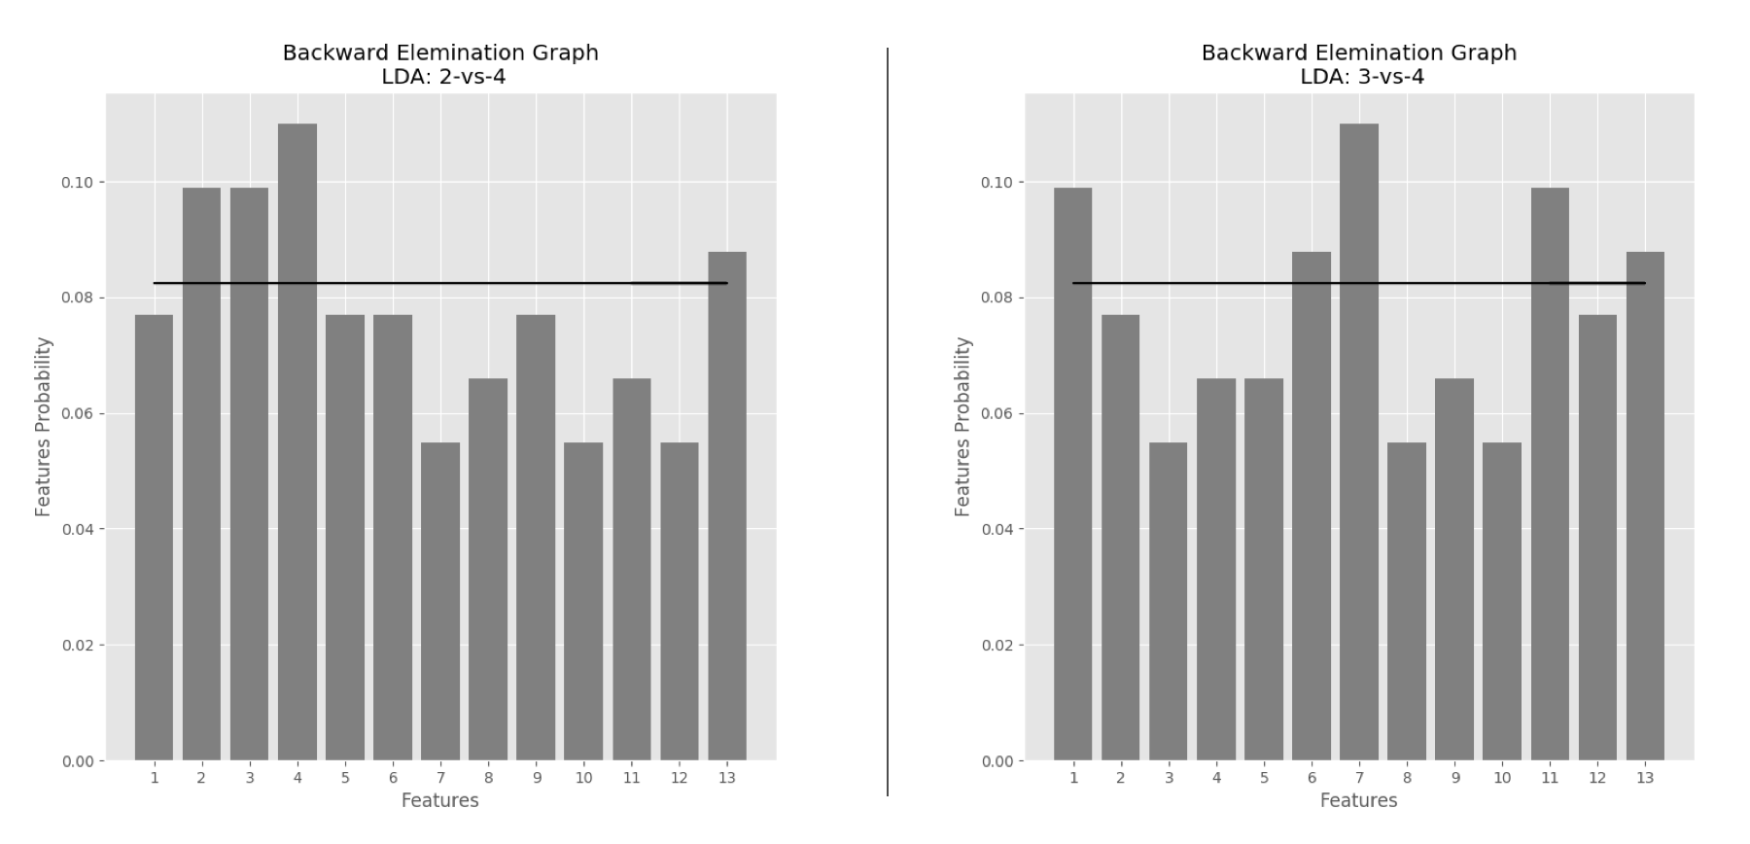

Figure 21 LDA Features Selection: 2 vs 4/C9 classification (left); 3 vs 4/C10 classification (right)

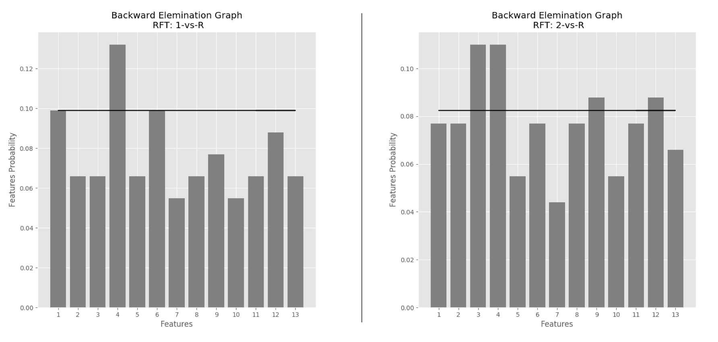

Figure 22 RFT Features Selection: 1 vs Rest/C1 classification (left); 2 vs Rest/C2 classification (right)

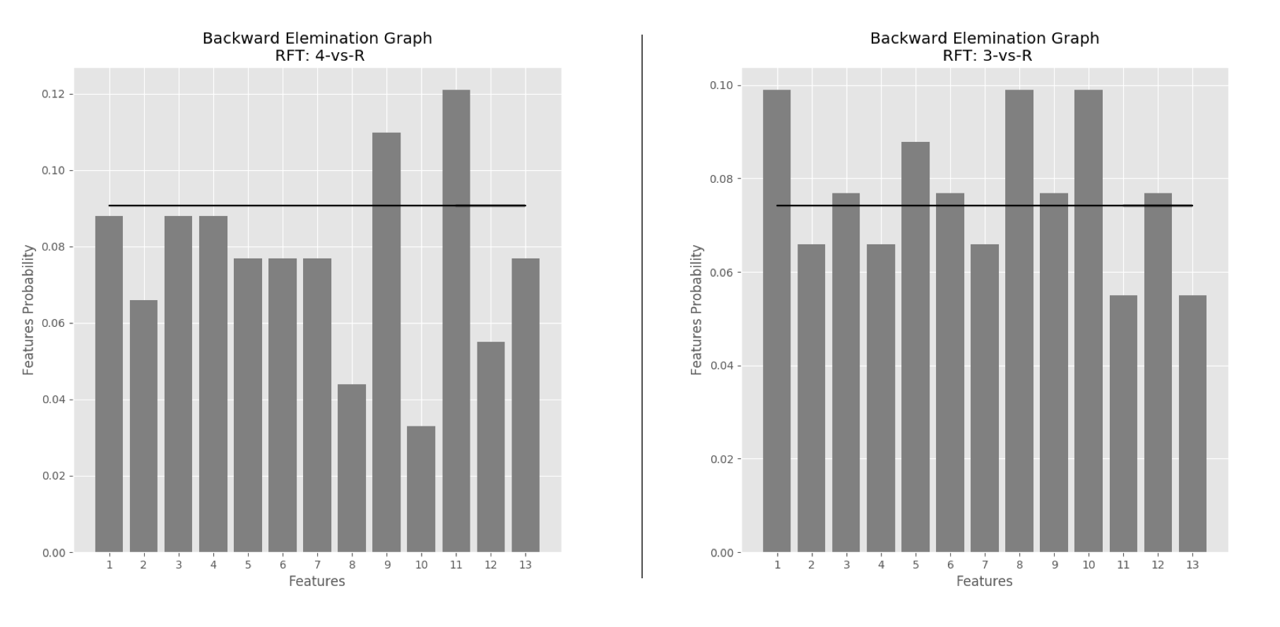

Figure 23 RFT Features Selection: 3 vs Rest/C3 classification (left); 4 vs Rest/C4 classification (right)

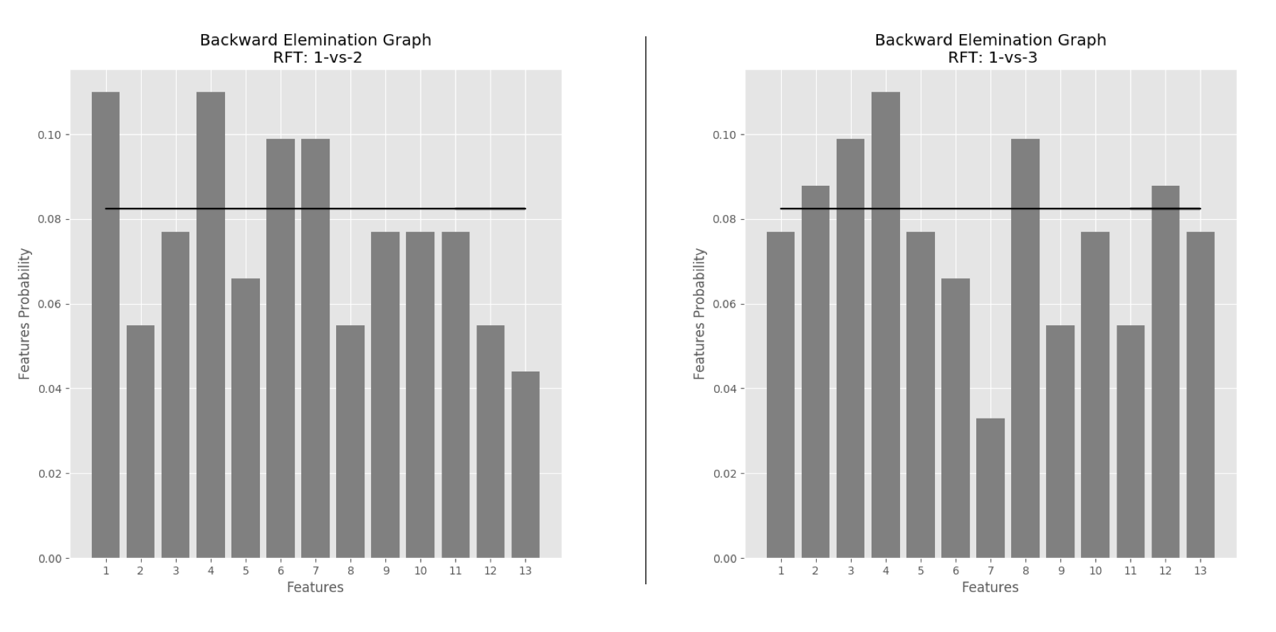

Figure 24 RFT Features Selection: 1 vs 2/C5 classification (left); 1 vs 3/C6 classification (right)

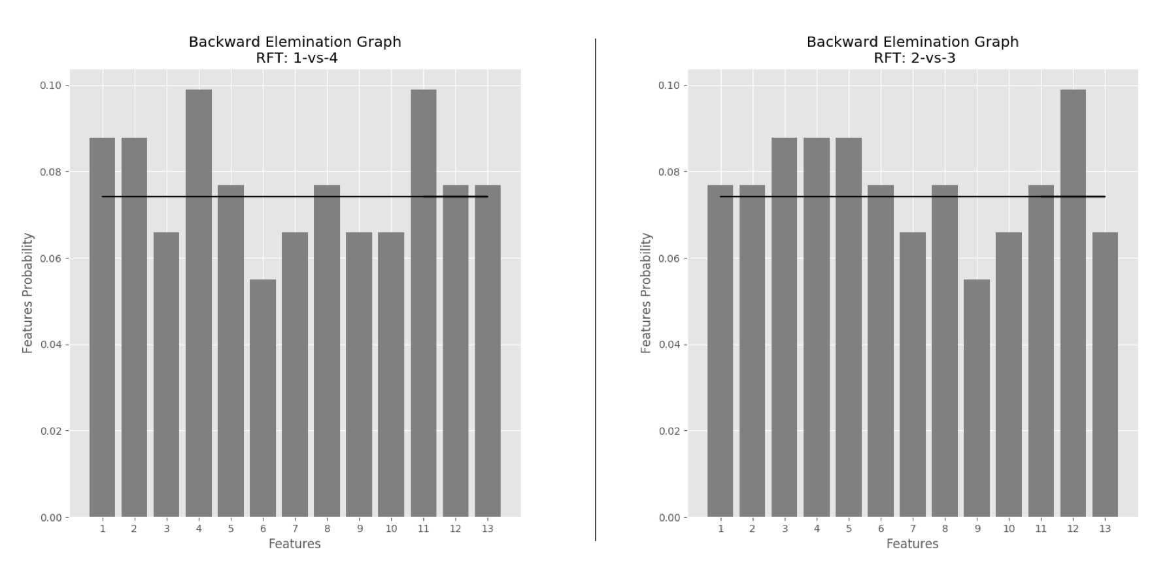

Figure 25 RFT Features Selection: 1 vs 4/C7 classification (left); 2 vs 3/C8 classification (right)

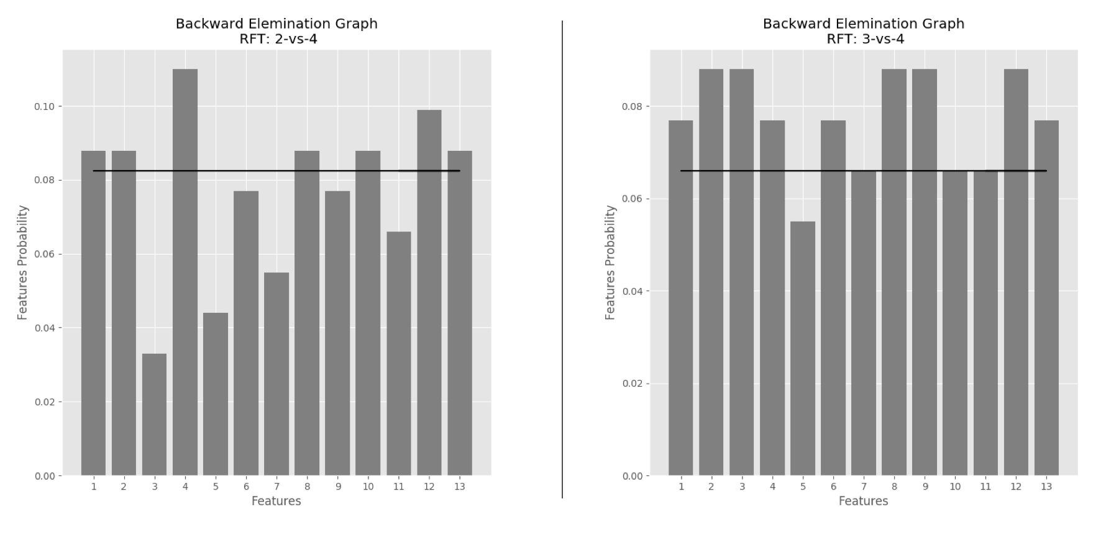

Figure 26 RFT Features Selection: 2 vs 4/C9 classification (left); 3 vs 4/C10 classification (right)

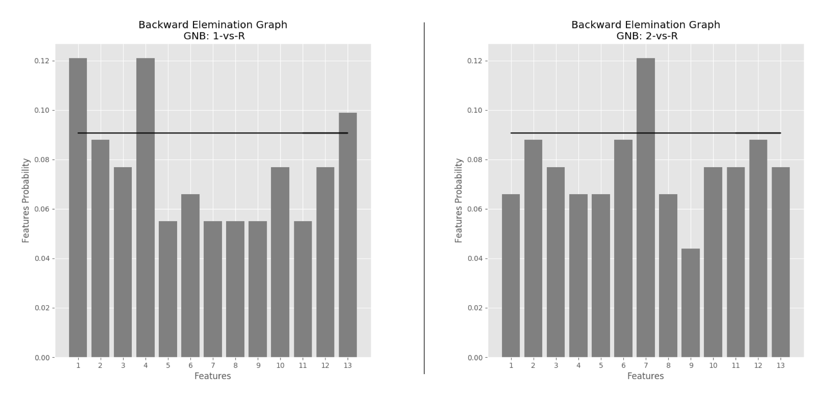

Figure 27 GNB Features Selection: 1 vs Rest/C1 classification (left); 2 vs Rest/C2 classification (right)

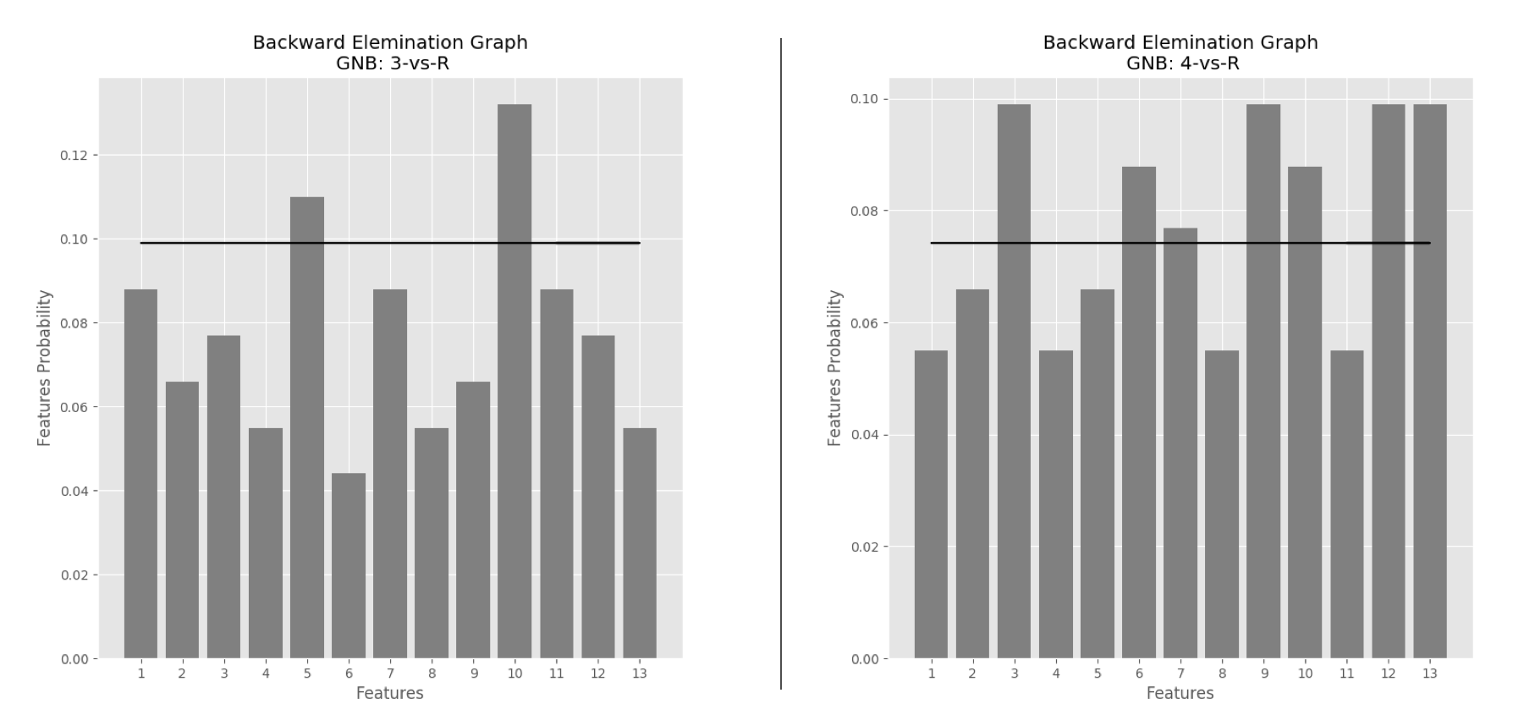

Figure 28 GNB Features Selection: 3 vs Rest/C3 classification (left); 4 vs Rest/C4 classification (right)

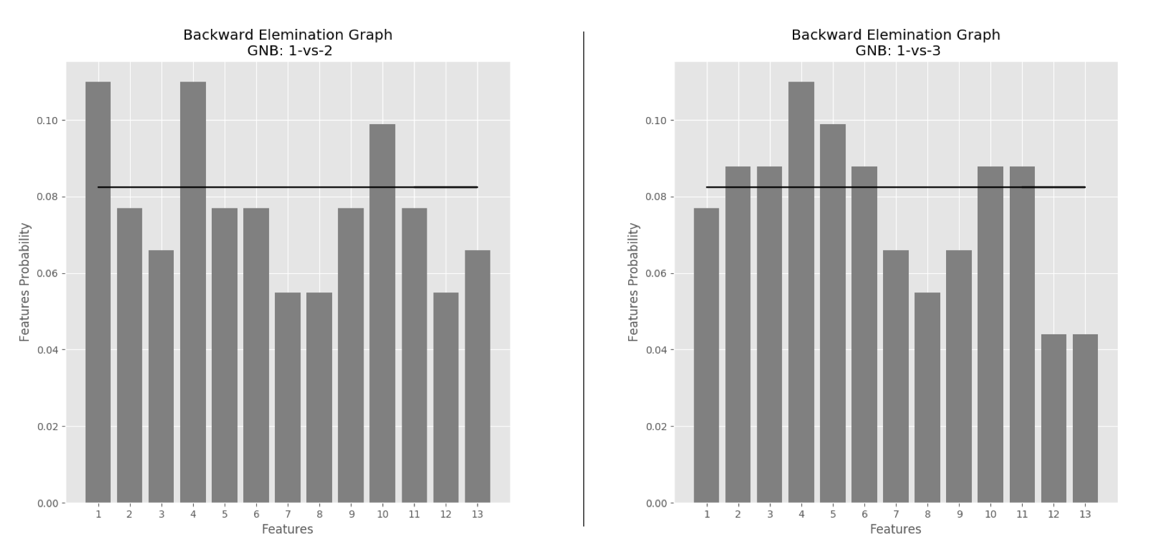

Figure 29 GNB Features Selection: 1 vs 2/C5 classification (left); 1 vs 3/C6 classification (right)

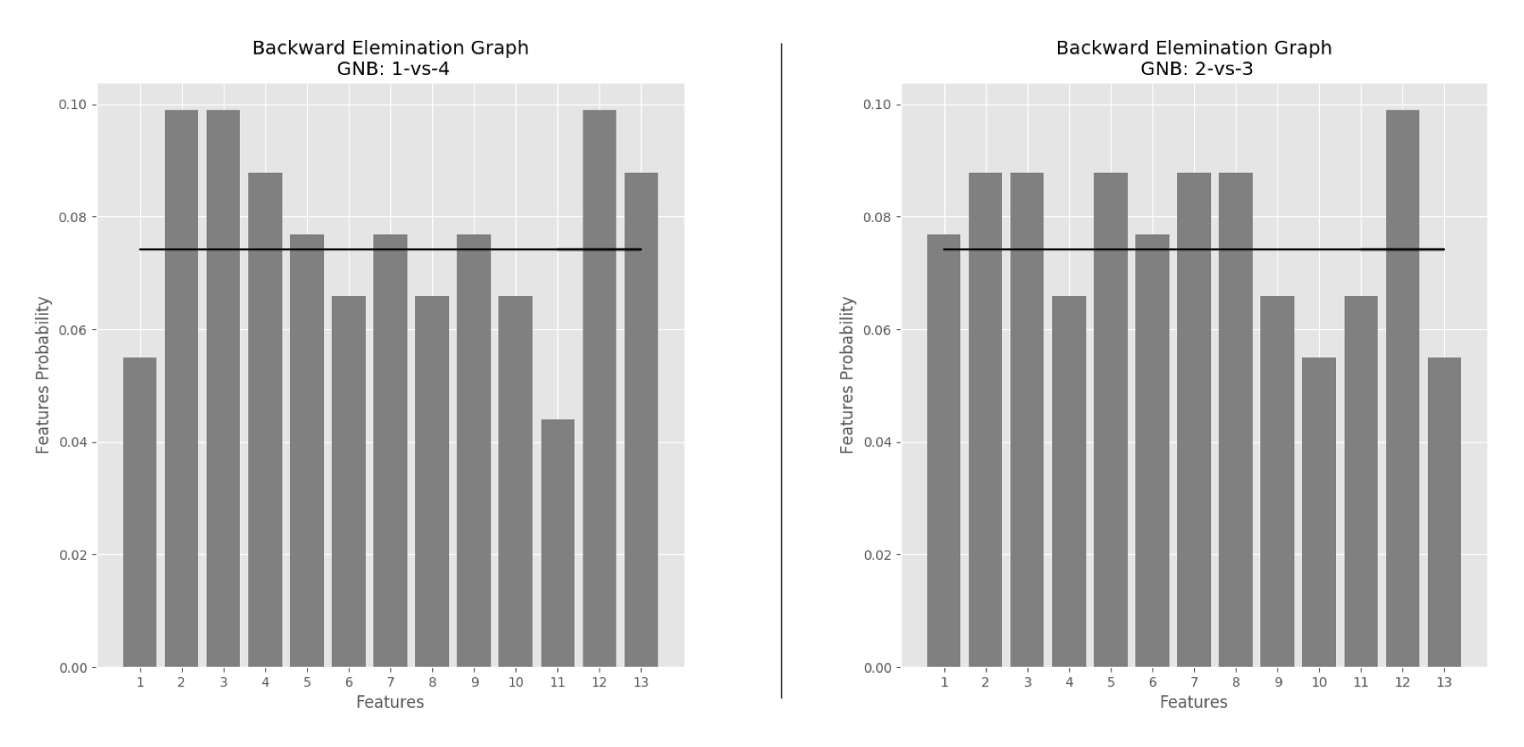

Figure 30 GNB Features Selection: 1 vs 4/C7 classification (left); 2 vs 3/C8 classification (right)

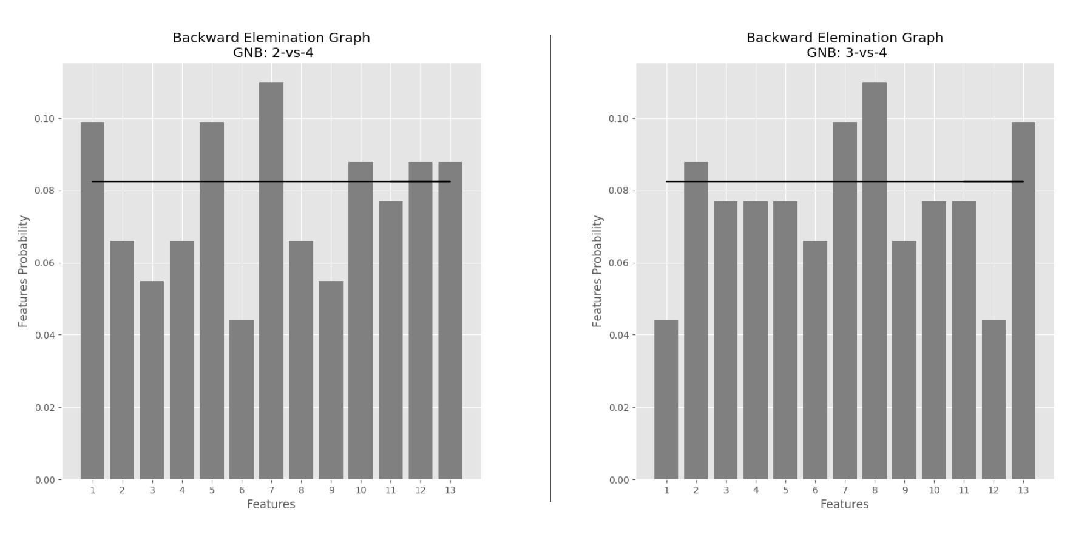

Figure 31 GNB Features Selection: 2 vs 4/C9 classification (left); 3 vs 4/C10 classification (right)

Appendix B

This Section shows the results of the ROC curve of the classifier for all the classification. Figures from 34 to 38 describing the ROC curve for KNN classifier, Figures 39 to 43 describing the ROC curve for SVM classifier, Figures 44 to 48 describing the ROC curve for LDA, Figures 49 to 53 describing the ROC curve for RFT and Figures 54 to 58 describing the curve for GNB.

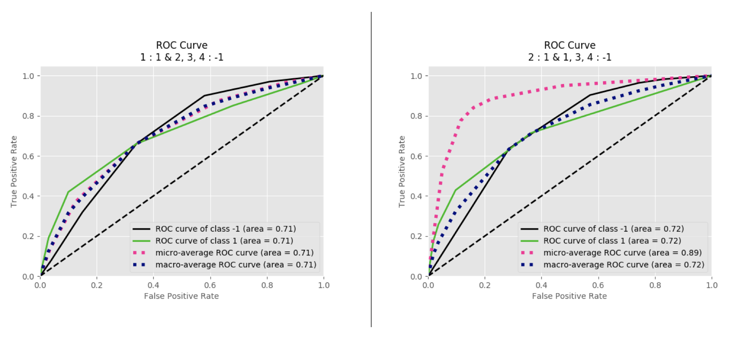

Figure 34 KNN ROC curve: 1 vs Rest/C1 classification (left); 2 vs Rest/C2 classification (right)

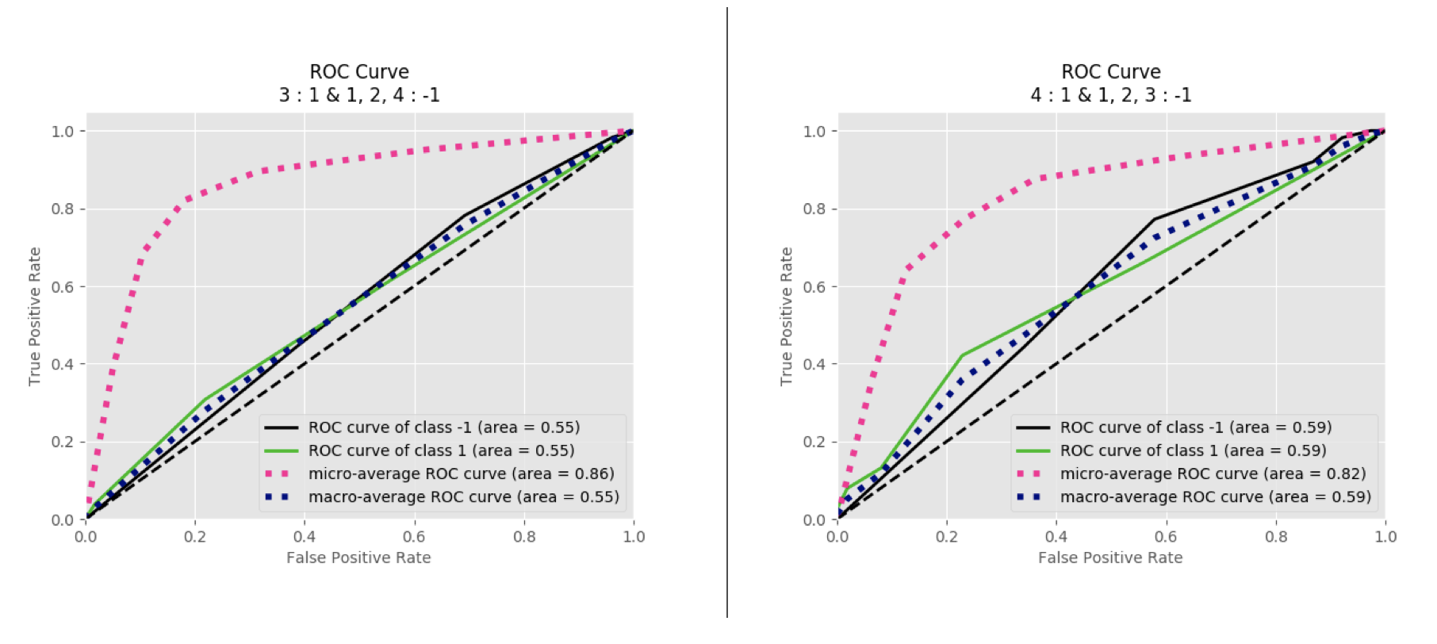

Figure 35 KNN ROC curve: 3 vs Rest/C3 classification (left); 4 vs Rest/C4 classification (right)

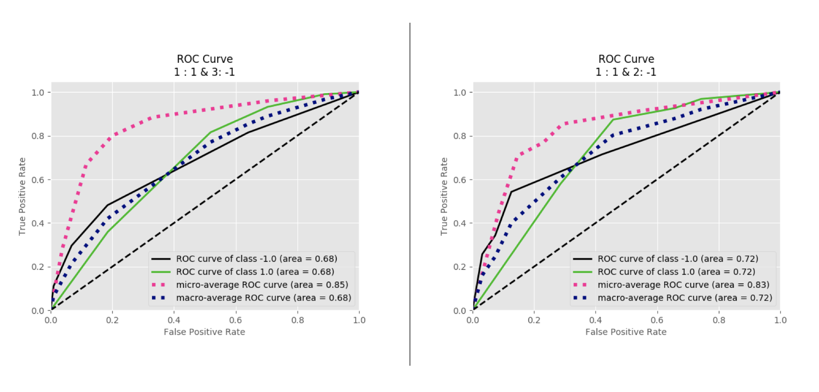

Figure 36 KNN ROC curve: 1 vs 2/C5 classification (left); 2 vs 3/C6 classification (right)

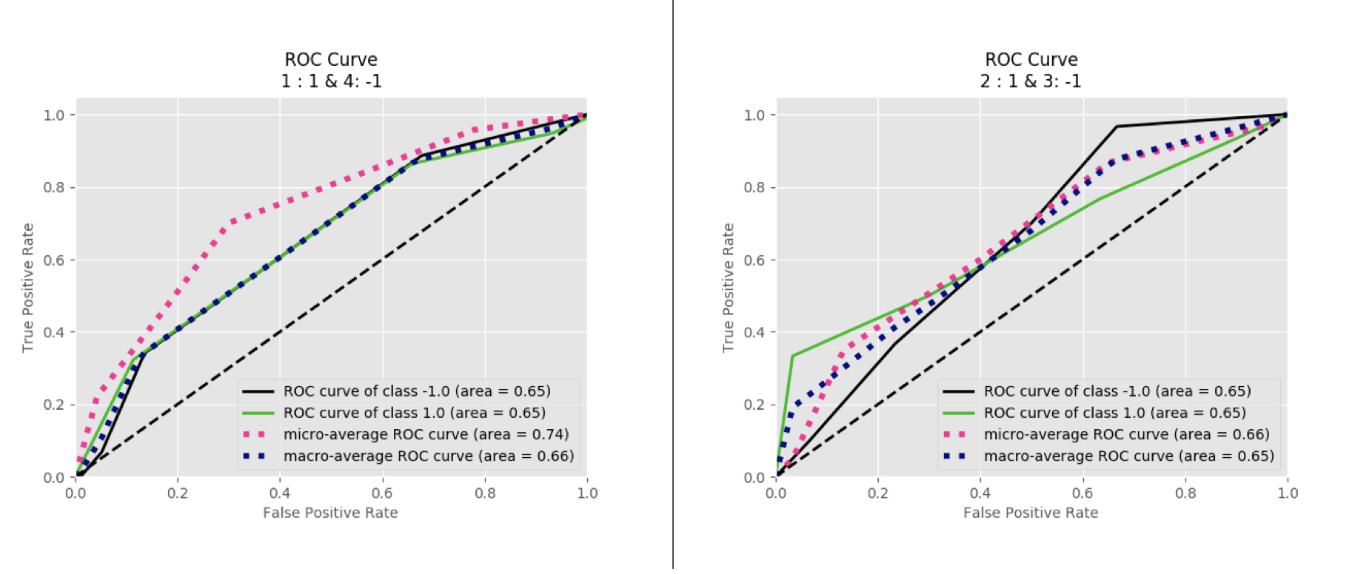

Figure 37 KNN ROC curve: 1 vs 4/C7 classification (left); 2 vs 3/C8 classification (right)

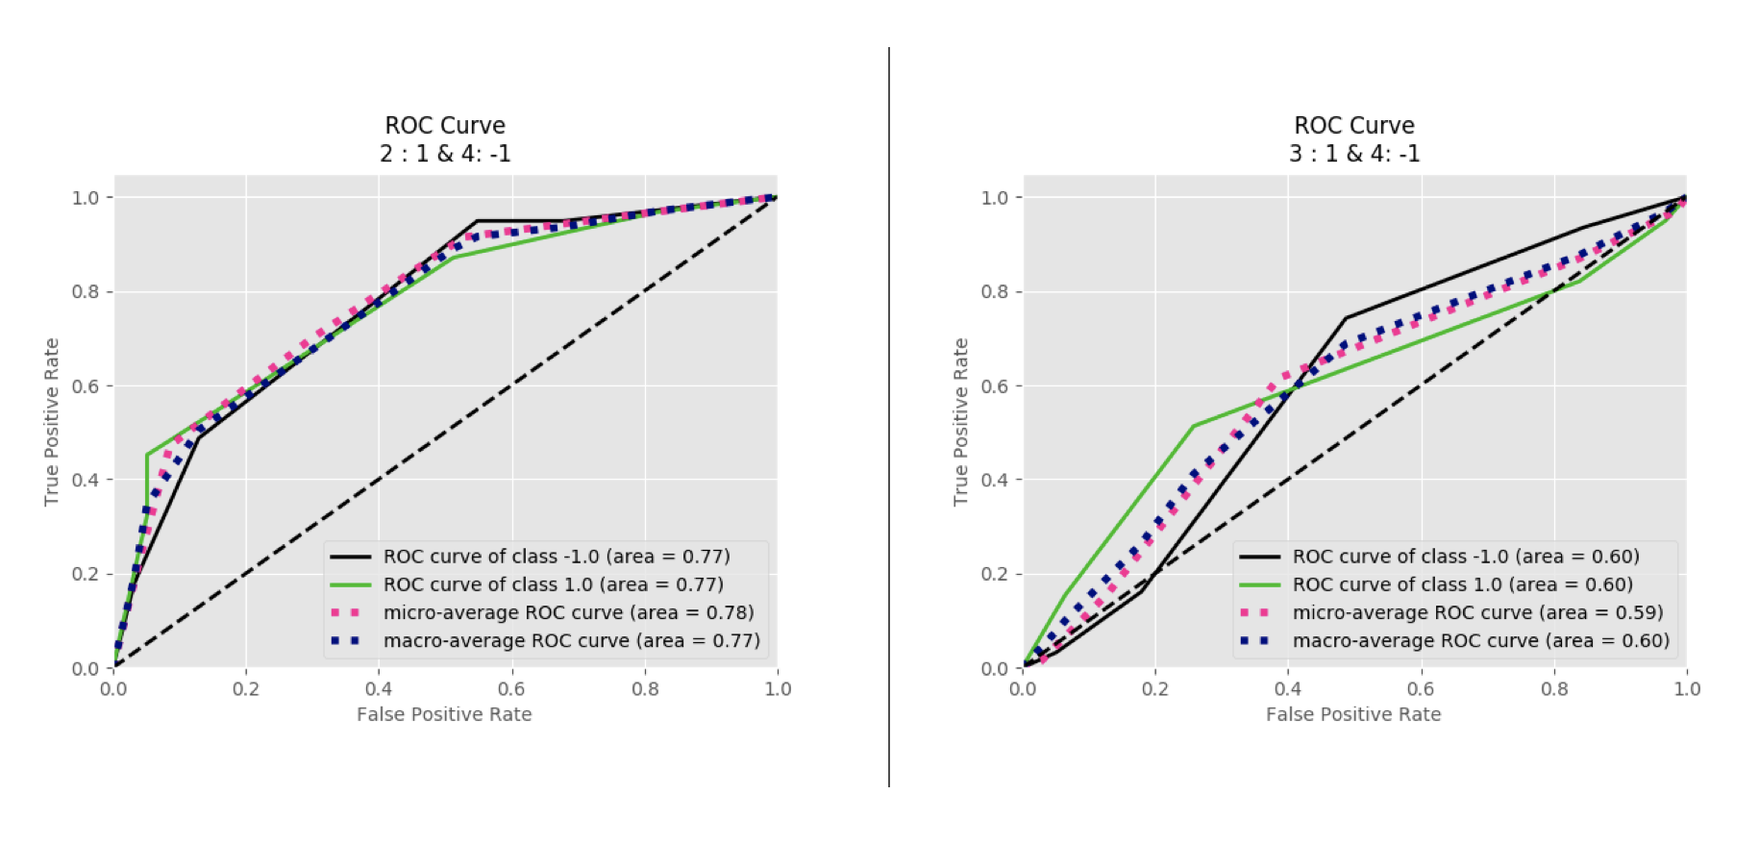

Figure 38 KNN ROC curve: 2 vs 4/C9 classification (left); 3 vs 4/C10 classification (right)

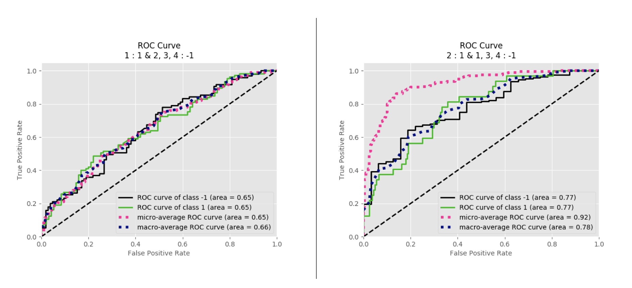

Figure 39 SVM ROC curve: 1 vs Rest/C1 classification (left); 2 vs Rest/C2 classification (right)  
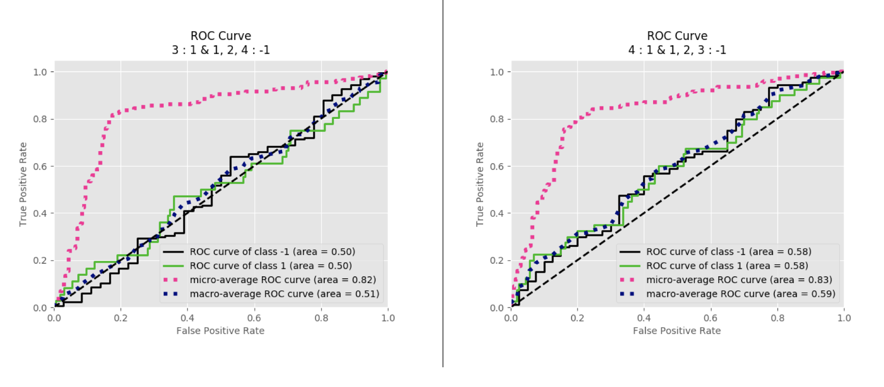

Figure 40 SVM ROC curve: 3 vs Rest/C3 classification (left); 4 vs Rest/C4 classification (right)

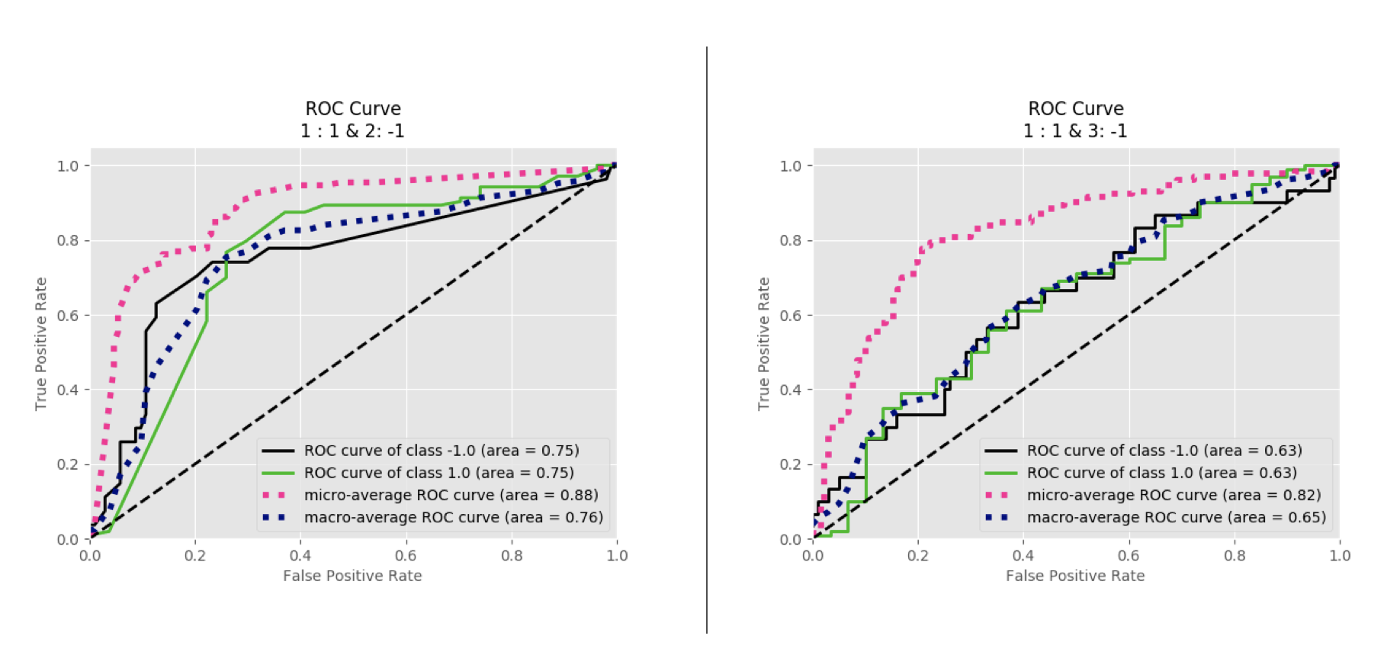

Figure 41 SVM ROC curve: 1 vs 2/C5 classification (left); 1 vs 3/C6 classification (right)

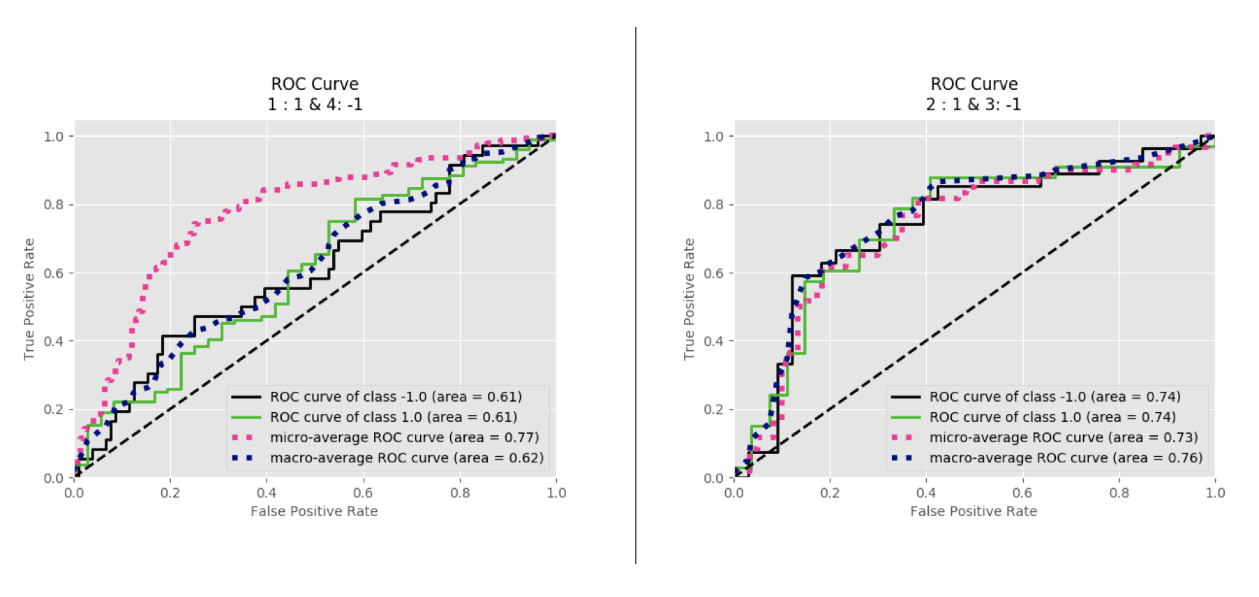

Figure 42 SVM ROC curve: 1 vs 4/C7 classification (left); 2 vs 3/C8 classification (right)

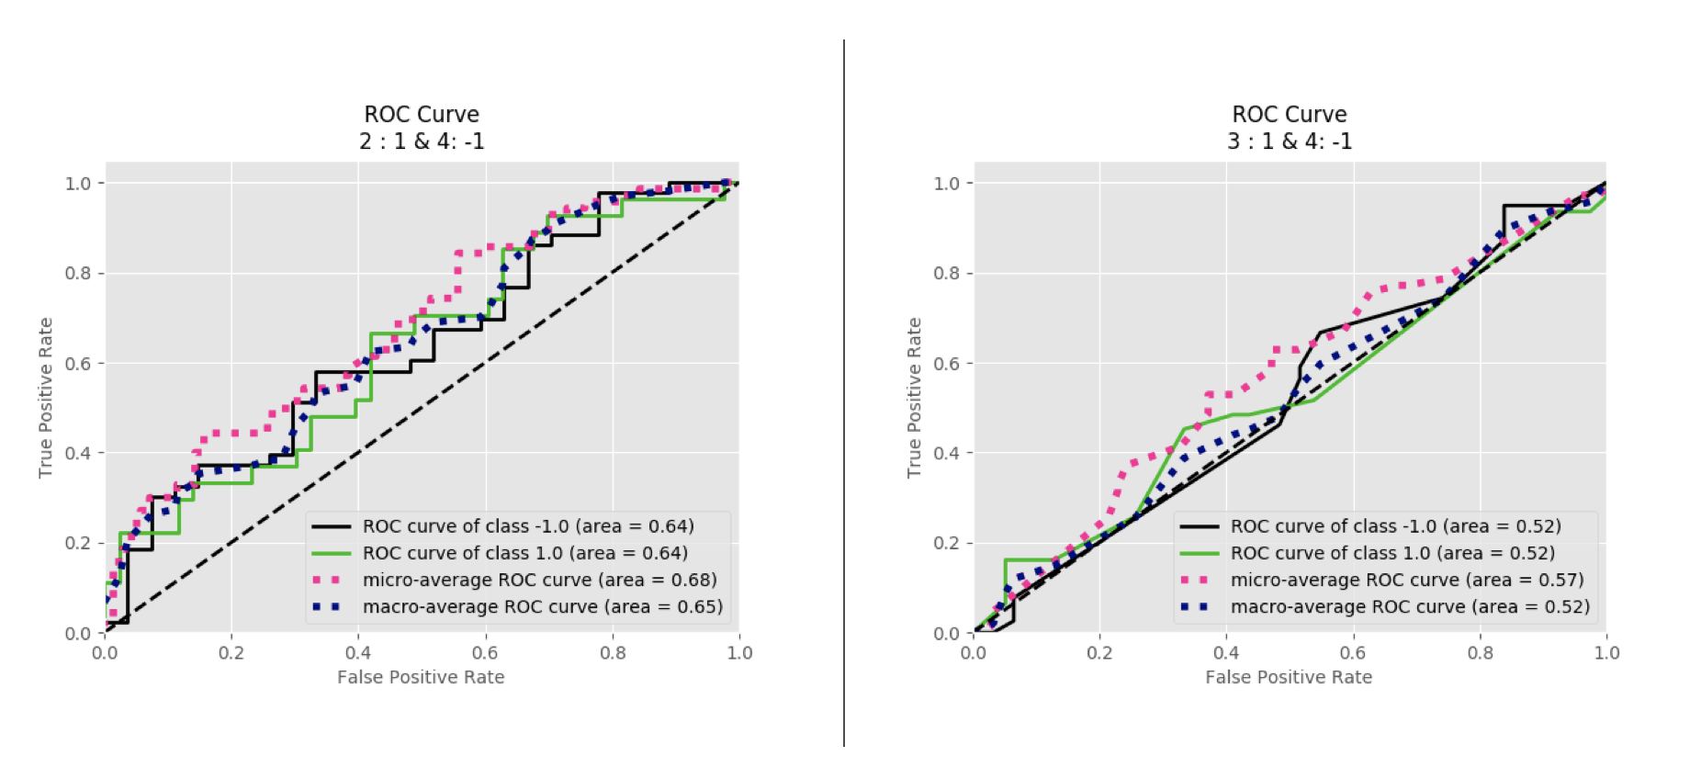

Figure 43 SVM ROC curve: 2 vs 4/C9 classification (left); 3 vs 4/C10 classification (right)

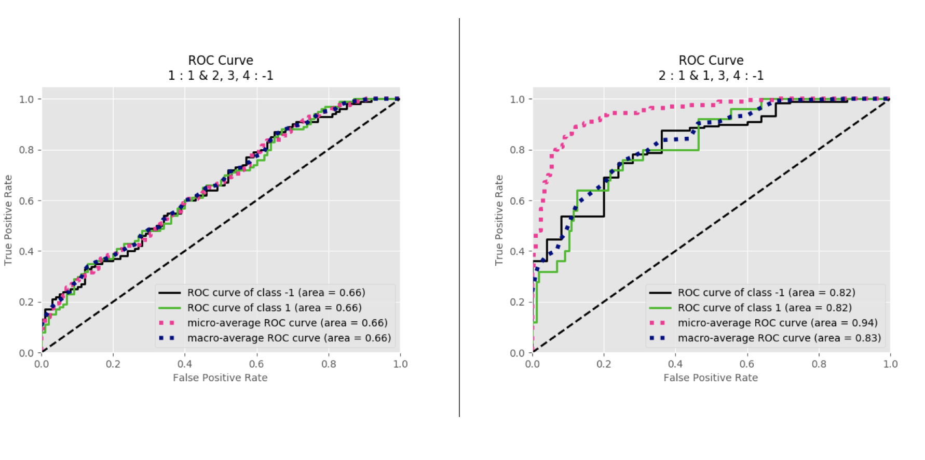

Figure 44 LDA ROC curve: 1 vs Rest/C1 classification (left); 2 vs Rest/C2 classification (right)

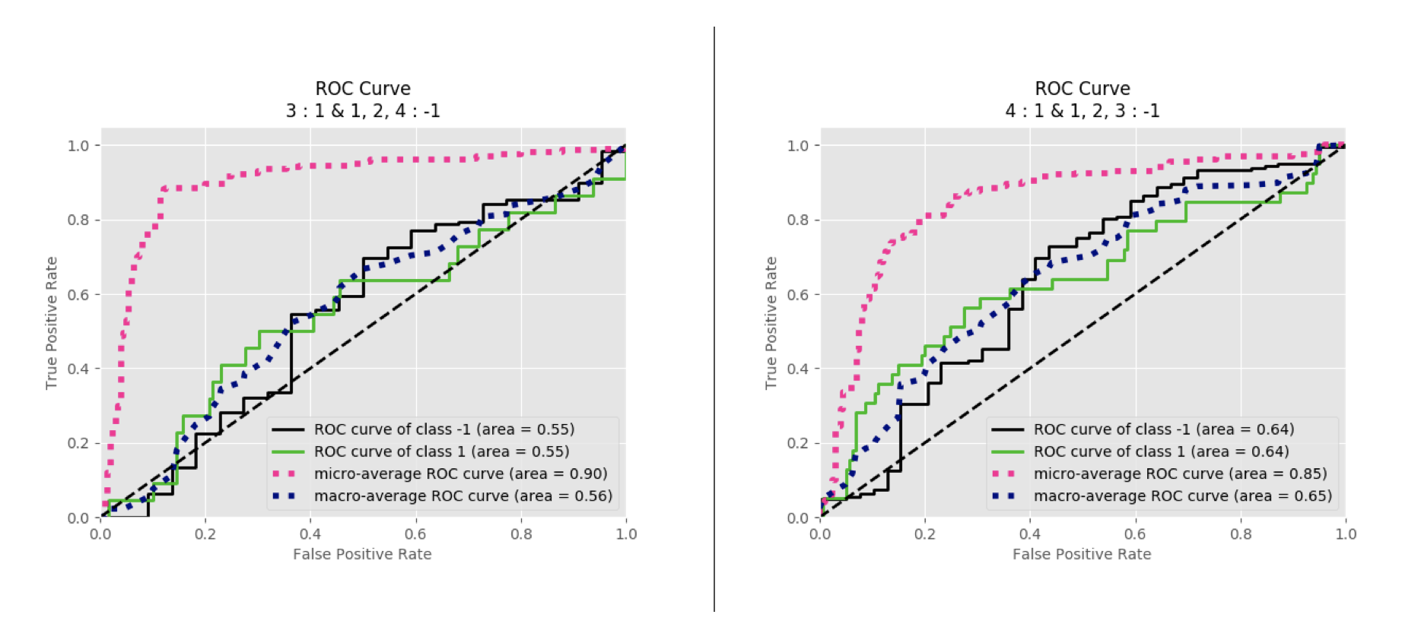

Figure 45 LDA ROC curve: 3 vs Rest/C3 classification (left); 4 vs Rest/C4 classification (right)

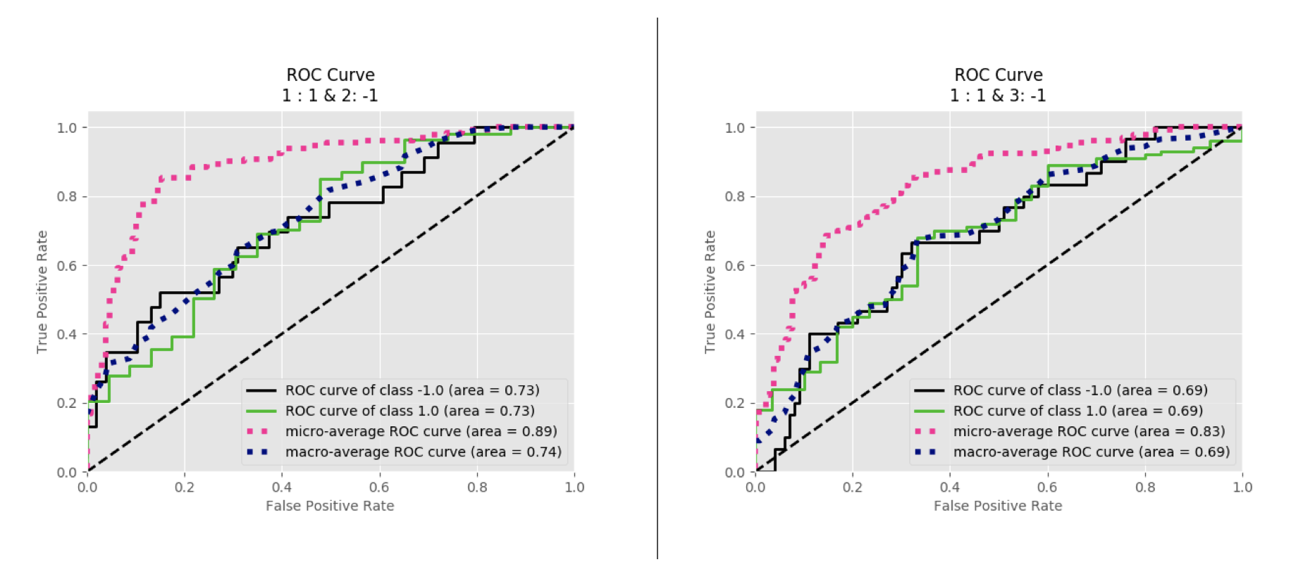

Figure 46 LDA ROC curve: 1 vs 2/C5 classification (left); 1 vs 3/C6 classification (right)

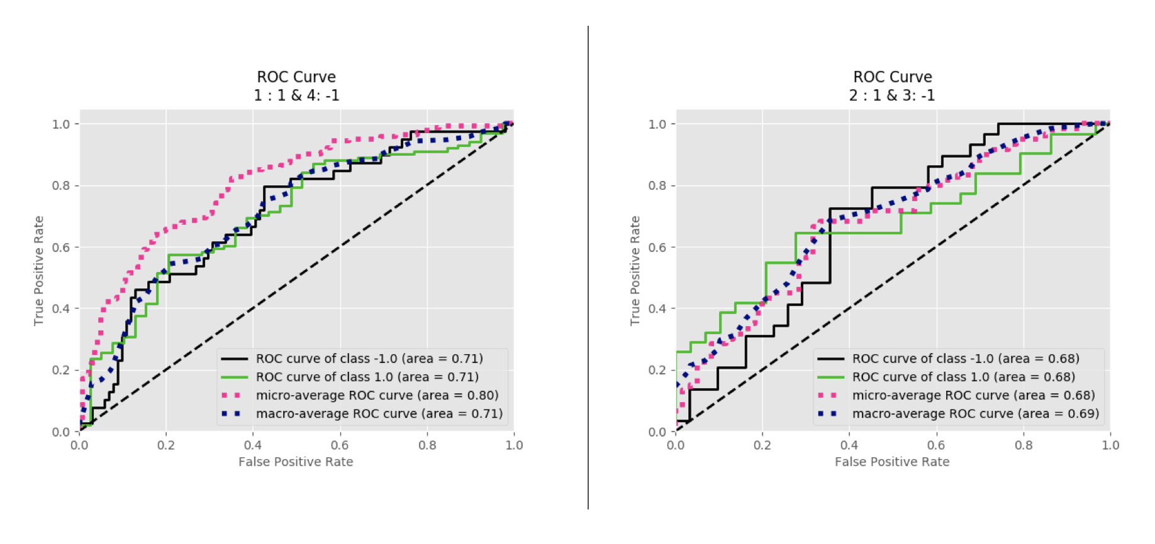

Figure 47 LDA ROC curve: 1 vs 4/C7 classification (left); 2 vs 3/C8 classification (right)

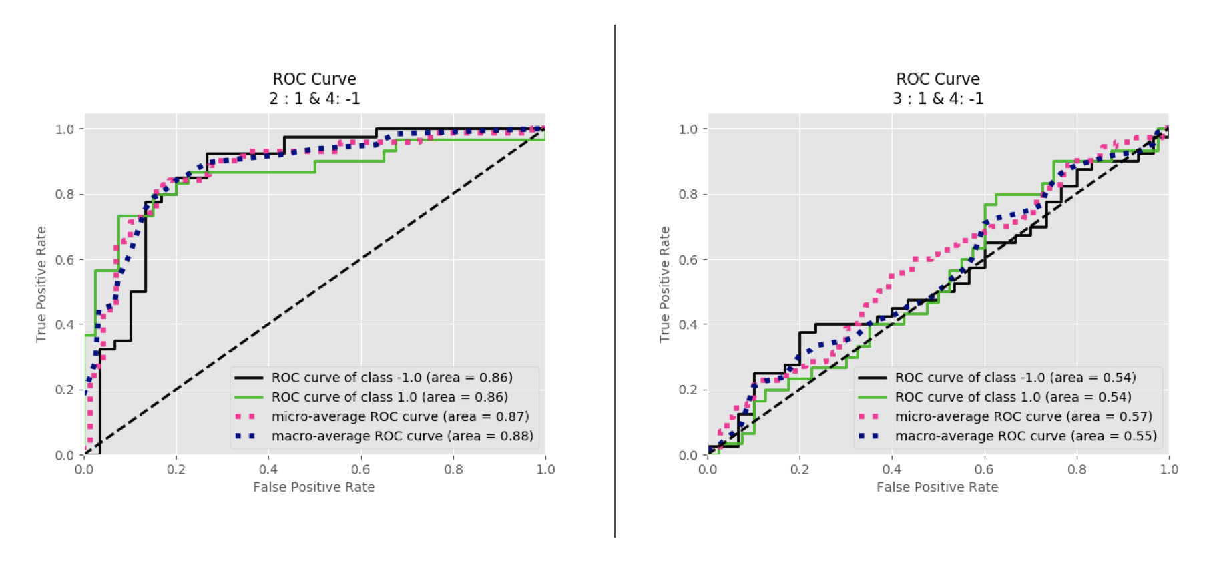

Figure 48 LDA ROC curve: 2 vs 4/C9 classification (left); 3 vs 4/C10 classification (right)

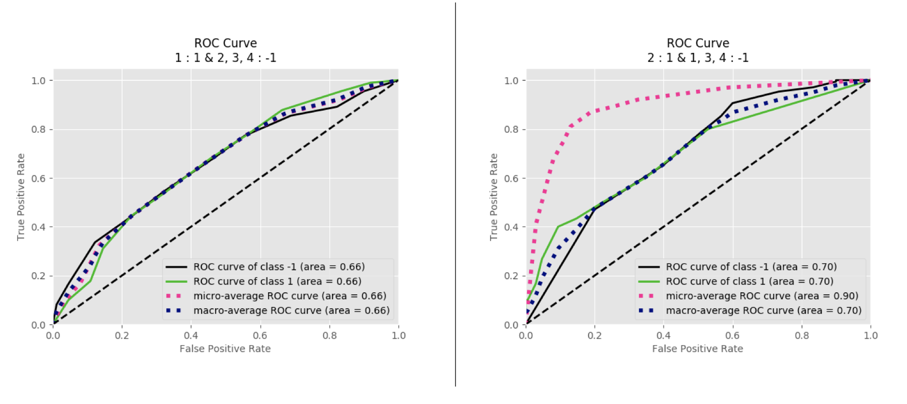

Figure 49 RFT ROC curve: 1 vs Rest/C1 classification (left); 2 vs Rest/C2 classification (right)

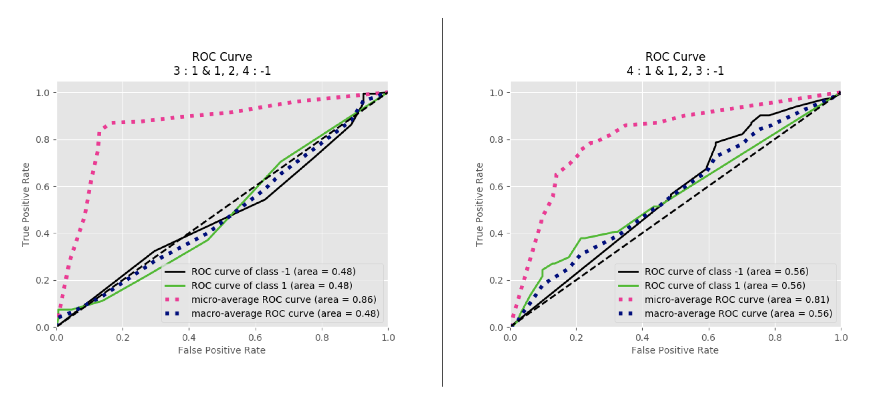

Figure 50 RFT ROC curve: 3 vs Rest/C3 classification (left); 4 vs Rest/C4 classification (right)

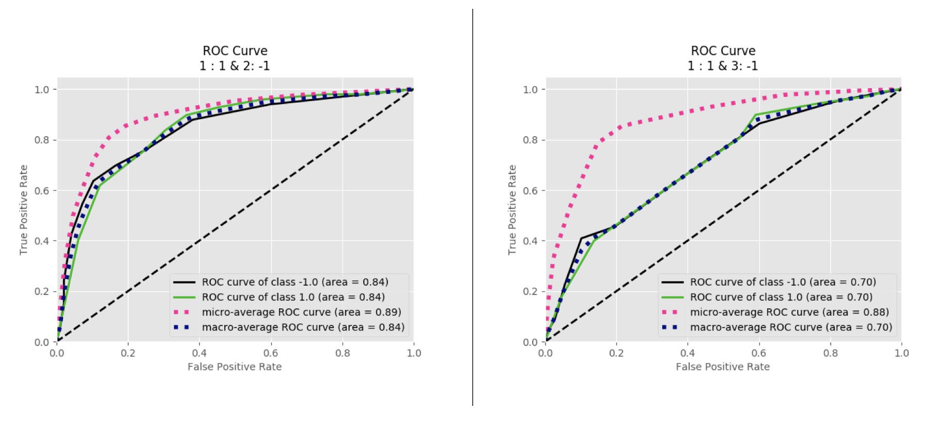

Figure 51 RFT ROC curve: 1 vs 2/C5 classification (left); 1 vs 3/C6 classification (right)

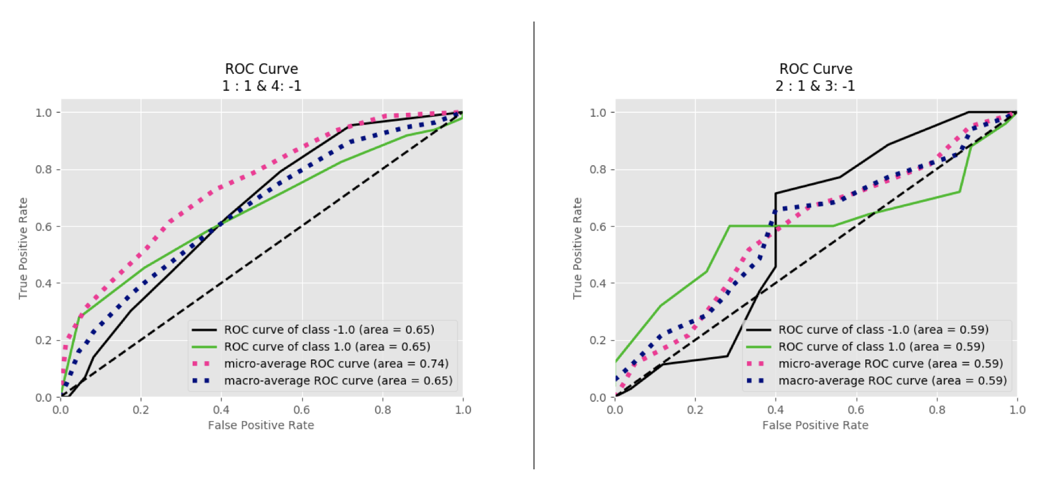

Figure 52 RFT ROC curve: 1 vs 4/C7 classification (left); 2 vs 3/C8 classification (right)

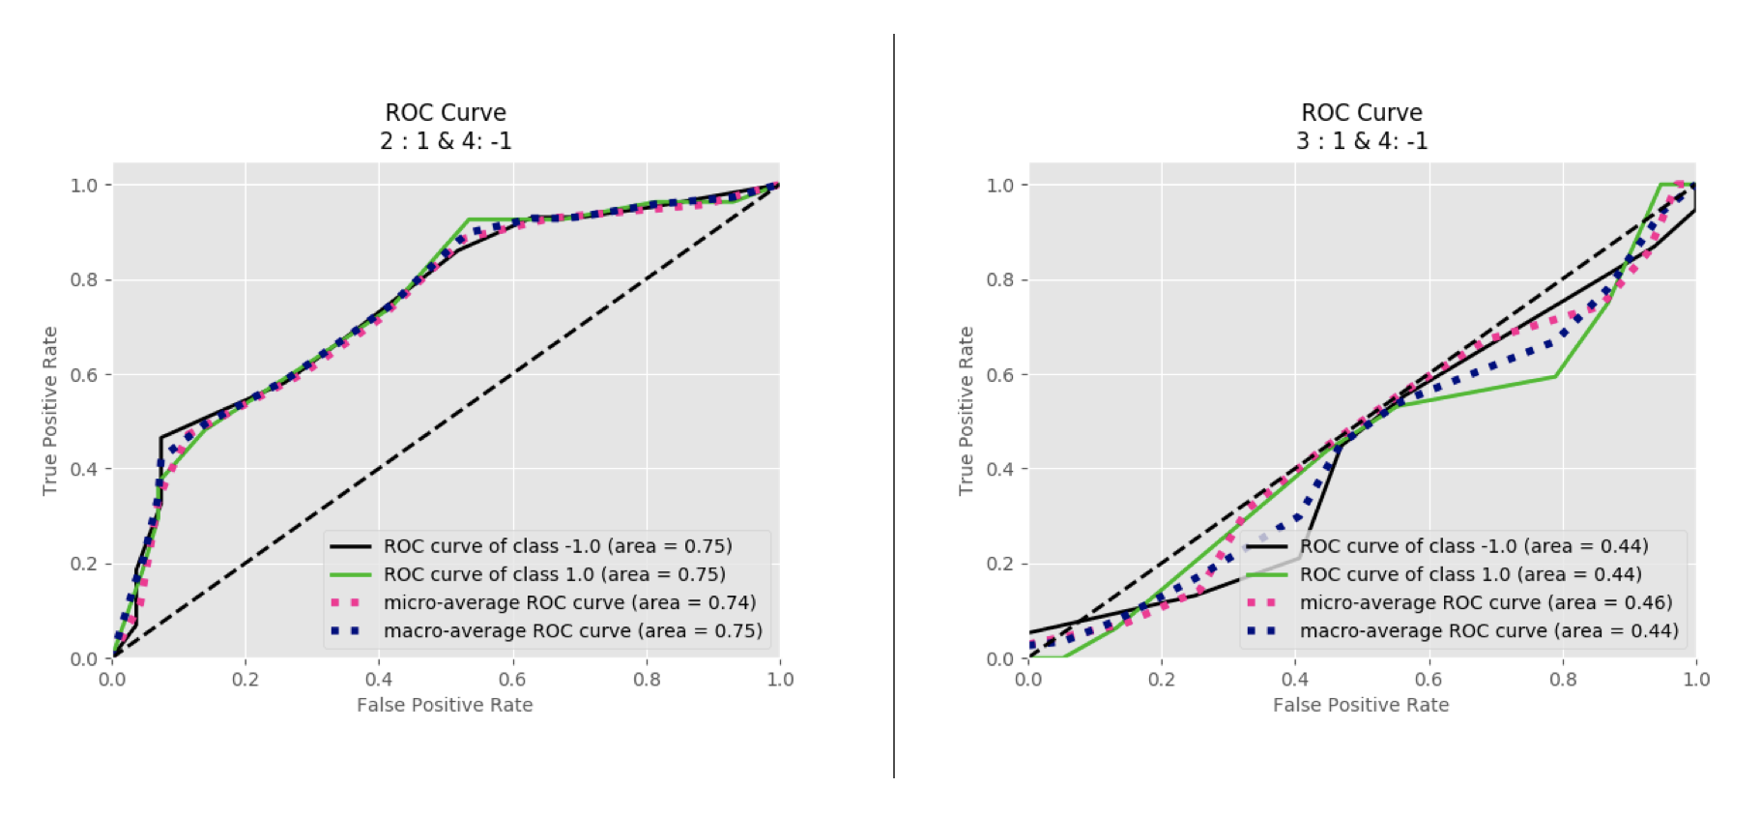

Figure 53 RFT ROC curve: 2 vs 4/C9 classification (left); 3 vs 4/C10 classification (right)

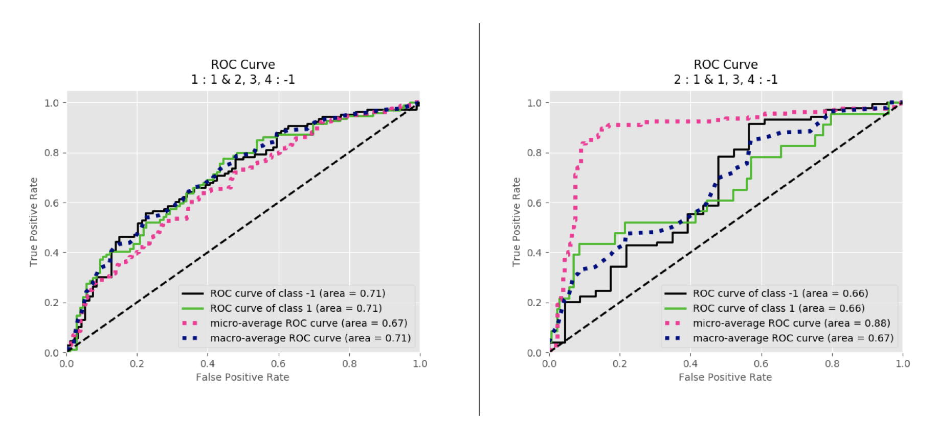

Figure 54 GNB ROC curve: 1 vs Rest/C1 classification (left); 2 vs Rest/C2 classification (right)

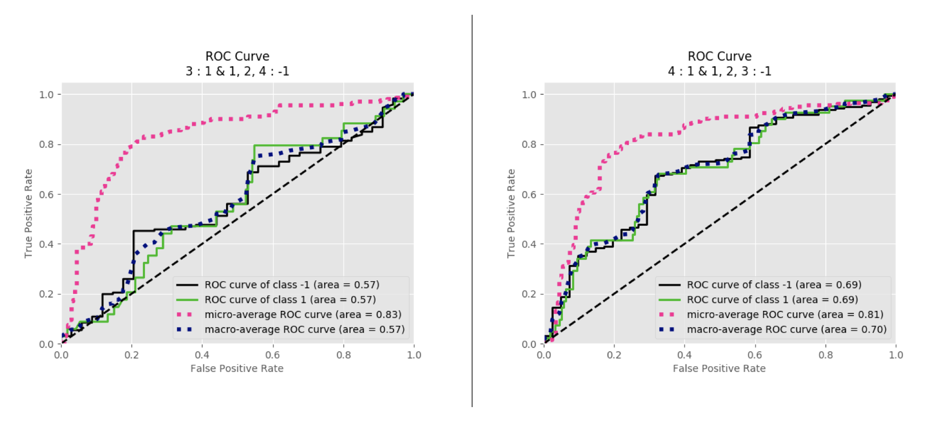

Figure 55 GNB ROC curve: 3 vs Rest/C3 classification (left); 4 vs Rest/C4 classification (right)

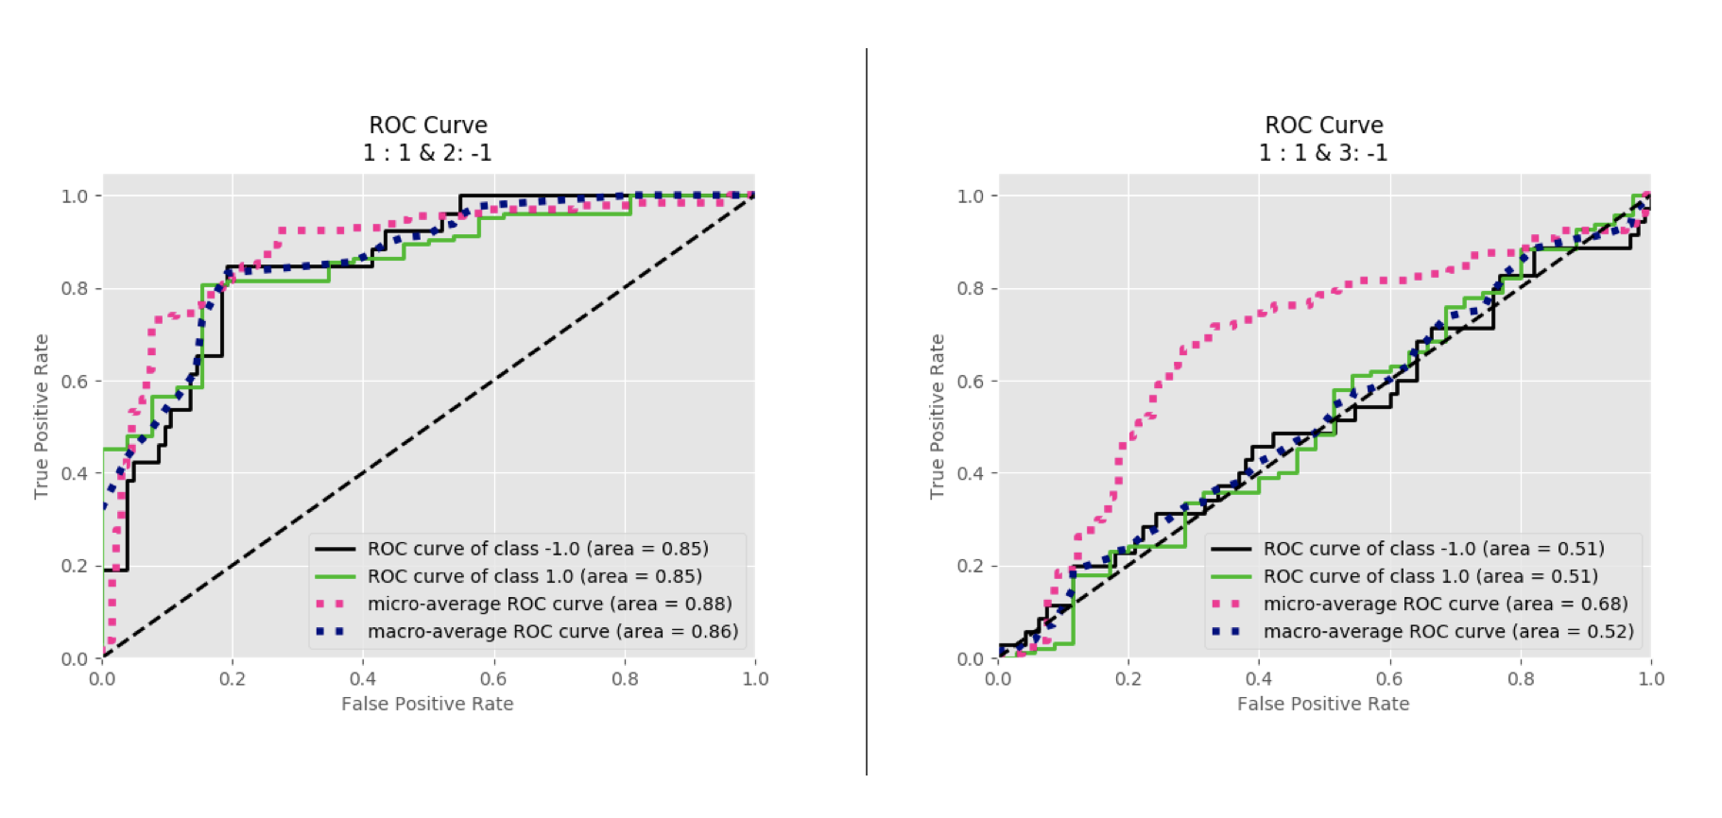

Figure 56 GNB ROC curve: 1 vs 2/C5 classification (left); 1 vs 3/C6 classification (right)

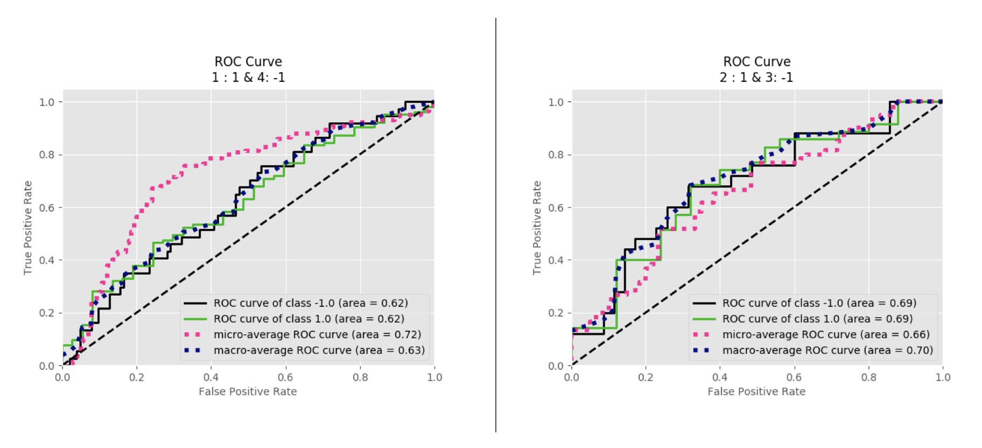

Figure 57 GNB ROC curve: 1 vs 4/C7 classification (left); 2 vs 3/C8 classification (right)

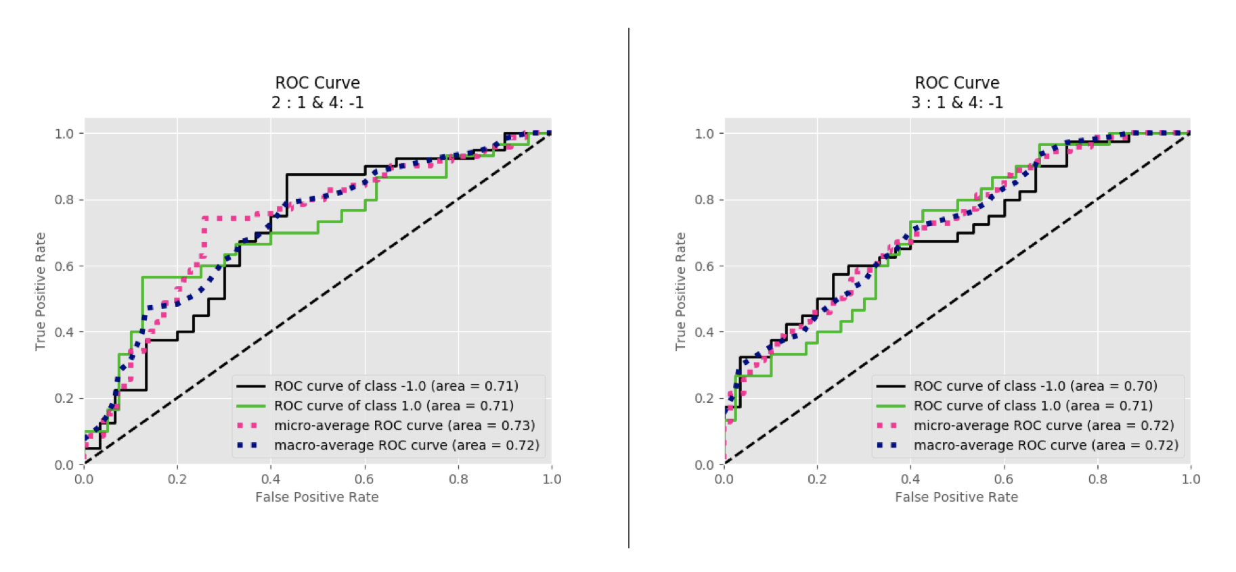

Figure 58 GNB ROC curve: 2 vs 4/C9 classification (left); 3 vs 4/C10 classification (right)

Appendix C

This Section shows the results of the ROC curve for the classifier after removing the wrongly classified trials by the participants. Figures 59 to 63 describing the ROC curve for KNN classifier, Figure from 64 to 68 describing the ROC curve for SVM classifier, Figure describing 69 to 73 describing the ROC curve for LDA classifier, Figure from 74 to 78 describing the ROC curve for RFT classifier, and Figure 79 to 83 describing the curve for GNB after removing the wrongly classified trials by the participants.

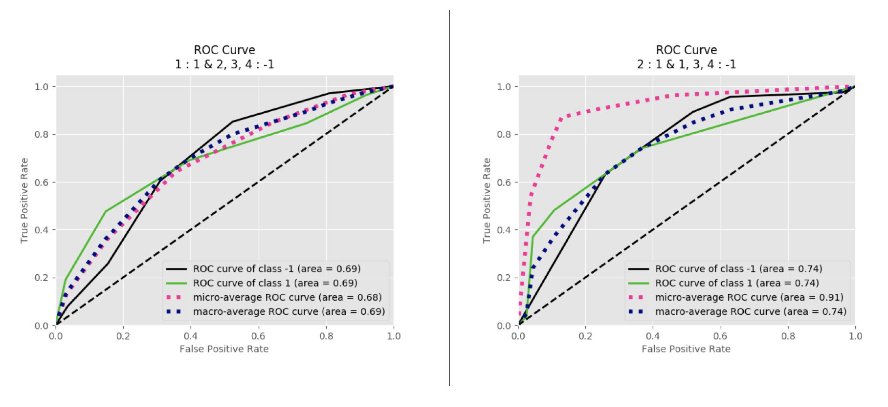

Figure 59 KNN ROC curve after removing false predicted data: 1 vs Rest/C1 classification (left); 2 vs Rest/C2 classification (right)

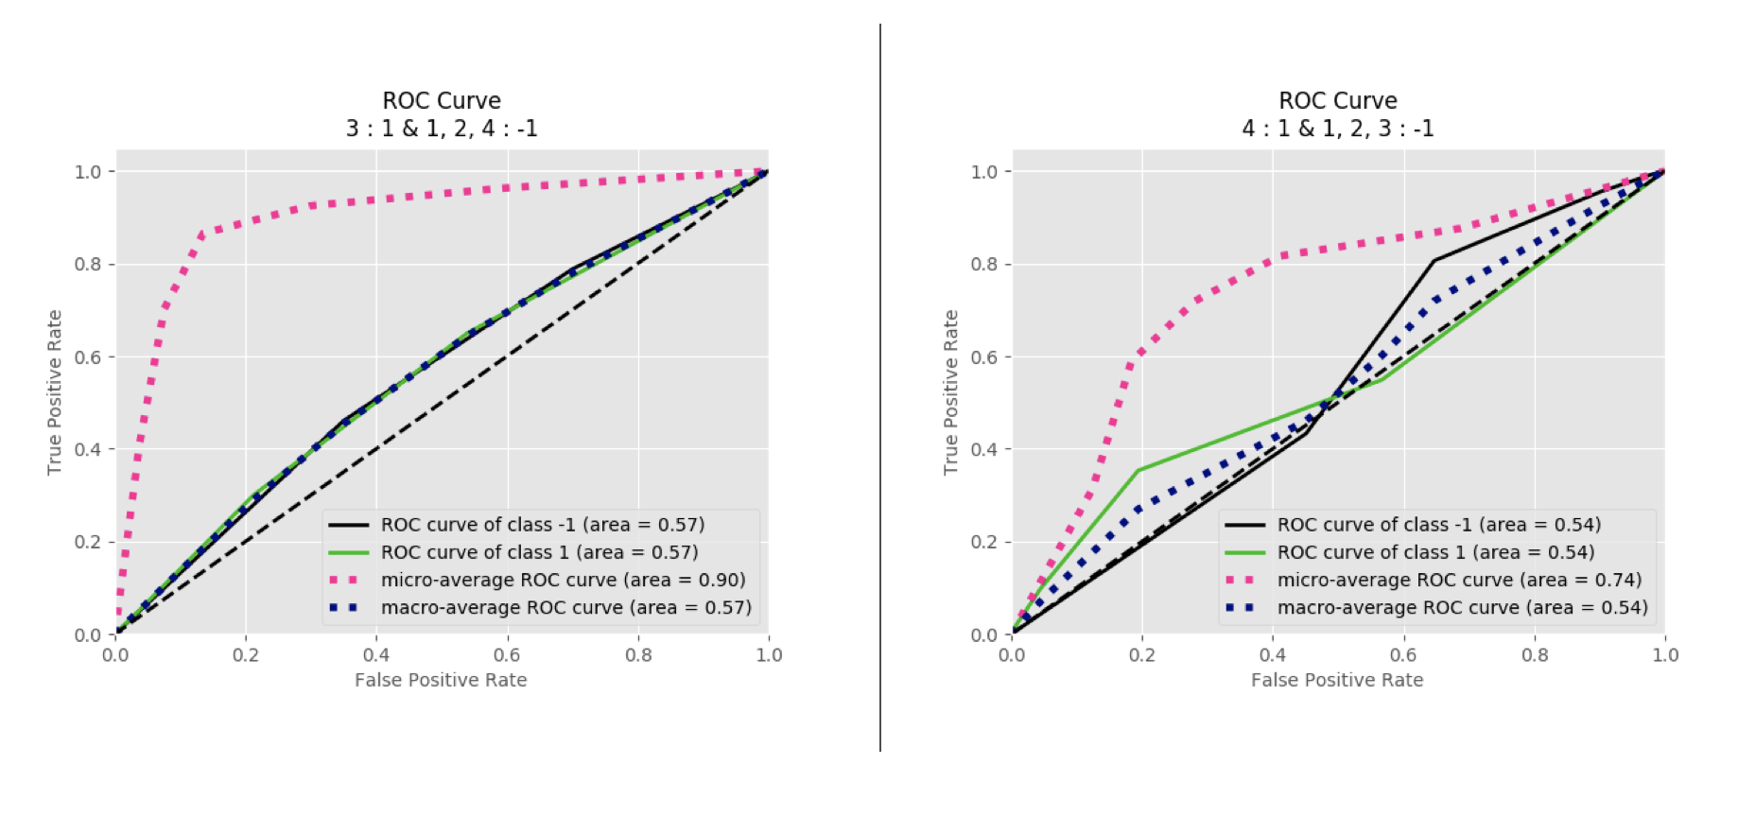

Figure 60 KNN ROC curve after removing false predicted data: 3 vs Rest/C3 classification (left); 4 vs Rest/C4 classification (right)

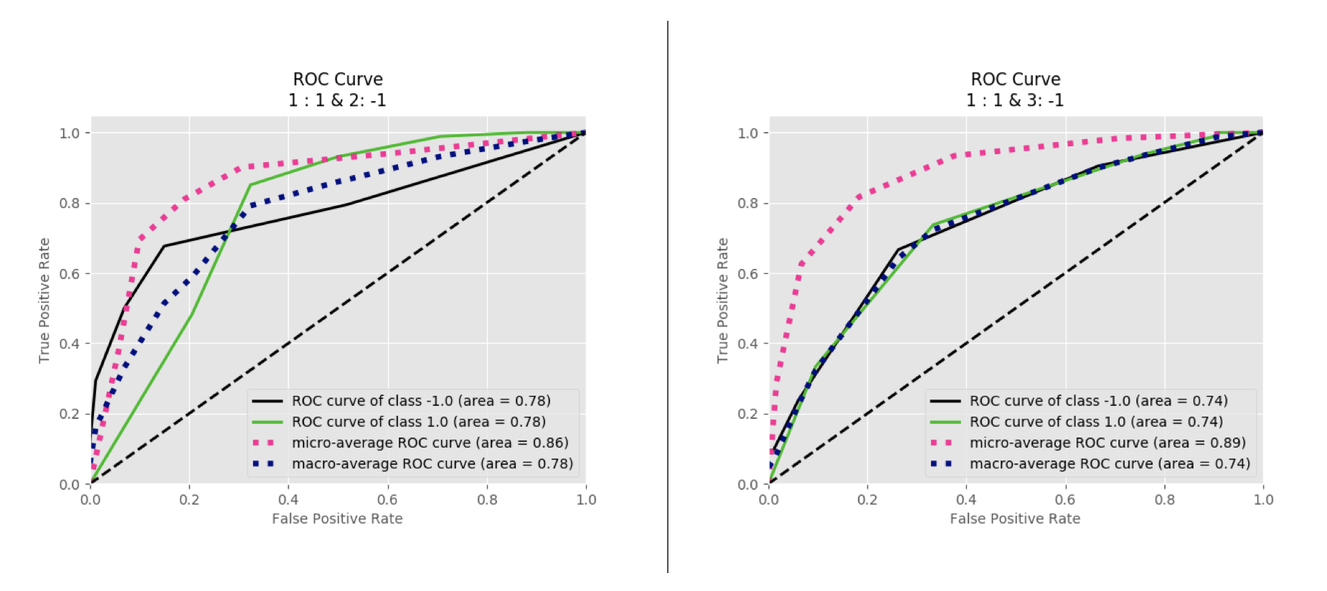

Figure 61 KNN ROC curve after removing false predicted data: 1 vs 2/C5 classification (left); 1 vs 3/C6 classification (right)

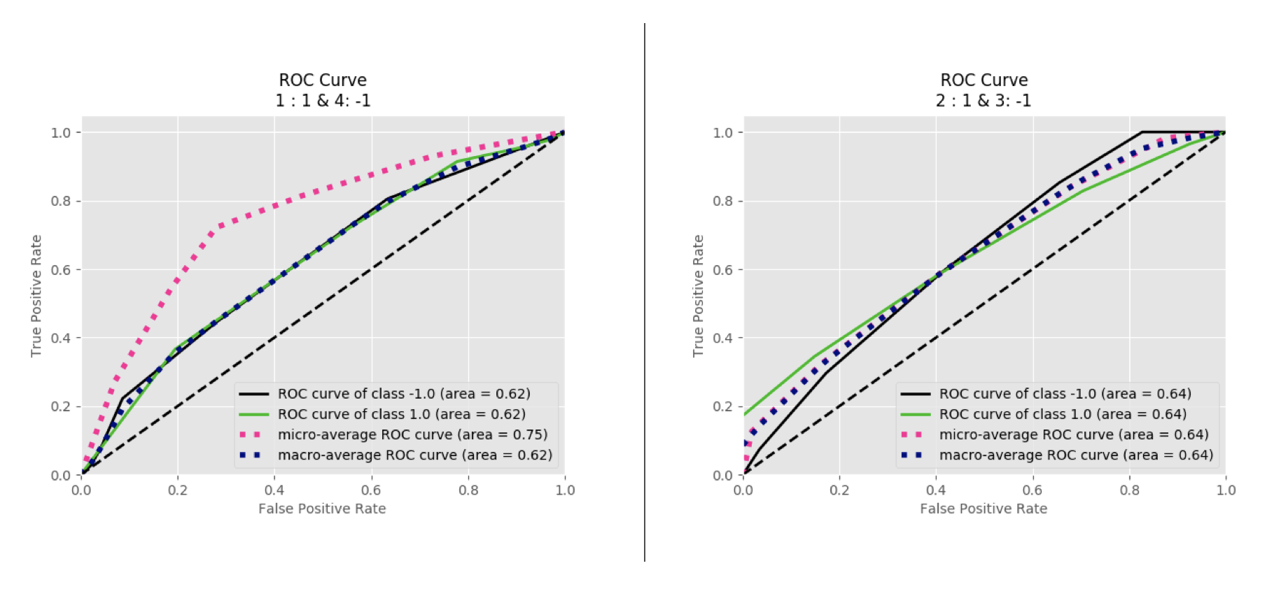

Figure 62 KNN ROC curve after removing false predicted data: 1 vs 4/C7 classification (left); 2 vs 3/C8 classification (right)

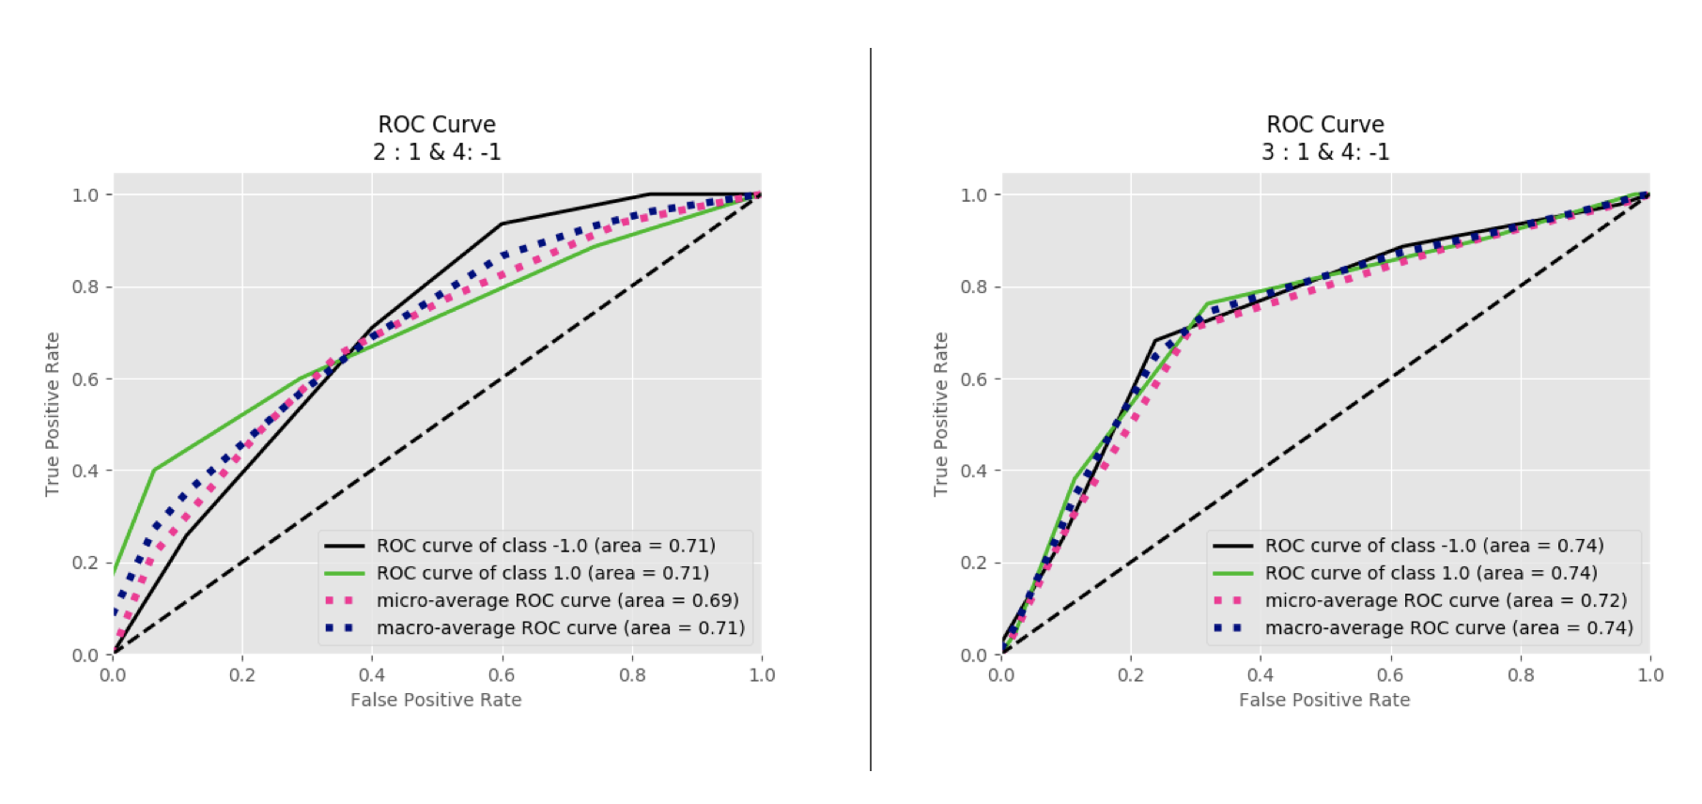

Figure 63 KNN ROC curve after removing false predicted data: 2 vs 4/C9 classification (left); 3 vs 4/C10 classification (right)

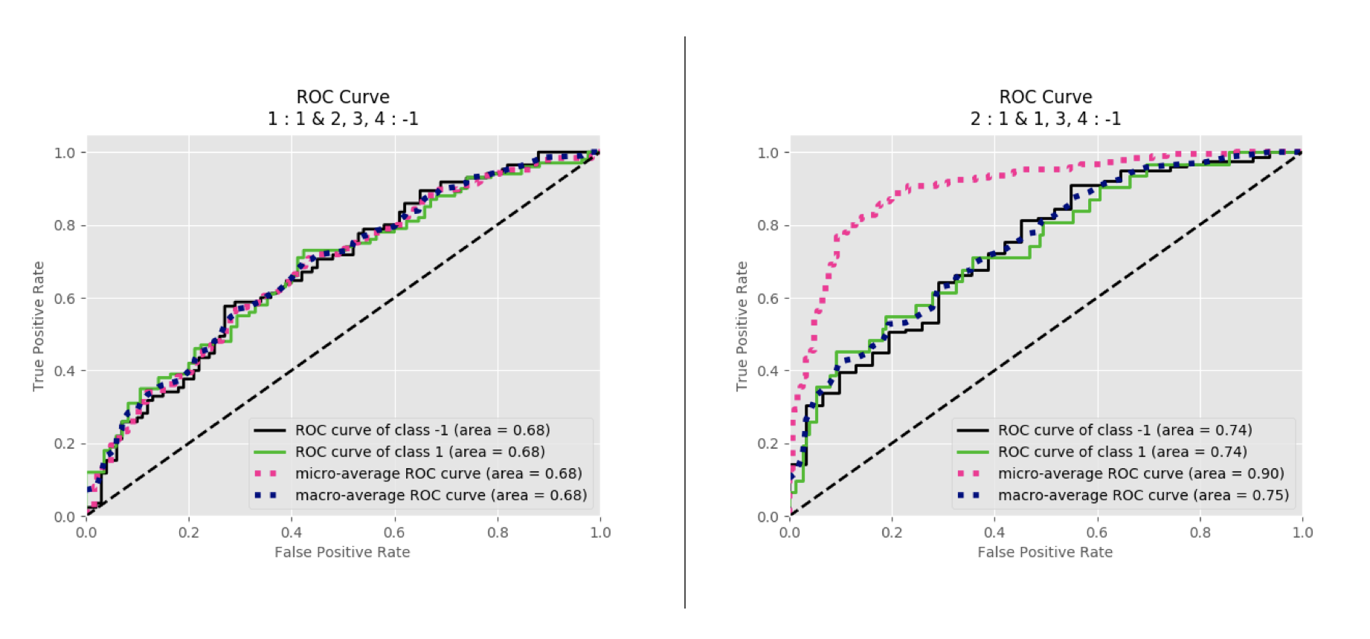

Figure 64 SVM ROC curve after removing false predicted data: 1 vs Rest/C1 classification (left); 2 vs Rest/C2 classification (right)

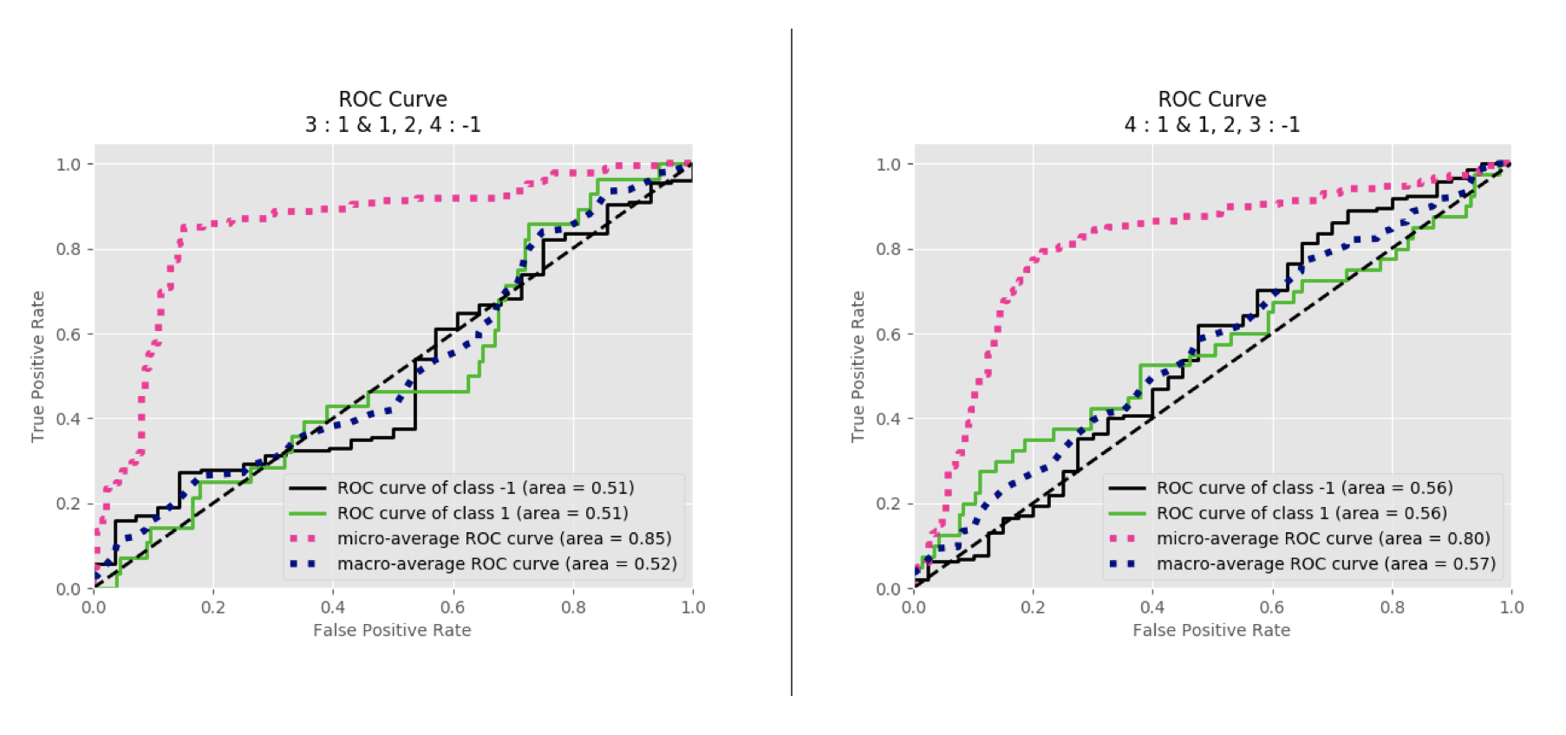

Figure 65 SVM ROC curve after removing false predicted data: 3 vs Rest/C3 classification (left); 4 vs Rest/C4 classification (right)

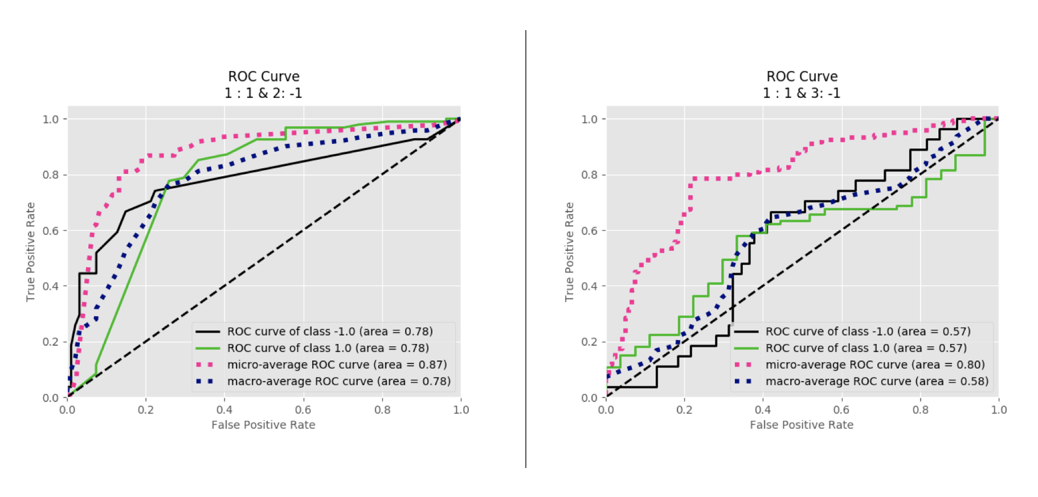

Figure 66 SVM ROC curve after removing false predicted data: 1 vs 2/C5 classification (left); 1 vs 3/C6 classification (right)

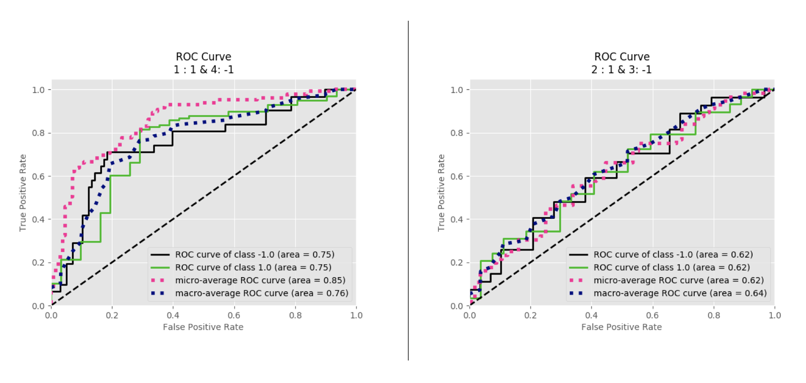

Figure 67 SVM ROC curve after removing false predicted data: 1 vs 4/C7 classification (left); 2 vs 3/C8 classification (right)

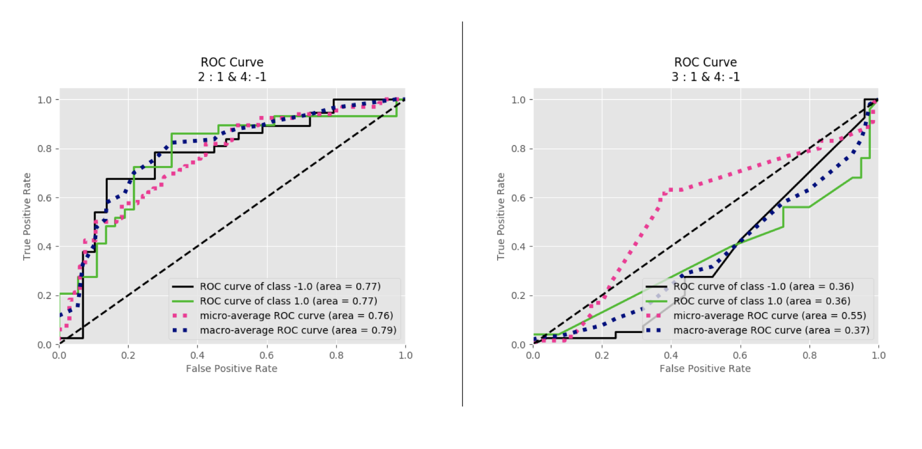

Figure 68 SVM ROC curve after removing false predicted data: 2 vs 4/C9 classification (left); 3 vs 4/C10 classification (right)

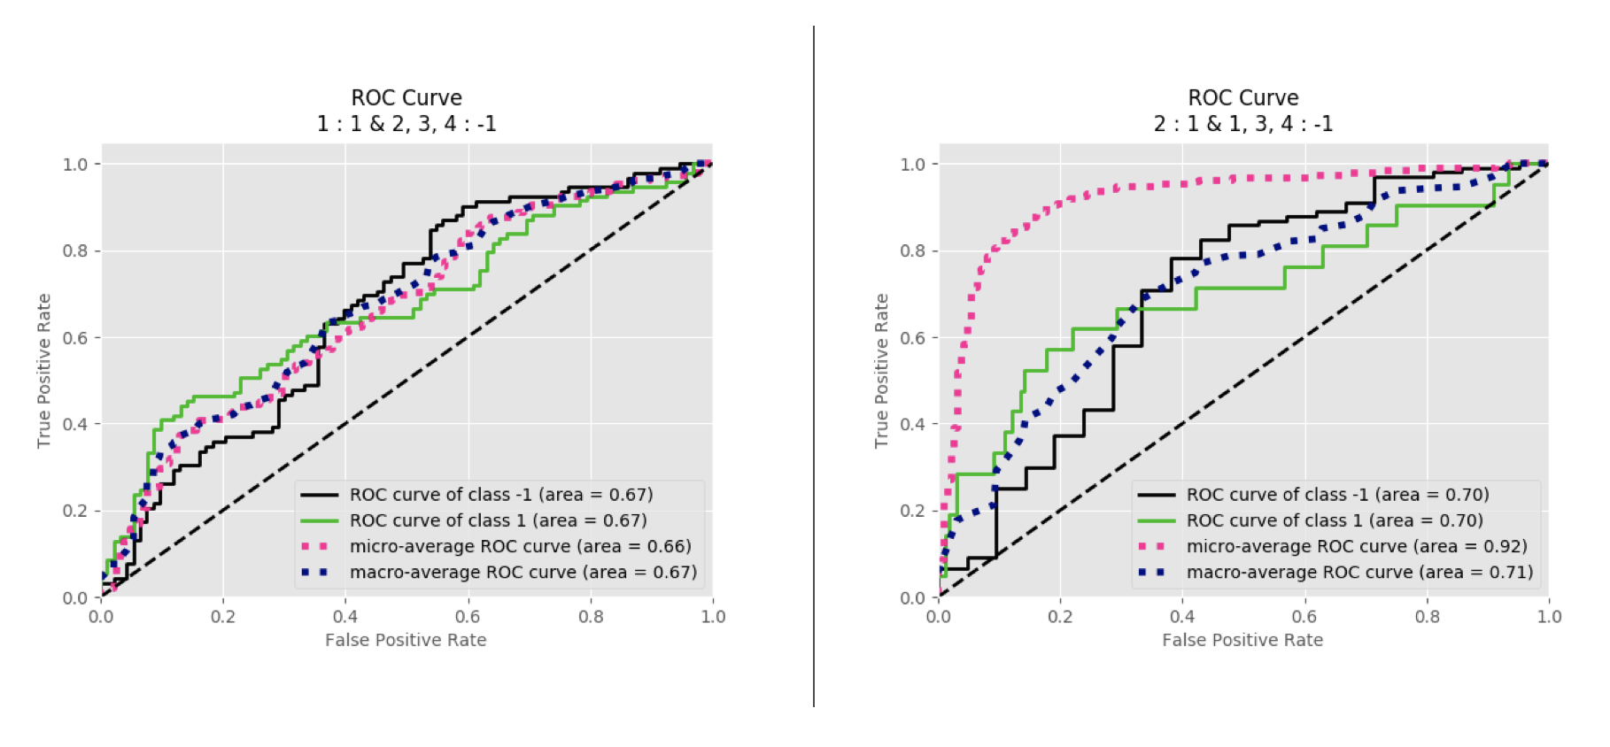

Figure 69 LDA ROC curve after removing false predicted data: 1 vs Rest/C1 classification (left); 2 vs Rest/C2 classification (right)

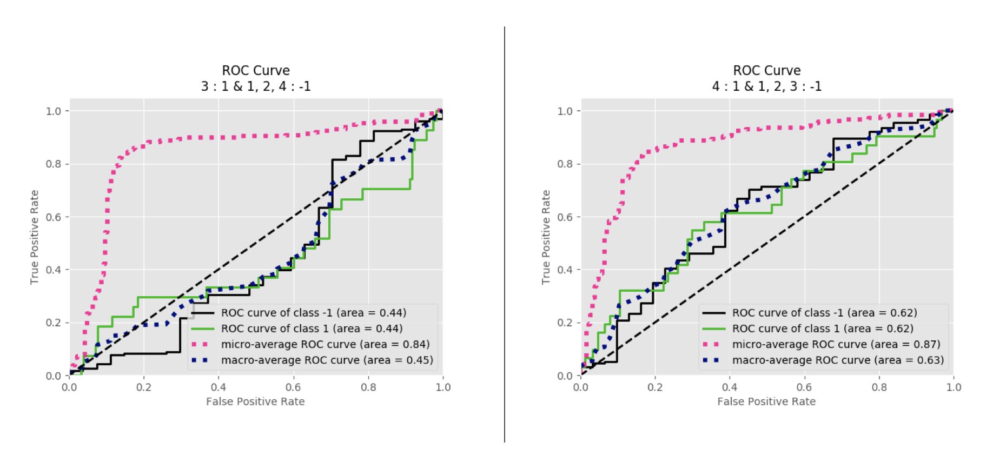

Figure 70 LDA ROC curve after removing false predicted data: 3 vs Rest/C3 classification (left); 4 vs Rest/C4 classification (right)

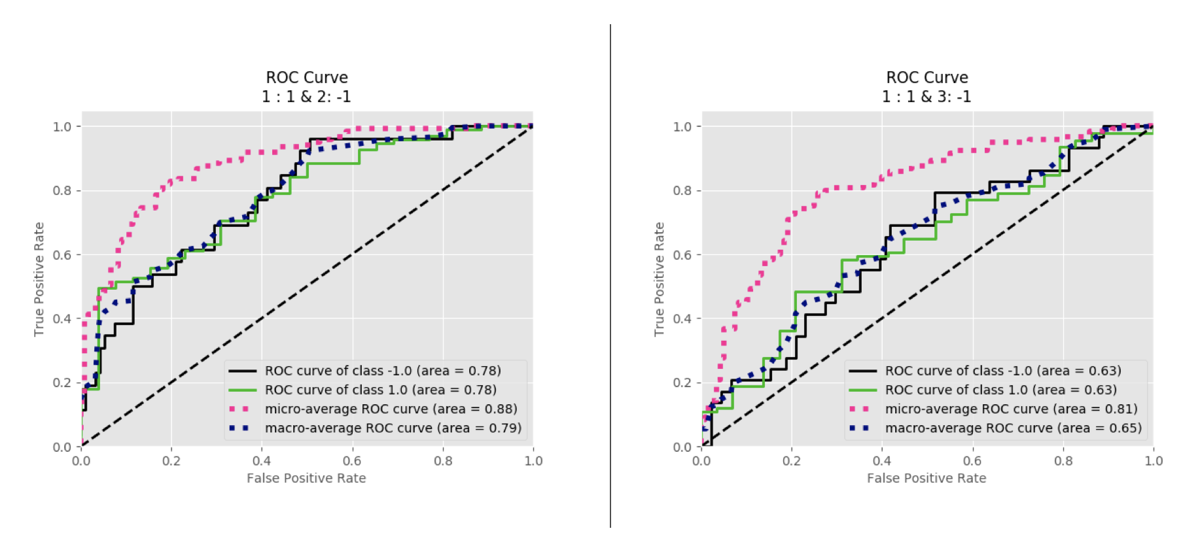

Figure 71 LDA ROC curve after removing false predicted data: 1 vs 2/C5 classification (left); 1 vs 3/C6 classification (right)

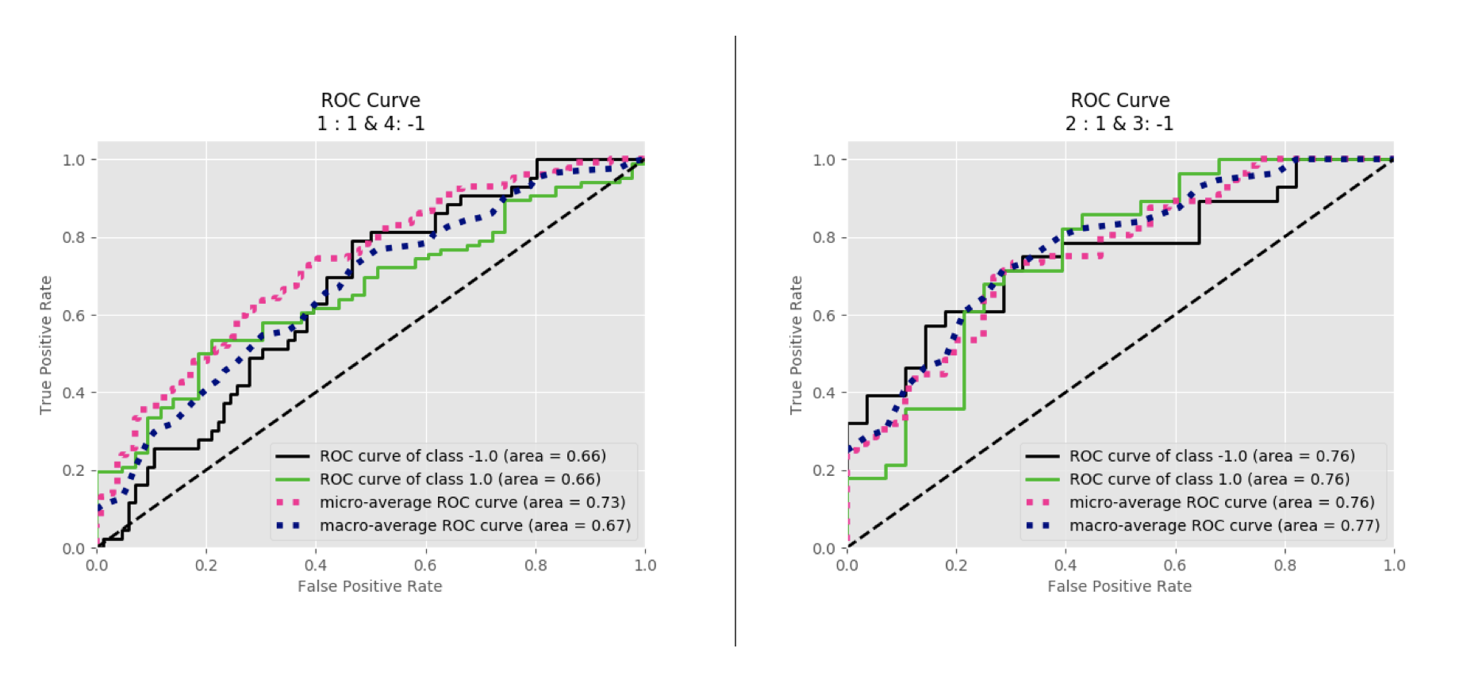

Figure 72 LDA ROC curve after removing false predicted data: 1 vs 4/C7 classification (left); 2 vs 3/C8 classification (right)

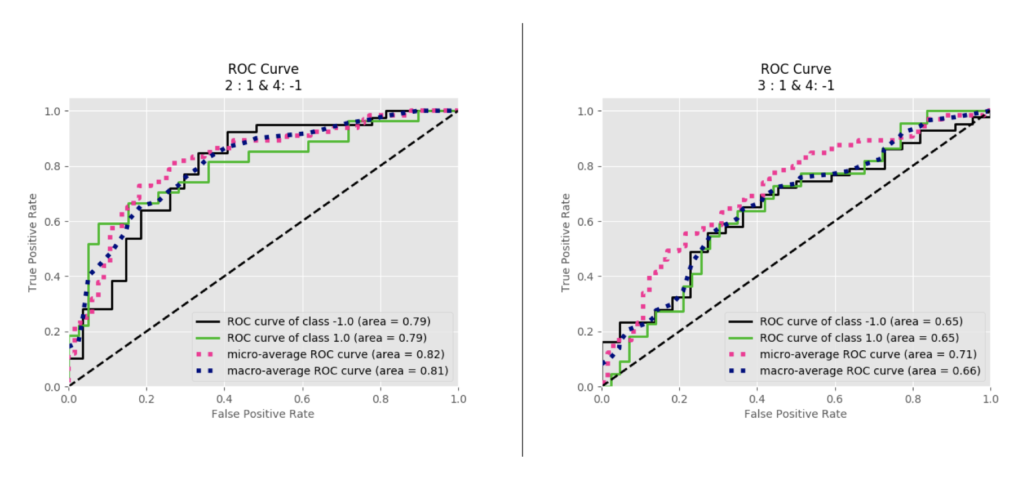

Figure 73 LDA ROC curve after removing false predicted data: 2 vs 4/C1 classification (left); 3 vs 4/C2 classification (right)

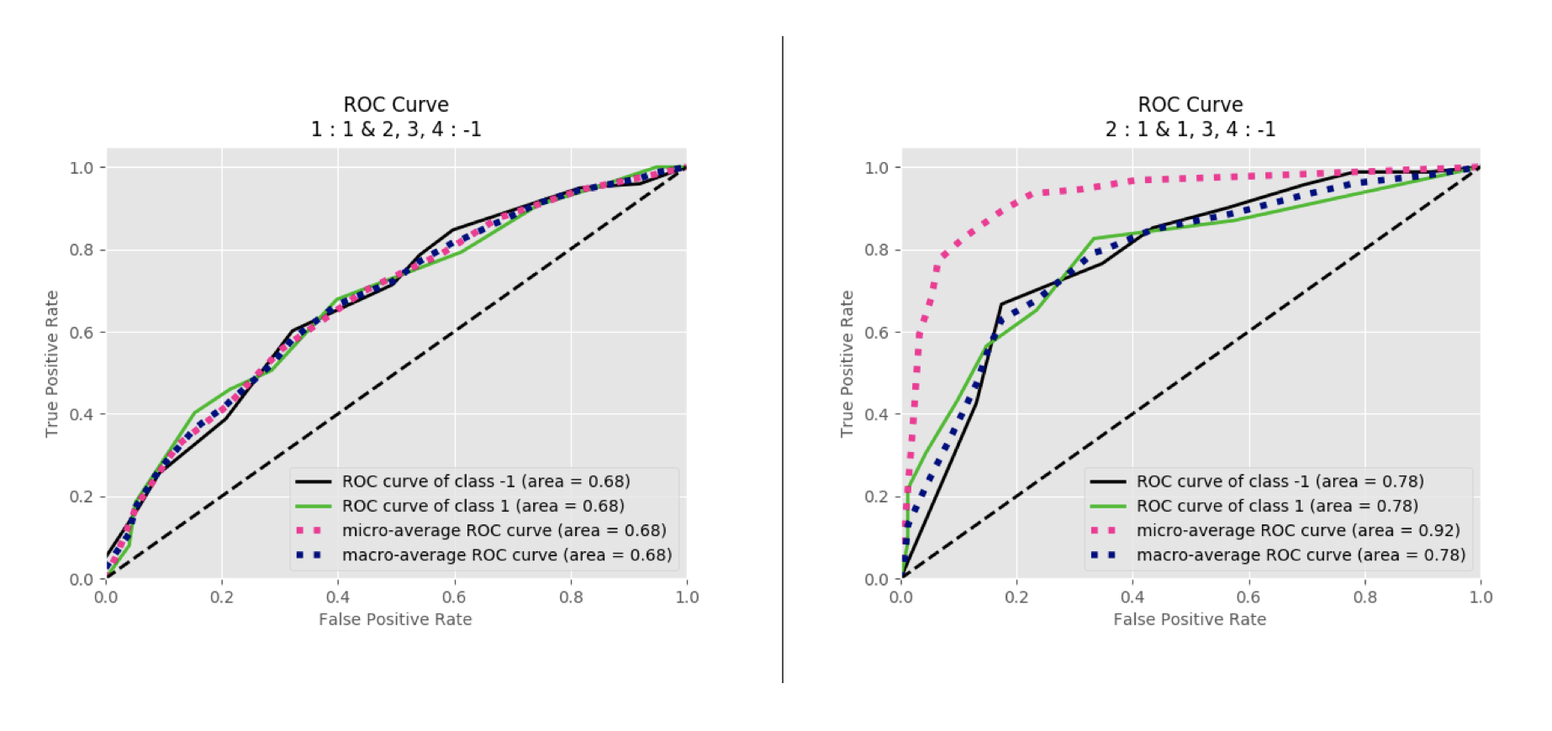

Figure 74 RFT ROC curve after removing false predicted data: 1 vs Rest/C1 classification (left); 2 vs Rest/C2 classification (right)

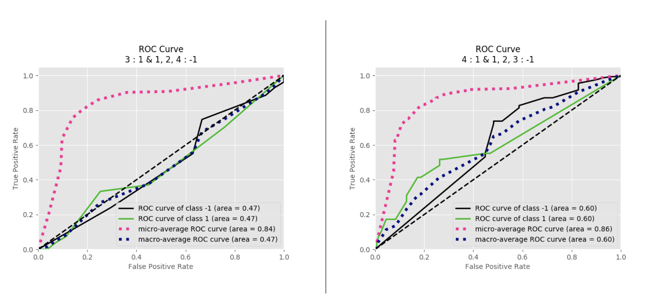

Figure 75 RFT ROC curve after removing false predicted data: 3 vs Rest/C3 classification (left); 4 vs Rest/C4 classification (right)

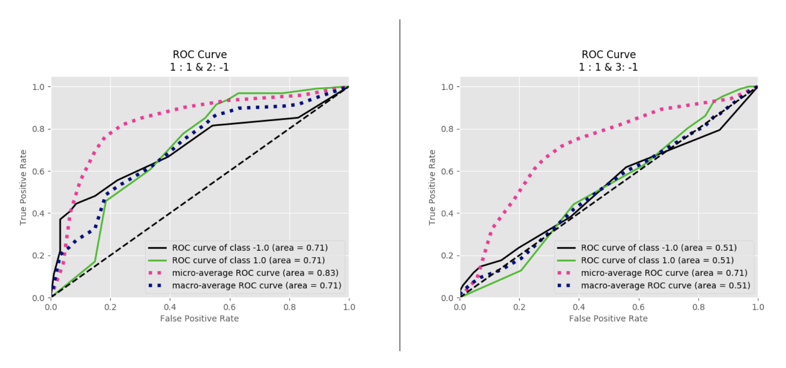

Figure 76 RFT ROC curve after removing false predicted data: 1 vs 2/C5 classification (left); 1 vs 3/C6 classification (right)

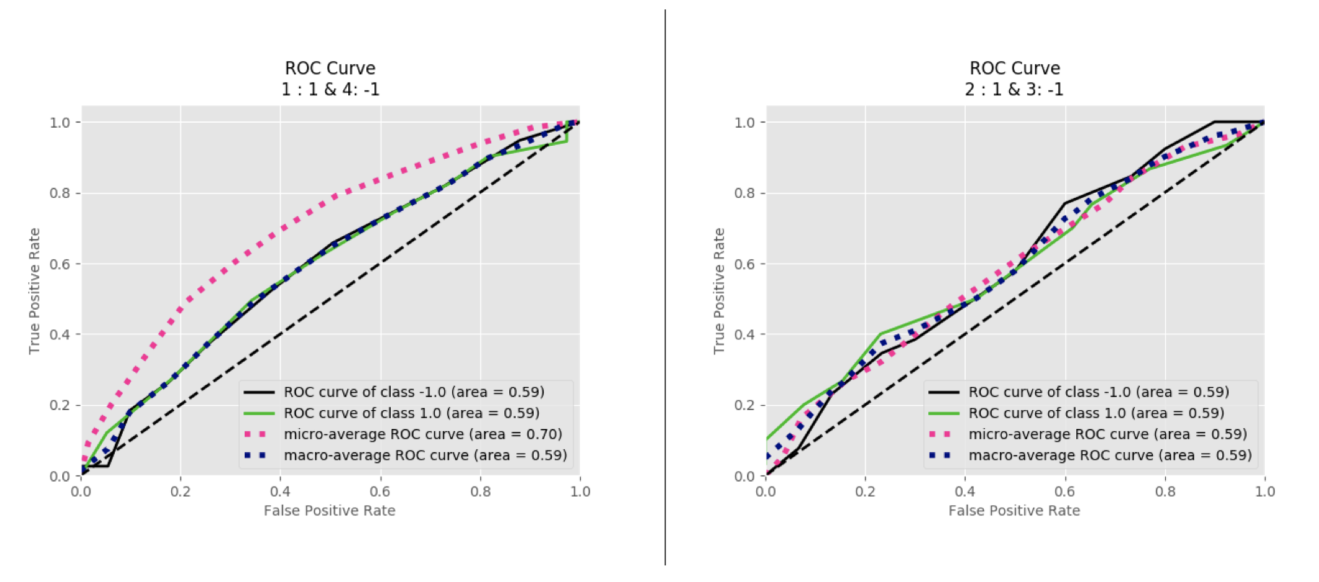

Figure 77 RFT ROC curve after removing false predicted data: 1 vs 4/C7 classification (left); 2 vs 3/C8 classification (right)

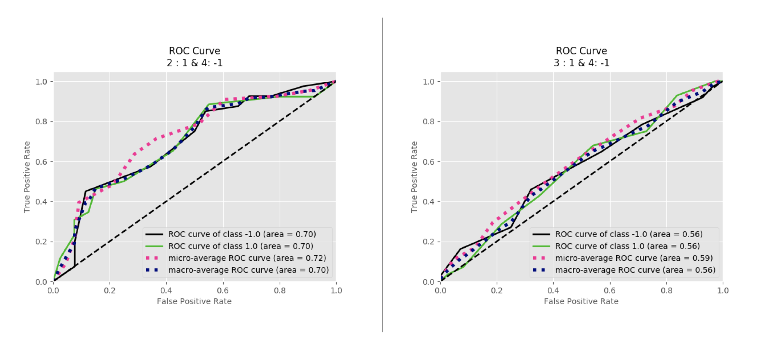

Figure 78 RFT ROC curve after removing false predicted data: 2 vs 4/C9 classification (left); 3 vs 4/C10 classification (right)

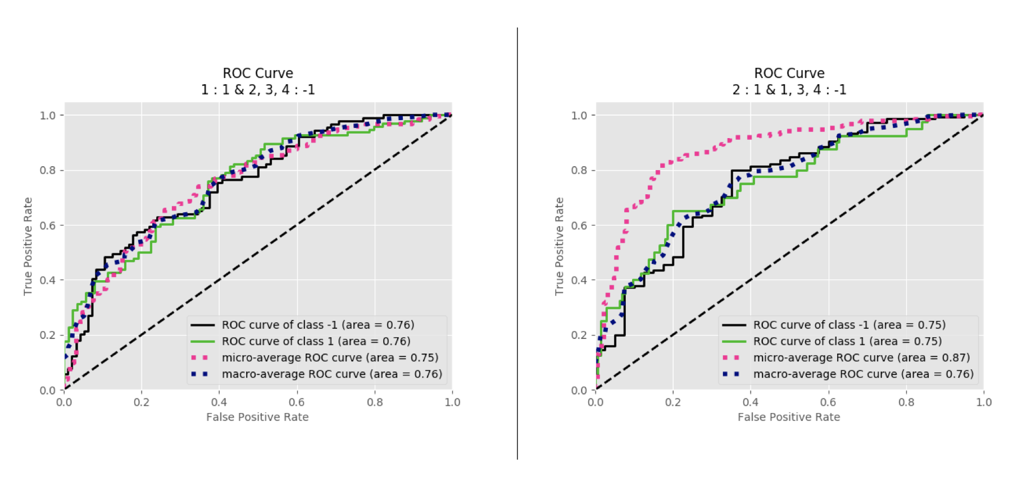

Figure 79 GNB ROC curve after removing false predicted data: 1 vs Rest/C1 classification (left); 2 vs Rest/C2 classification (right)

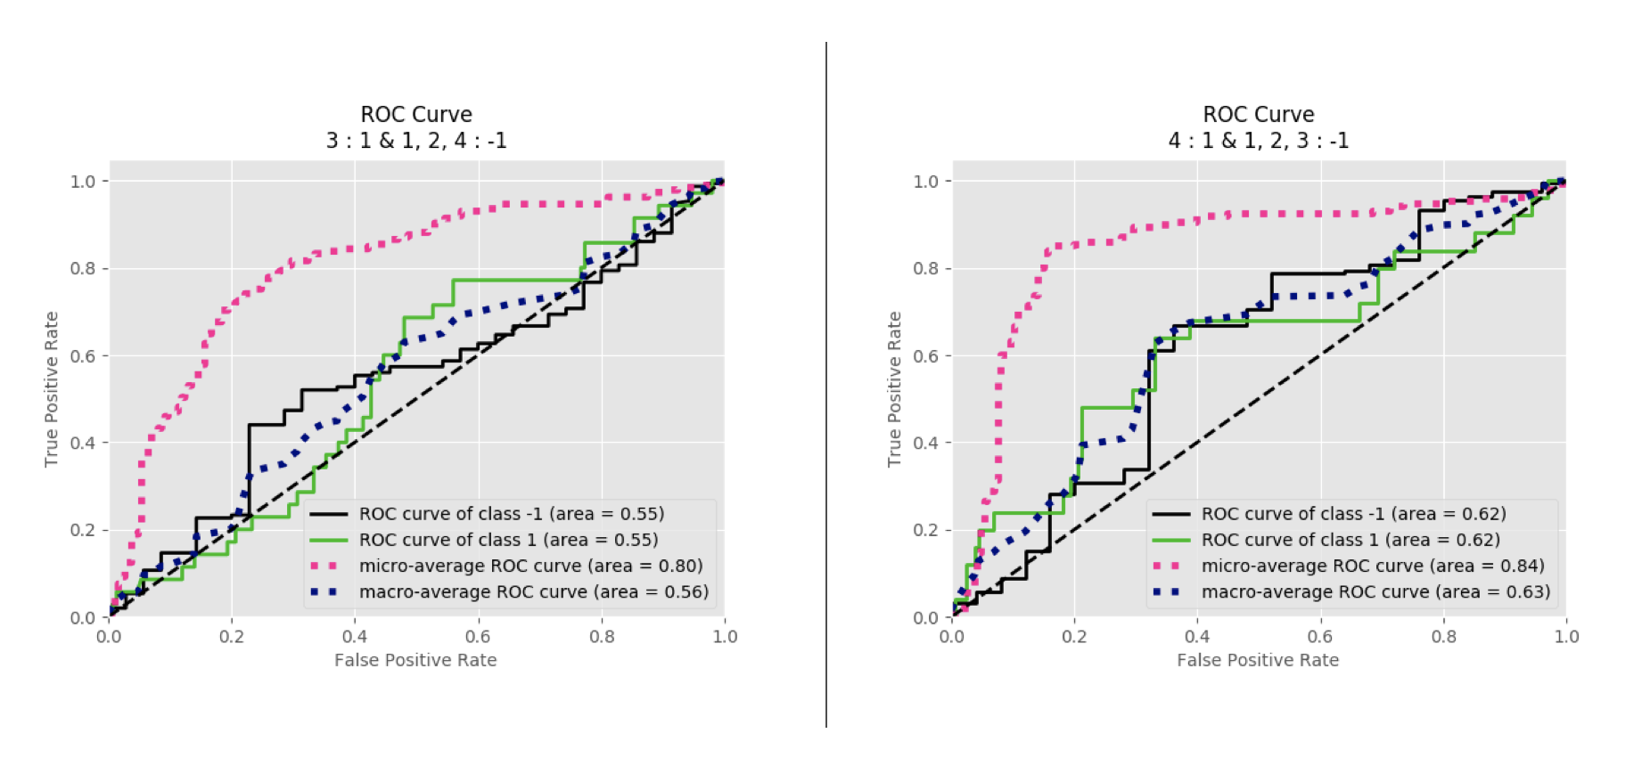

Figure 80 GNB ROC curve after removing false predicted data: 3 vs Rest/C3 classification (left); 4 vs Rest/C4 classification (right)

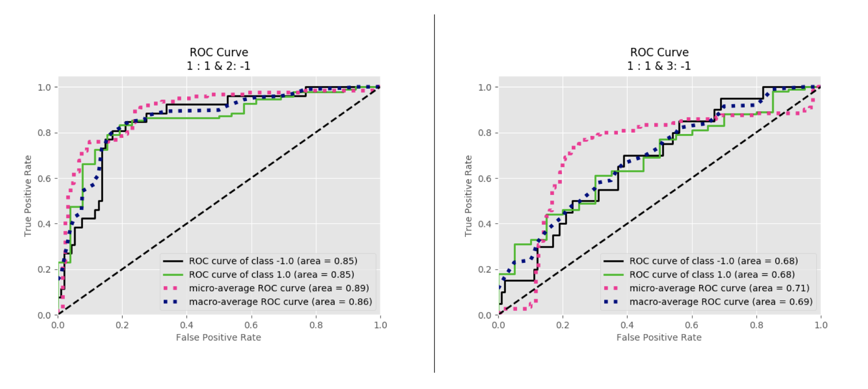

Figure 81 GNB ROC curve after removing false predicted data: 1 vs 2/C5 classification (left); 1 vs 3/C6 classification (right)

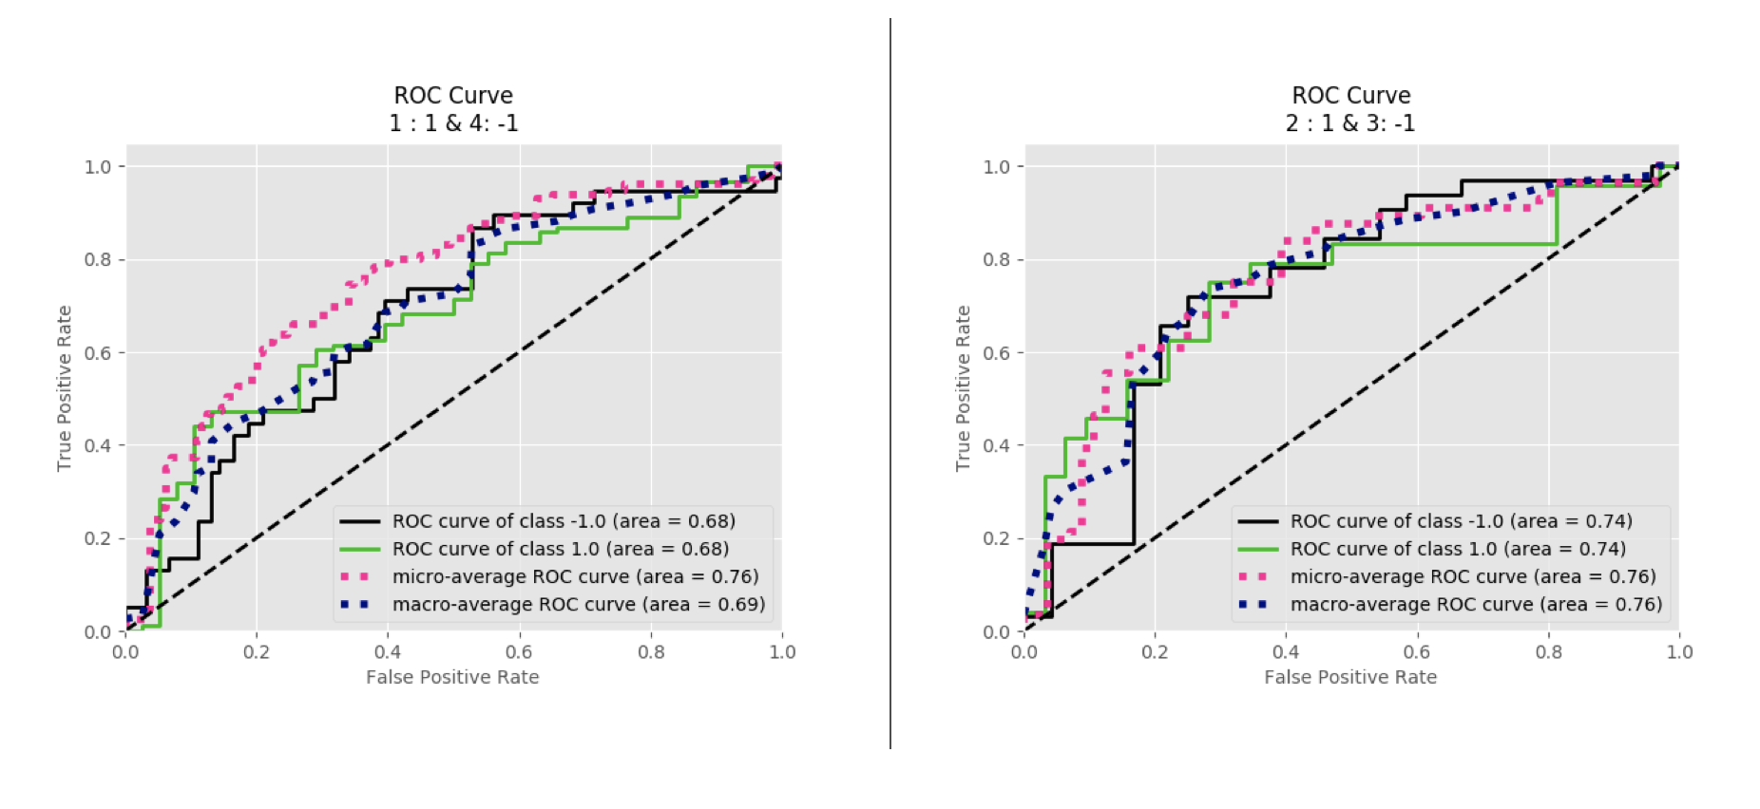

Figure 82 GNB ROC curve after removing false predicted data: 1 vs 4/C7 classification (left); 2 vs 3/C8 classification (right)

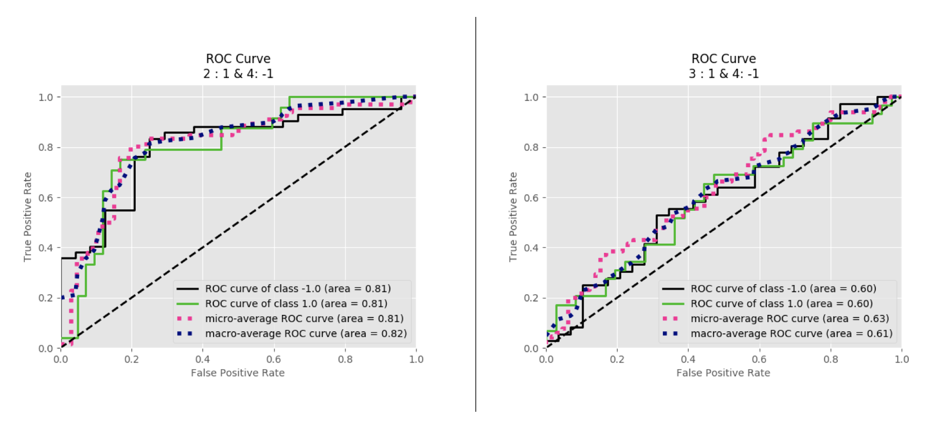

Figure 83 GNB ROC curve after removing false predicted data: 2 vs 4/C9 classification (left); 3 vs 4/C10 classification (right)